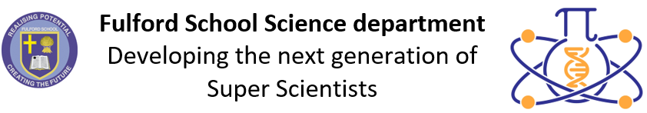 | Science Assessment Calendar  2025-2026

 | Year 7 | Year 8 | Year 9 | Year 10 | Year 11 | Year 12 | Year 13
Half-term 1  1 Sept 25 –  24 Oct 25 | 7.8 Organisms:  TA question on  cell structure | 8.8 Organisms:  TA question on ventilation | P1a Energy:  TA question on energy resources | TA questions:  - B2: Food tests  - C2: Ionic Compounds  - P1: SHC | TA questions:  - B5: Reaction times  - C6: Rate of reaction  - P5: Forces | End of  topic tests | End of topic tests
Half-term 2  3 Nov 25 –  19 Dec 25 | Test 1 – 1 hour  Topics:  - 7.1 Forces  - 7.5 Matter  - 7.8 Organisms | Test 1 – 1 hour  Topics:  - 8.1 Forces  - 8.5 Matter  - 8.8 Organisms | Test 1 – 3 x 30mins  Topics:  - B1a  - C9  - P1a | Test 1 – 3 x 45mins  Topics:  - B1, B4, B2a  - C1, C2, C3  - P1a, P2a, P3, P1b | November mocks  (whole-school)  w/c 3/11/25 | End of  topic tests | End of topic tests
Half-term 3  5 Jan 26 –  13 Feb 26 | 7.5 Matter:  TA question on separating mixtures | 8.6 Chemical Reactions: TA question on endothermic and exothermic reactions | C9 Atmospheric Chemistry: TA question on  atmospheric pollution | Test 2 – 3 x 45 mins  Topics:  - B2  - C3, C4  - P1, P2 | TA questions:  - B7: Sampling  - C7: Fractional Distilation  - P6: Waves | Science mocks | Spring mocks  w/c 5/1/26
Half-term 4  23 Feb 26 –  27 Mar 26 | Test 2 – 1 hour  Topics:  - 7.2 Electricity  - 7.6 Reactions  - 7.9 Ecosystems | Test 2 – 1 hour  Topics:  - 8.2 Electricity and Magnetism  - 8.6 Reactions  - 8.9 Ecosystems | Test 2 – 3 x 30mins  Topics:  - B1  - C1  - P1a, P2a | TA questions:  - B5: Reaction times  - C5: Temperature  Changes RPA  - P2: Resistance | February mocks  w/c 26/1/26  45 minutes | Y12 Exams  w/c  9/3/26 | End of topic tests
Half-term 5  13 Apr 26 –  22 May 26 | 7.3 Energy:  TA question on energy resources | 8.2 Electromagnets:  TA question on electromagnets | B4 Bioenergetics: TA question on photosynthesis | Y10 Exams w/c 13/4/26  Paper 1: 3 x 75mins  (new static tests) | TA questions in Biology, Chemistry and Physics on How Science Works | End of  topic tests
Half-term 6  1 June 26 –  20 July 26 | Test 3 – 1 hour  EOY assessment -questions from topics and skills from breadth of Y7 | Test 3 – 1 hour  EOY assessment -questions from  topics and skills from breadth of Y8 | Test 3 – 3 x 45mins  EOY assessments:  - B1, B4  - C1, C2, C9  - P1a, P2a, P3 | HSW TA questions:  - Biol: Enzymes / Osmosis  - Chem: Rate of Reaction  - Phys: Hooke’s Law |  | EOY test option  w/c 15/6/26

