Fulford School
Fulfordgate, Heslington Lane, Fulford, York. YO10 4FY
T: 01904 633300 E: office@fulford.york.sch.uk W:www.fulford.york.sch.uk

24th November 2023

Dear Parents and Carers,

I hope that this letter finds you and your family well. As we enter the season of Advent and in preparation for the Christmas celebrations, we are completing a variety of events at school. The events we are running are as follows:

Design a Christmas card competition: A competition to design the school Christmas card, with the winner’s card being sent to the local community. The card must be A5 in size, and can be done by hand or on a computer. Deadline: Monday 4th December.

Christmas Jumper & Christmas Dinner Day: Year 7 to 11 on Wednesday 6th December & Year 12 and 13 on Thursday 7th December.

Students will be able to wear their Christmas jumpers, jumpers decorated with Christmas baubles, tinsel etc., or non-uniform.

This year, the Fulford student leadership team have selected two charities to support – York Foodbank and SASH.

We would love for students to donate to either charity or both! All food donations will go to the York Foodbank and all cash collected will go to SASH.

Food donations should be brought to school on the day. If you are making a food donation,
please see information below:

Currently short of: instant mash potato, UHT Milk, long life cartoons of juice, sweets and
chocolate, powered milk, sponge puddings (cupboard/tinned), jars of jam (not homemade),
laundry detergent, jars of coffee and bags for life or strong carrier bags.

Already well stocked in: baked beans and tinned spaghetti, pasta, and nappies size 1 and 7.

We are unable to accept: baby milk, chilled/frozen products, homemade items and out or
date or opened items.

For further details, please see the York Food Bank website - https://york.foodbank.org.uk/

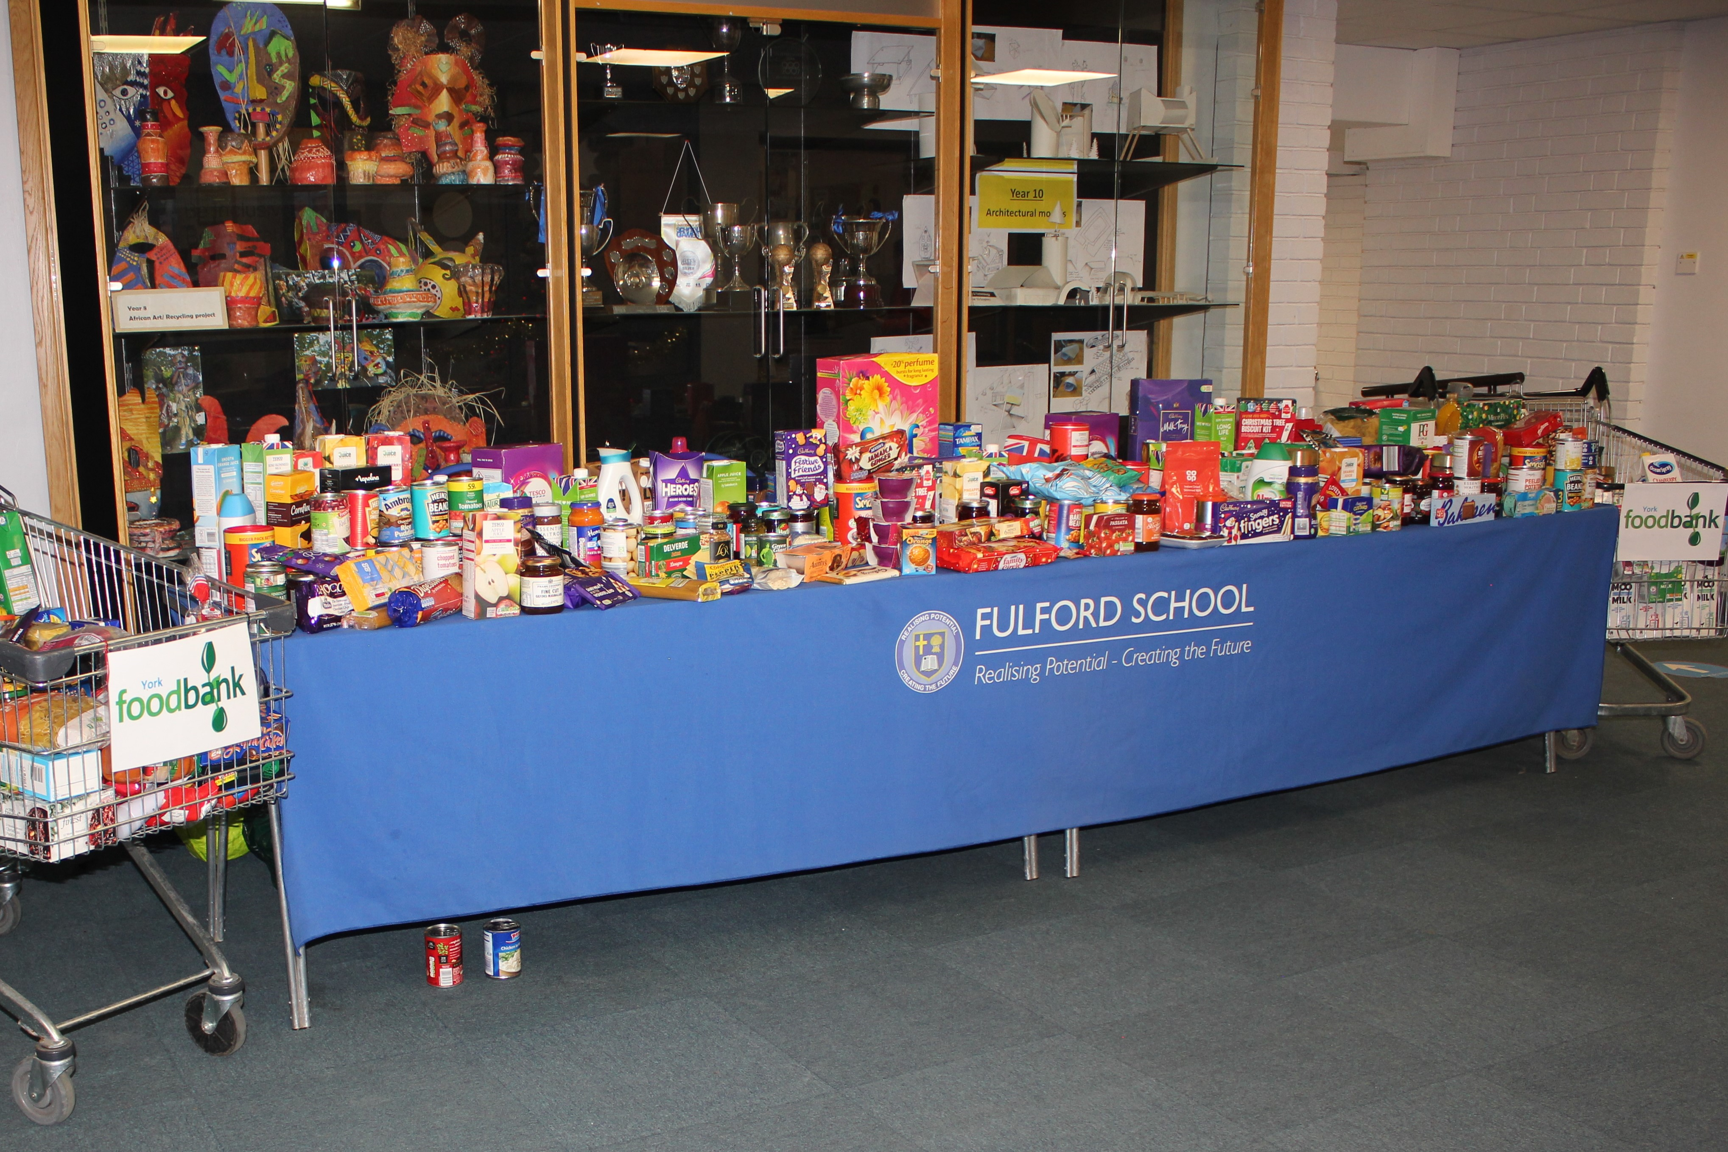

SASH (Safe and Sound Homes) is a youth homelessness charity that works across York, North and East Yorkshire.

Their aim is to help young people 16 -25 who are facing homelessness.

The suggested donation is a minimum of £1 and should be brought to school on the day

https://www.sash-uk.org.uk/

Winter Concert: Wednesday 6th December. The Winter Concert takes place from 6.30pm – 8.30pm. Tickets are £5 and can be purchased by ParentPay. Only tickets purchased prior to the evening will be accepted and they are selling out fast for the event already.

Suits and Sparkle Day. Friday 22nd December. For the final day of term, we have given the staff a chance to dress up in whatever they would have worn for a typical staff Christmas Party. Full glitzy dresses and smart suits – the works!

Students are also invited to also take part in the Christmas themed day or to wear non-uniform. (We will not be asking for donations on this day).

*School will finish after period 3, 12:40pm, on the 22nd December. Buses will run as normal at this earlier time.

Christmas Attendance Raffle. To encourage attendance for the final two weeks of term (Monday 11th December – Friday 22nd December), and to allow some Christmas prizes to be given, there will be a raffle on the final morning; everyone with a 100% attendance in the final week will be entered.

There will be a draw for each year group with a selection of prizes on offer. Authorised absence will be taken into account when compiling the names of the students entered into the draw.

We hope that as many of you as possible will join us for some of the events and help to support the local community. If students do not want to take part this is fine, and normal school uniform can be worn.

School will re-open for the Spring Term on Monday 8th January.

If you have any questions, please do not hesitate to contact me at school or by email harrisr@fulford.york.sch.uk

Please take care and have a great Christmas and New Year.

Kind regards,
Russell Harris
Associate Head (Pastoral)

The South York Multi-Academy Trust.
Registered address: Fulfordgate, Heslington Lane, Fulford, York YO10 4FY.
A charitable company limited guarantee registered in England and Wales.
(company number:11082297)

