Year 9 Key terms
In this booklet you will find key terms that you have used in science this year; these will be useful to learn for your end of year 9 test.
You need to try and learn and remember all the key terms, with their definitions. One way of doing this is to make each one into a revision card, with the term on one side and its definition on the other – look at this example:
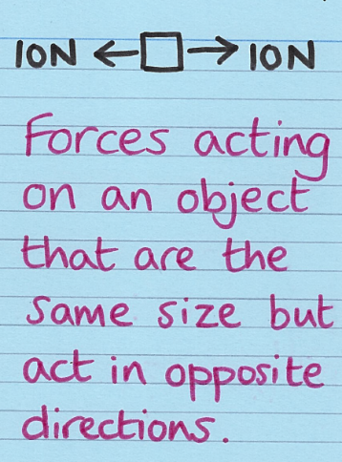
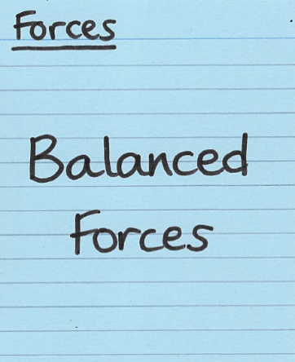

Write the key Write what
term on one it means on
side the back

Use this table to record how many revision cards you have made, then
practise using them – ask a friend to test you!
Year 9 Science Topic | I have made revision cards | I have practised using the revision cards at least 10 times
Cell Biology Part 1
Cell Biology Part 2
Photosynthesis - (Bioenergetics Part 1)
Respiration
(Bioenergetics Part 2)
Energy - Part 1
Electricity - Part 1
Particle Model of Matter
Atomic Structure and the Periodic table
The Periodic Table
Structure and Bonding
Chemical Changes

Good luck – from Fulford School Science Department
Fulford School Science Department
Developing the next generation of Super Scientists

Year 9 – Five key terms | Part 1 - Cell Biology

Eukaryotic cell | Large, complex cells (including animal and plant cells) with a cell membrane, cytoplasm and genetic material enclosed in a nucleus. | Nucleus Nucleus
Prokaryotic cell | Small, simple cells (including bacteria) with cytoplasm and a cell membrane surrounded by a cell wall. Their genetic material (a single DNA loop) is not enclosed in a nucleus. They may have small rings of DNA called plasmids. | No nucleus  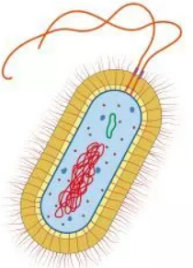
Differentiation | A cell acquires different sub-cellular structures to allow it to perform a certain function. (Differentiation results in the development of specialised cells). | 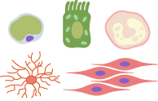
Electron microscope | A microscope which uses an electron beam (instead of light) to study cells in much finer detail. They have a much higher magnification and resolving power than a light microscope. | 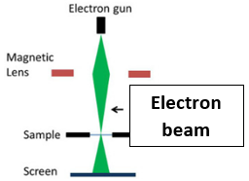
Resolution / resolving power (of a microscope) | The ability to see clear detail by distinguishing between two close points on an image. | 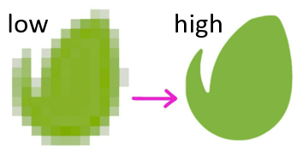

Five key ideas  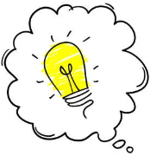  All cells contain DNA, a cell membrane (controls movement of substances) and ribosomes (for protein synthesis) | Sub-cellular structures are ‘parts inside a cell’. Sub-cellular structures in animal cells include the nucleus, cytoplasm, cell membrane, mitochondria and ribosomes. Plant cells also have a cellulose cell wall, permanent vacuole and some have chloroplasts. |  | Specialised cells in animals include sperm, nerve and muscle cells. In plants, these include root hair cells, xylem and phloem cells.
 | Magnification = | size of image_  size of real object | Microscopy techniques have developed over time, increasing our understanding of sub-cellular structures.

Fulford School Science Department
Developing the next generation of Super Scientists

Year 9 – Five key terms | Part 2 - Cell Biology

Mitosis | One copy of each chromosome (a chromatid) is pulled to each end of the cell and the nucleus divides. This is followed by the cytoplasm and cell membrane dividing to form two genetically identical cells. | 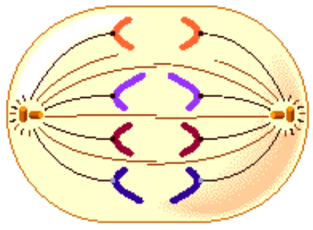
Stem cell | An undifferentiated cell of an organism, which is capable of giving rise to many more cells of the same type, and from which certain other cells can arise from differentiation. | 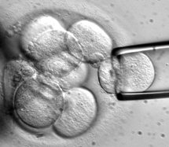
Diffusion | The net movement of particles (of any substance in solution, or particles of a gas) from an area of higher concentration to an area of lower concentration. Diffusion occurs down a concentration gradient. | 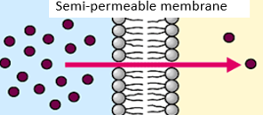
Osmosis | The diffusion of water molecules from a dilute solution to a concentrated solution, through a partially permeable membrane. | 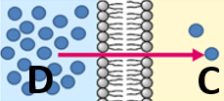
Active transport | Particles move from a dilute solution (lower concentration of particles) to a more concentrated solution (higher concentration of particles), through a partially permeable membrane. Particles move against a concentration gradient - this needs energy from respiration. | 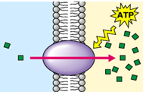

Five key ideas  All cells contain DNA, a cell membrane (which controls the movement of substances) and ribosomes (for making proteins) |  | Before a cell can divide (during interphase) it replicates its DNA to form two copies of each chromosome (the copies are called chromatids). The cell also needs to grow and increase the number of sub-cellular structures, e.g. mitochondria and ribosomes. These events happen during the cell cycle, before mitosis. | Stem cells from human embryos (‘embryonic stem cells’) can be cloned and made to differentiate into different types of human cells. Stem cells from adult bone marrow (‘adult stem cells’) can only form different blood cells.
 |  | The rate of diffusion is faster if there is:  - a steeper concentration gradient;  - a higher temperature;  - a larger surface area;  - a short diffusion pathway | Exchange surfaces (e.g. alveoli in the lungs and villi in the small intestine) have large surface areas, short diffusion pathways and rich blood supplies.
Oxygen debt | The build up of lactic acid during long periods of vigorous activity results in muscles becoming fatigued and an oxygen debt builds up.  (HT) Volume of extra oxygen needed to react with lactic acid and remove it from cells is the oxygen debt. |  |  | 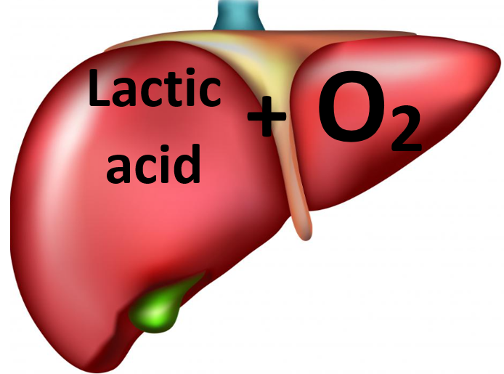
Metabolism | The sum of all the reactions in a cell or the body. The energy needed for enzyme-controlled processes of metabolism is transferred by respiration in cells.

Five key ideas  Respiration is an exothermic reaction, that occurs all the time in living cells. In eukaryotic cells, most of the reactions occur inside mitochondria | Cellular respiration, releases energy from glucose, transferring energy to cells for their life processes. The complete oxidation of glucose via aerobic respiration transfers more energy than the incomplete oxidation via anaerobic respiration. | Uses of energy  Organisms need energy for:  - Building larger molecules  - Muscle contraction to move  - Keeping warm  - Active transport
 | Reactions of metabolism include:  - Respiration, to transfer energy to cells  - Making starch and cellulose using glucose in plants  - Making amino acids, from glucose and nitrates, for protein synthesis in plants  - Making glycogen in animals  - Making lipids from glycerol and fatty acids  - Breaking down excess proteins into urea | During exercise the heart rate and breathing rate (& depth) increase – muscle cells need:  - to do more respiration  - to release more energy, so need to get…..  - more oxygenated blood  Never say respiration ‘makes/produces’ energy

Fulford School Science Department
Developing the next generation of Super Scientists

Year 9 – Five key terms | Photosynthesis

Photosynthesis | 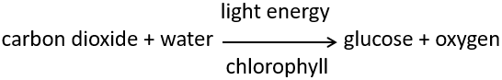  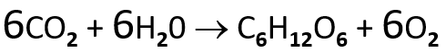 | 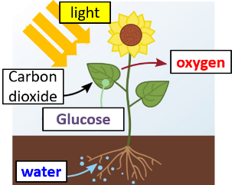
Chlorophyll | A green pigment inside chloroplasts that absorbs light energy for photosynthesis. | 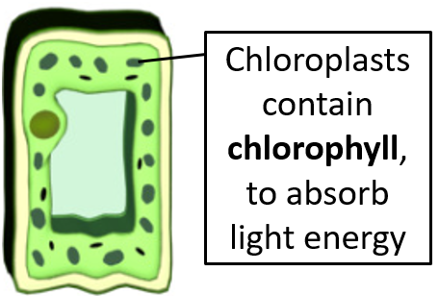
Endothermic reaction | Photosynthesis is endothermic, in which energy is transferred from the environment to chloroplasts by light; the energy is used to create glucose and oxygen, from carbon dioxide and water. | 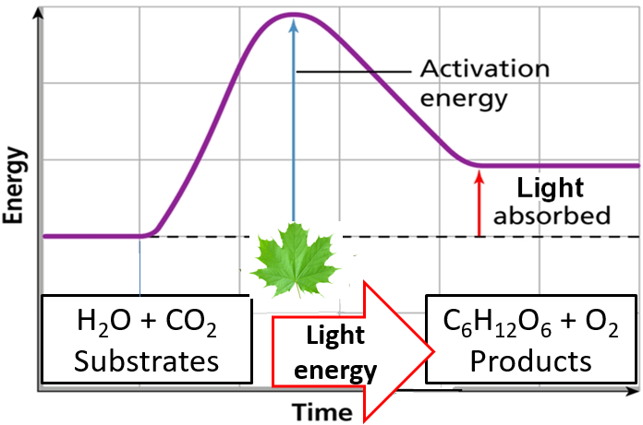
Limiting factors | Temperature, light intensity, CO₂ concentration and the amount of chlorophyll, affect the rate of photosynthesis. Any one factor can limit photosynthesis; increasing a limiting factor will increase the rate of photosynthesis. | 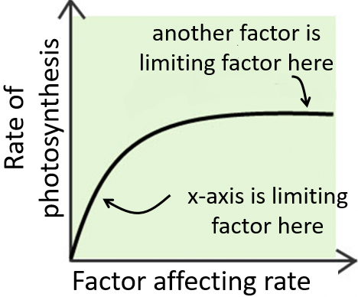
Inverse square law  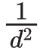 | (HT) Light intensity is inversely proportional to the square of the distance between a plant and the light source. | 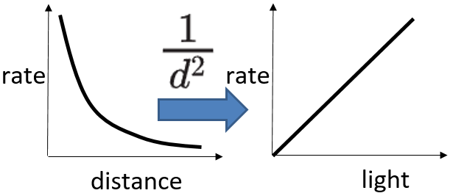

Five key ideas  Chlorosis  If a plant lacks Mg²⁺, less chlorophyll is made, so less light energy is absorbed for photosynthesis | Limiting factor graphs  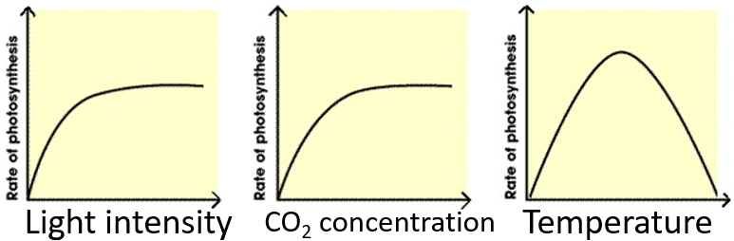 | Limiting factors are important in economics of enhancing conditions in greenhouses to gain maximum rate of photosynthesis while still maintaining profit.
 | Uses of glucose after photosynthesis  • for respiration, to release energy  • to make insoluble starch for storage  • to make fat or oil for storage  • to make cellulose, to strengthen cell walls  • to make amino acids for protein synthesis | To make proteins, plants need glucose from photosynthesis and nitrate ions, which are absorbed from the soil

Fulford School Science Department
Developing the next generation of Super Scientists

Year 9 – Five key terms | Respiration

Aerobic respiration | Releasing energy from glucose using oxygen:  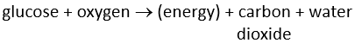 | 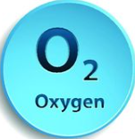  More  energy
Anaerobic respiration in muscle cells | Releasing energy from glucose without oxygen:  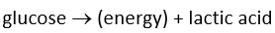 | 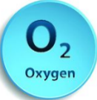  Less  energy
Fermentation | Anaerobic respiration (without oxygen) that  occurs in plants and yeast cells:  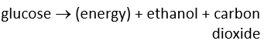  Has economic importance in making bread and alcoholic drinks. | Less  energy
Oxygen debt | The build up of lactic acid during long periods of vigorous activity results in muscles becoming fatigued and an oxygen debt builds up.  (HT) Volume of extra oxygen needed to react with lactic acid and remove it from cells is the oxygen debt.
Metabolism | The sum of all the reactions in a cell or the body. The energy needed for enzyme-controlled processes of metabolism is transferred by respiration in cells.

Five key ideas  Respiration is an exothermic reaction, that occurs all the time in living cells. In eukaryotic cells, most of the reactions occur inside mitochondria | Cellular respiration, releases energy from glucose, transferring energy to cells for their life processes. The complete oxidation of glucose via aerobic respiration transfers more energy than the incomplete oxidation via anaerobic respiration. | Uses of energy  Organisms need energy for:  - Building larger molecules  - Muscle contraction to move  - Keeping warm  - Active transport
 | Reactions of metabolism include:  - Respiration, to transfer energy to cells  - Making starch and cellulose using glucose in plants  - Making amino acids, from glucose and nitrates, for protein synthesis in plants  - Making glycogen in animals  - Making lipids from glycerol and fatty acids  - Breaking down excess proteins into urea | During exercise the heart rate and breathing rate (& depth) increase – muscle cells need:  - to do more respiration  - to release more energy, so need to get…..  - more oxygenated blood  Never say respiration ‘makes/produces’ energy

Fulford School Science Department
Developing the next generation of Super Scientists

Year 9 Physics | Energy - Part 1

Renewable energy resource | A renewable energy resource is one that can be replaced or replenished. | 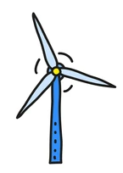
Non-renewable energy resource | A non-renewable energy resource is one that cannot be replaced or replenished. | 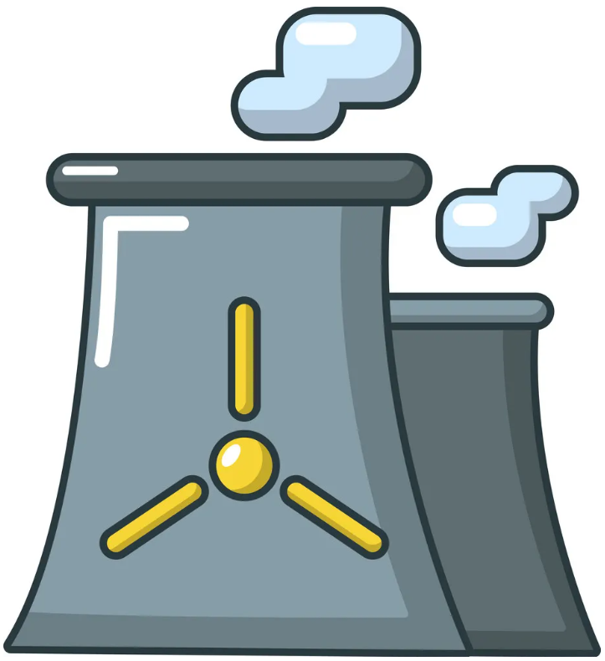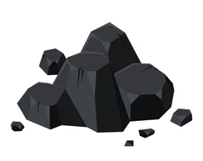
Biofuel | Renewable energy resources created from either plant products (e.g. wood) or animal dung.  Burnt to produce electricity like fossil fuels. | 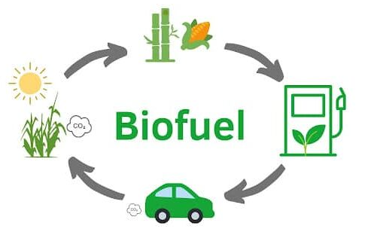
Joule | The unit of energy stored by an object (J). | 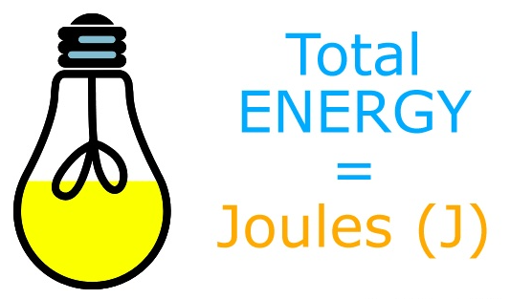
Carbon dioxide | Greenhouse gas that contributes to global warming. Emitted as a product of combustion of fossil fuels and biofuels. | 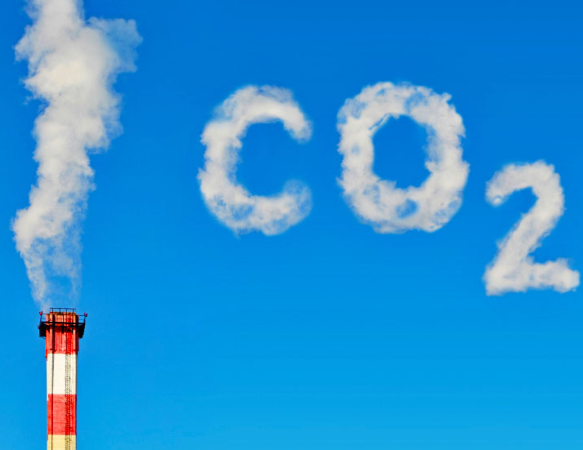

Five key ideas | Energy cannot be created or destroyed, only transferred from one place to another. Energy stores are locations where energy can be said to be stored.  This is known as the conservation of energy law. | Energy pathways are the physical processes which cause the energy stores to empty and fill:  - Mechanically - an object accelerates or deforms due to a force acting on it  - Electrically - work done by moving charges  - By heating - energy transferred from a hotter to a colder object, when distorted by forces or when an electric current is passed through them  - By radiation – all objects emit and absorb radiation – e.g. as they emit radiation their thermal energy store decreases.
Elastic potential energy is associated with objects which are compressed (squashed) or extended (stretched)  E_{E} = ½ x spring constant (N/m) x extension² (m) | Kinetic energy is the energy associated with a moving object  E_{K} = ½ x mass (kg) x velocity² (m/s) | Gravitational potential energy is the energy associated with anything that has mass and is inside a gravitational field.  E_{P} = mass (kg) x gravitational field strength (N/kg) x height (m)

Fulford School Science Department
Developing the next generation of Super Scientists

Year 9 Physics Five key terms | Electricity - Part 1

Charge, Q | A material property, measured in Coulombs (C). | 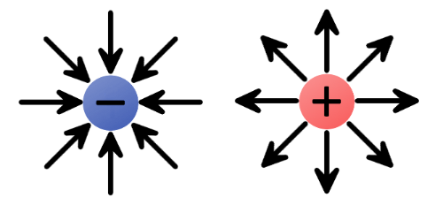
Current, I | The flow of charge, measured in Amps (A) | 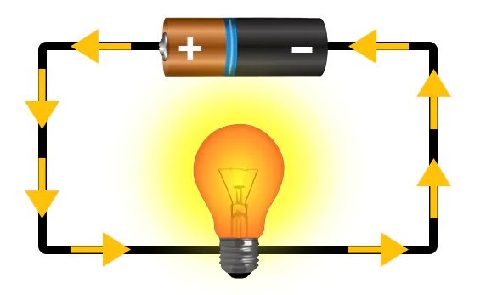
Potential difference, V | The difference in potential energy per unit of charge between two points in a circuit, measured in Volts (V) | 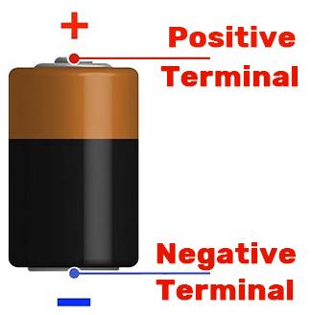
Resistance, R | A measure of how difficult it is for charge to flow around a circuit. | 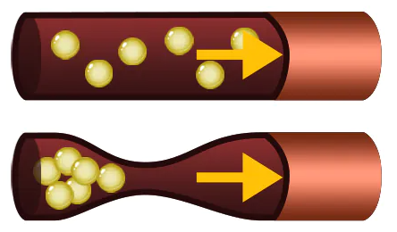
Series & Parallel | Two methods for connecting components together in a circuit | 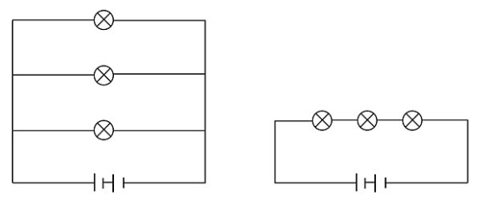

Five key ideas | We use symbols to represent circuit components rather than drawings of what the components look like, this is to keep the diagram simple, for example;  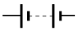  Battery  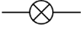  Bulb  Resistor | When components are connected in a single loop of wire, we call it a series circuit.  When components are connected in multiple branches of wires, we call it a parallel circuit.
The total resistance in a series combination is the sum of the individual resistances.  R_{T} = R₁ + R₂ + R₃ + …  The total resistance in a parallel combination is less than the smallest individual resistance in the combination.  R_{T} < R₁ R_{T} < R₂ R_{T} < R₃ | Current is the same everywhere along a series combination;  I_{T} = I₁ = I₂ = I₃ = …  Current splits among branches of parallel combinations.  The total current flowing into a junction is equal to the total current flowing out of a junction;  I_{T} = I₁ + I₂ + I₃ + … | The total potential difference from the power supply is shared across the components in a series combination;  V_{T} = V₁ + V₂ + V₃ + …  Potential difference on each branch is the same as the total power supply in a parallel combination.  V_{T} = V₁ = V₂ = V₃ = …

Fulford School Science department
Developing the next generation of Super Scientists

Year 9 Physics Five key terms | Particle Model of Matter

Density | Density is defined as the mass per unit volume of a material. | 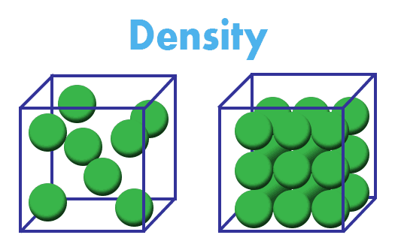
Specific Heat Capacity, c | The specific heat capacity of a substance is the amount of energy required to raise the temperature of 1 kg of a material by 1 °C. | E = m c Δθ
Specific Latent Heat, L | The specific latent heat of a substance is the amount of energy required to change the state of 1 kg of the substance with no change in temperature. | E = m L
Internal energy | The internal energy of a system is the total kinetic energy and potential energy of all the particles in the system.
Gas pressure | Gas pressure is the force exerted by a gas on a specific area. | 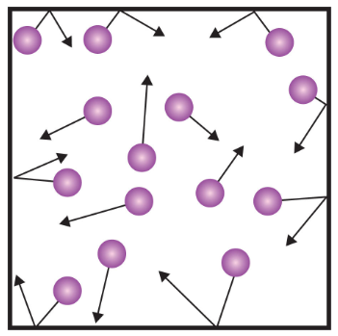

Five key ideas | The particles in solids, liquids and gases have kinetic energy because they are always moving. If you increase the temperature, you increase the mean kinetic energy of the particles.  They also have potential energy because their motion keeps them separated. This opposes the forces trying to pull them together. The particles in gases have the most potential energy because they are furthest apart.  The internal energy of a system is the total kinetic energy and potential energy of all the particles in the system. | Particles in a gas move in random directions at all times.  The particles in a gas collide with each other and the walls of their container without losing any of their kinetic energy.  The temperature of the gas is related to the average kinetic energy of the molecules. As the kinetic energy of the molecules increases, so does the temperature of the gas.
Each substance has a value called its specific latent heat, describing how much energy is needed to change state of 1kg of the substance.  When a change of state occurs, any heat energy supplied breaks the bonds between molecules.  No change in temperature occurs during this time. | The greater the temperature the greater the average kinetic energy and hence the speed of the particles (Kinetic energy = ½ m v²).  Increased temperature of the gas increases average kinetic energy and increases speed of the particles, which increases the collisions of the particles with the cylinder wall.  There is more force on the container over a certain area and therefore a greater pressure. | 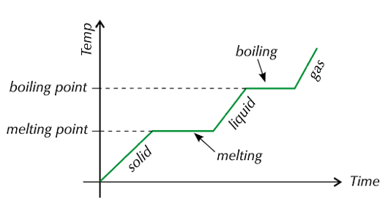

Fulford School Science Department
Developing the next generation of Super Scientists

Year 9 Chemistry - Five key terms | Atomic Structure

Atom | A tiny particle that is the building block of everything. It is the smallest particle of an element. | 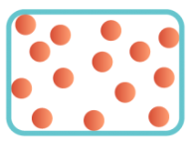
Element | A substance made up of a single type of atom. | 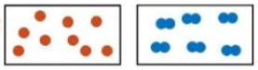
Compound | A substance made from two or more different types of atom, chemically joined together | 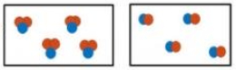
Mixture | A substance made from 2 or more different elements or compounds not joined together, so it can be separated | 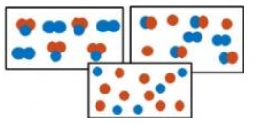
Subatomic particles | Smaller than an atom. Used to describe the particles: Protons, Neutrons and electrons. | Particle Mass Charge  Proton 1 +1  Neutron 1 0  Electron Negligible (nearly zero) -1

Five key ideas | 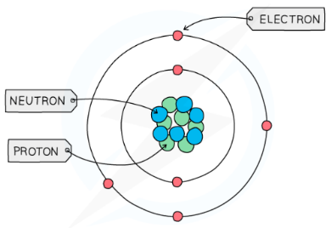  Structure of the Atom | Electron Configuration  Electrons are arranged in shells around the outside of the nucleus. Shell 1 holds only 2 electrons. All other shells hold 8 electrons. These shells must be filled from the lowest shell first.
Separating Mixtures  Since mixtures contain different substances not joined to each other, they can be separated by either filtering, evaporation, distillation, fractional distillation or chromatography. This relies on the substances having different properties such as different boiling points. | Models of the Atom  Over time, our understanding of what an atom is made from has changed, from Dalton’s spheres, to the Plum Pudding model, to the modern Nuclear model. These changes happened as new evidence was discovered that caused scientists to rethink their ideas. | Chemical Equations  All chemical reactions can be represented using equations. The symbols used represent elements and these can be found on the periodic table. The number of atoms on each side of an equation must be the same as atoms cannot be created or destroyed. This is called balancing an equation and is done by adding numbers at the start of an element. The small numbers after an atomic symbol cannot change.

Fulford School Science Department
Developing the next generation of Super Scientists

Year 9 Chemistry - Five key terms | The Periodic Table

Periodic Table | A list of all known elements, ordered according to atomic number | 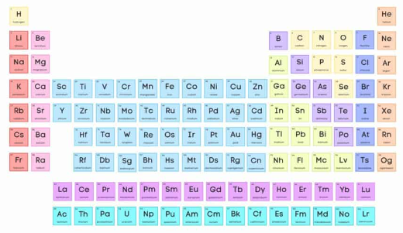
Group | A column of elements on the periodic table with similar properties | 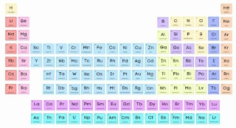
Halogen | An element from group 7 | 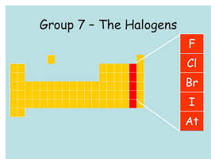
Alkali Metal | An element from group 1. Called alkali metals because they produce an alkali when reacted with water | 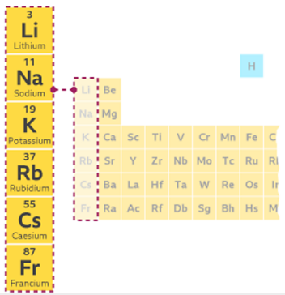
Noble Gas | An element from group 0. Called Noble Gases because they are all very unreactive (inert) | 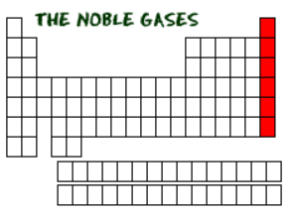

Five key ideas | Element Symbols  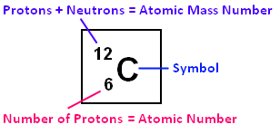 | Trends  Groups 1 elements get more reactive as you move down the group. Group 7 get less reactive moving down the group. There are other trends in terms of melting and boiling points for groups 1, 7 & 0 that need to be learnt.
Periodic Table Development  The periodic table has changed a lot over time – the earliest periodic table had just 2 columns! Many scientists have contributed to this over a long time period with the most prominent being Dmitri Mendeleev. | Outer Shell electrons  Reactivity depends on the outer shell of electrons – on how many electrons are in this shell and how far away from the nucleus this shell is. | Isotopes  An isotope of an element has the same number of protons in the nucleus, but a different number of neutrons.

Fulford School Science Department
Developing the next generation of Super Scientists

Year 9 Chemistry - Five key terms | Structure & Bonding

Ionic Bond | A type of bond formed between a metal and a non-metal. The metal loses electrons to become a positive ion, the non-metal gains these electrons becoming a negative ion. | 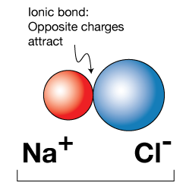
Covalent Bond | A type of bond formed between 2 non-metals. Involves the sharing of a pair of electrons. | 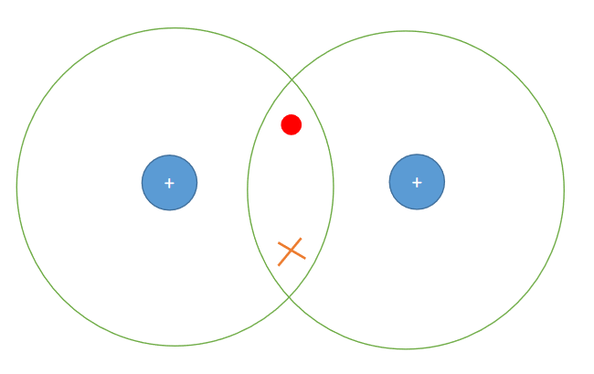
Metallic Bond | The bonding between metals. Made from rows of positive metal ions and delocalised electrons that move through the whole metal. | 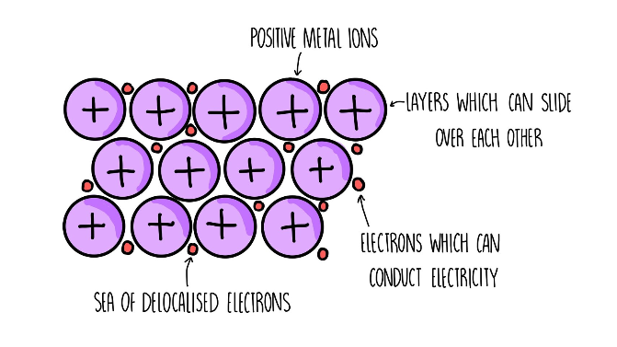
Intermolecular forces | Weak, temporary forces of attraction between small/simple covalent molecules. Takes little energy to break. | 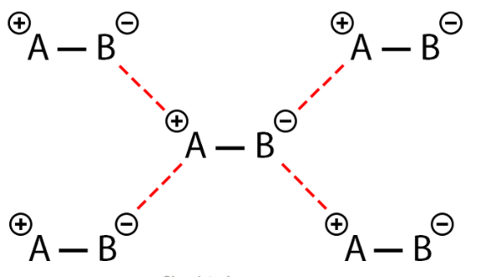
Giant ionic lattice | The name given to the giant 3-dimensional structure formed by repeating positive and negative ions. | 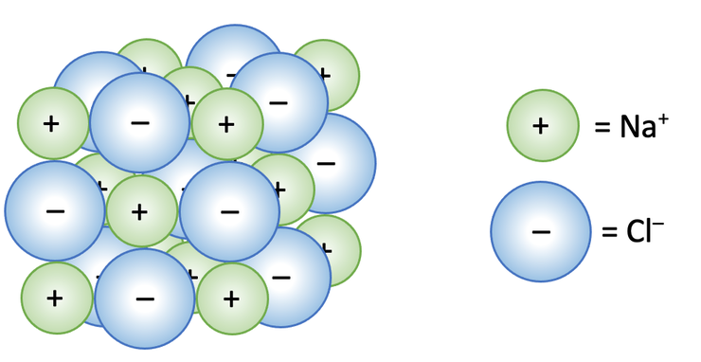

Five key ideas | Electrostatic Forces  The name given to the forces between positive and negative charges. Electrostatic attraction is what holds ionic bonds together. | Giant Covalent Structures  Diamond, Graphite, Graphene, Silicon Dioxide and fullerenes are all giant covalent structures made from millions of atoms all covalently bonded to each other. This gives them unique properties such as electrical conductivity or extreme hardness.
Simple Covalent Molecules  The name given to any non-metal substance that exists as a molecule (a group of atoms bonded together). Molecules are held to each other by weak intermolecular forces | States of matter  Matter exists either as a solid, liquid or gas. Moving between states requires a change in energy. The particle model explains the behaviour and properties of each state of matter. | Properties of substances  The melting/boiling point and electrical conductivity of a material is linked to its bonding. Bonding can be used to explain properties.

Fulford School Science Department
Developing the next generation of Super Scientists

Year 9 Chemistry - Five key terms | Chemical Changes

Acid | A substance that releases H⁺ ions when in a solution | 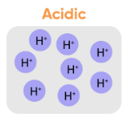
Base | A substance that will react with H⁺ ions to remove them from a solution. A soluble base is called an alkali. | 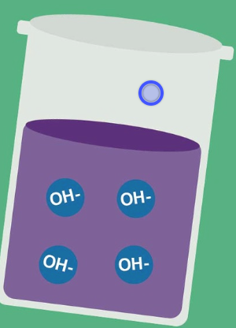
Displacement | Where a more reactive metal takes the place of a less reactive metal in a compound. | 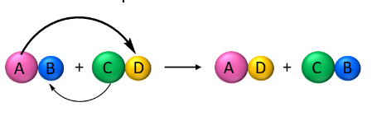
Oxidation | Where something in a reaction gains oxygen | 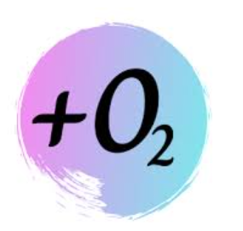
Reduction | Where something in a reaction loses oxygen | 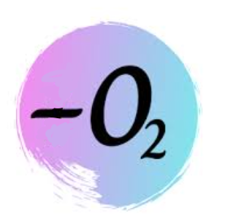

Five key ideas | Metal Reactivity  All metals react differently based on their electron configuration. A more reactive metal will bubble lots or even catch fire! Less reactive metals do nothing. | Reactions of Acids  Acid + Metal Salt + Hydrogen  Acid + Base Salt + Water  Acid + Metal Carbonate Salt + Water + Carbon Dioxide
pH  The scale that acidity is measured on. It goes from 1-14 where pH 1 is a strong acid, pH 7 is neutral and pH 14 is a strong alkali. | Naming Salts  Salts are formed from the reactions of acids. Their names are made from 2 words. The first work is from the metal involved in the reaction, the second word depends on the acid used. | Redox  In a redox reaction, one element will be oxidised and another reduced at the same time. It means the combination of reduction and oxidation.

