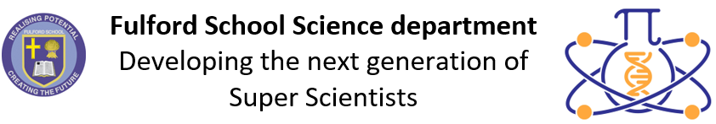 | Science Curriculum Overview  2023-2024

 | Key stage 3 |  |  | Key stage 4
 | Year 7 | Year 8 | Year 9 | Year 10 | Year 11
Half-term 1  4 Sept 23 –  27 Oct 23 | 7.0 Skills  7.1 Forces 1  7.5 Matter 1  7.8 Organisms 1 | 8.0 Skills  8.1 Forces 2  8.5 Matter 2  8.8 Organisms 2 | 9. Cells  9. Energy  9. Electricity  9. Atomic Structure  and Periodic Table | 10. Organisation  10. Energy  10. Electricity  10. Chemical  Changes  10. Energy Changes | 11. Waves  11. Homeostasis  11. Organic  Chemistry  11. Chemical  Analysis
Half-term 2
6 Nov 23 –
22 Dec 23
Half-term 3  8 Jan 24 –  9 Feb 24 | 7.2 Electromagnets 1  7.6 Reactions 1  7.9 Ecosystems 1 | 8.2 Electromagnets 2  8.6 Reactions 2  8.9 Ecosystems 2  7.7 Earth 1 | 9. Electricity  9. Structure and  Bonding  9. Cells | 10. Quantitative  Chemistry  10. Rates of  Reaction  10. Infection and  Response  10. Forces | 11. Electromagnets  11. Inheritance  11. Chemical  Analysis  11. Atmospheric  Chemistry
Half-term 4
19 Feb 24 –
22 Mar 24
Half-term 5  8 April 24 –  24 May 24 | 7.3 Energy 1  7.4 Waves 1  7.10 Genes 1 | 8.3 Energy 2  8. 4 Waves 2  8.7 Earth 2  8.10 Genes 2 | 9. Structure and  Bonding  9. Particle Model of  Matter  9. Bioenergetics  9. Chemical Changes | 10. Rates of  Reaction  10. Organic  Chemistry  10. Forces  10. Homeostasis | 11. Space  (Physics only)  11. Using Resources  11. Ecology  11. Electromagnets
Half-term 6
3 June 24 –
22 July 24

