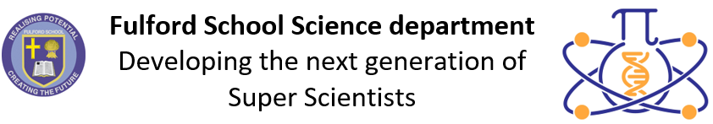 | Science Assessment Calendar  2023-2024

 | Year 7 | Year 8 | Year 9 | Year 10 | Year 11 | Year 12 | Year 13
Half-term 1  4 Sept 23 –  27 Oct 23 | 7.8 Organisms:  TA question on  cell structure | 8.8 Organisms:  TA question on ventilation | P1a Energy:  TA question on energy resources | TA questions:  - B2: Food tests  - C4: Making salts  - P1: SHC | TA questions:  - B5: Reaction times  - C7: Fractional distillation  - P5: Forces | End of  topic tests | End of topic tests
Half-term 2  6 Nov 23 –  22 Dec 23 | Test 1 – 1 hour  Topics:  - 7.1 Forces  - 7.5 Matter  - 7.8 Organisms | Test 1 – 1 hour  Topics:  - 8.1 Forces  - 8.5 Matter  - 8.8 Organisms | Test 1 – 3 x 30mins  Topics:  - B1a  - C1a  - P1a | Test 1 – 3 x 45mins  Topics:  - B1, B4, B2a  - C1, C2, C4  - P1a, P2a, P4, P1b | November mocks  (whole-school)  w/c 20/11 | End of  topic tests | End of topic tests
Half-term 3  8 Jan 24 –  9 Feb 24 | 7.5 Matter:  TA question on separating mixtures | 8.6 Chemical reactions: TA question on endothermic and exothermic reactions | C1b Periodic table: TA question on reactivity of groups | Test 2 – 3 x 45 mins  Topics:  - B2  - C4, C5  - P2 | TA questions:  - B7: Sampling  - C8: Chromatography  - P6: Waves | Science mocks | Spring mocks  w/c 8/1/24
Half-term 4  19 Feb 24 –  22 Mar 24 | Test 2 – 1 hour  Topics:  - 7.2 Electromagnets  - 7.6 Reactions  - 7.9 Ecosystems | Test 2 – 1 hour  Topics:  - 8.2 Electromagnets  - 8.6 Reactions  - 8.9 Ecosystems | Test 2 – 3 x 30mins  Topics:  - B1  - C1  - P1a, P2a | TA questions:  - B5: Reaction times  - C5: Endo/exothermic  reactions  - P2: Resistance | February mocks  w/c 19/2/24 | End of  topic tests | End of topic tests
Half-term 5  8 April 24 –  24 May 24 | 7.3 Energy:  TA question on energy resources | 8.2 Electromagnets:  TA question on electromagnets | B4 Bioenergetics: TA question on photosynthesis | EOY test w/c 8/4/24  Paper 1: 3 x 75mins | TA questions in Biology, Chemistry and Physics on How Science Works | End of  topic tests
Half-term 6  3 June 24 –  22 July 24 | Test 3 – 1 hour  EOY assessment -questions from topics and skills from breadth of Y7 | Test 3 – 1 hour  EOY assessment -questions from  topics and skills from breadth of Y8 | Test 3 – 3 x 45mins  EOY assessments:  - B1, B4  - C1, C2  - P1a, P2a, P3 | HSW TA questions:  - Biol: Enzymes / osmosis  - Chem: Rates  - Phys: Hooke’s Law |  | EOY exams w/c 24/6/24

