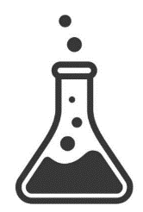
YEAR 7 CHEMISTRY
Matter  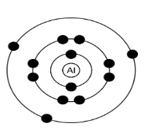 | Particles, States of matter, Diffusion, Separating methods, Solutions
Reactions | Chemical & Physical Changes, Acids & Alkalis, pH, Neutralisation, Reactions of Metals, Displacement
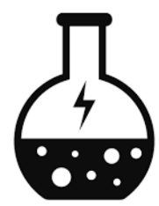  Energy | Changing state
Earth
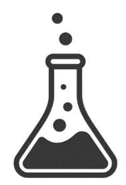
YEAR 8 CHEMISTRY
Matter | Elements/Compounds/Mixtures, Chemical Formulae, Periodic Table
Reactions | Conservation of mass, Combustion, Thermal Decomposition
Energy | Exothermic & Endothermic
Earth | Earth Structure, Rock Cycle, Space, The Atmosphere
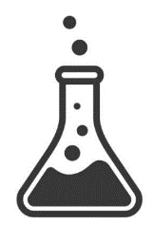
YEAR 9 CHEMISTRY
Matter | Atomic Structure, Periodic Table, Elements/Compounds/Mixtures, Structure & Bonding
Reactions | Group 1 & Group 7 trends, Reactivity Series, Displacement reactions
Energy | Trends in melting/boiling points, How bonding links to properties
Earth | Metal Extraction, Allotropes of Carbon
YEAR 10 CHEMISTRY
Matter | Quantitative Chemistry, Moles, Solutions, Measuring gas volumes
Reactions | pH Scale, Neutralisation and making salts, Electrolysis, Collision theory, Conservation of mass, Titration, Rates of reaction, Dynamic Equilibrium
Energy | Chemical Cells, Endothermic & Exothermic reactions, Catalysis
Earth | Metal extraction
YEAR 11 CHEMISTRY
Matter | Hydrocarbons, Fractional Distillation, Chromatography, Polymers, Formulations
Reactions | Gas tests, Reactions of organic compounds, Ion identification, Haber process
Energy | Spectroscopy, Trends in hydrocarbon properties
Earth | Crude Oil, Potable water, Metal Extraction, Atmospheric development, Climate Change, Pollution

