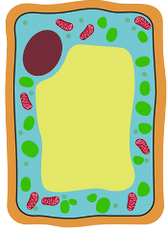
Year 7 Biology
Cells | 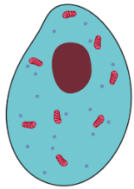  - Basic cell structure and specialised cells  - Comparing plant and animal cells
Organ systems | 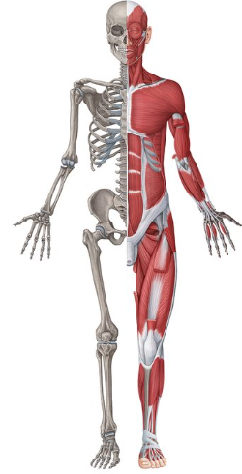  - Hierarchy of multicellular organisms  - Human skeletal, muscular and reproductive systems
Genetics and Evolution | - Gametes and fertilisation  - Variation within and between species  - Adaptation and competition
Biological molecules | 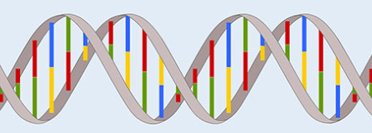  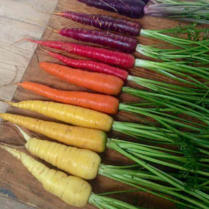  - DNA
Plant Biology | 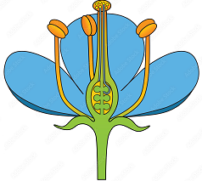  - Producers in food chains  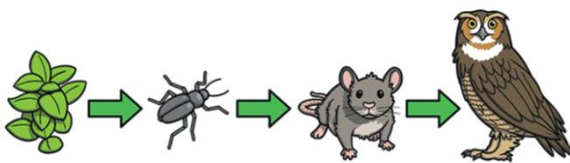  - Plant reproduction  - Ecosystems and sampling
Cells | 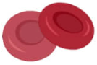  - Roles of specialised cells in human organ systems  - Roles of organelles in respiration and photosynthesis
Organ systems | 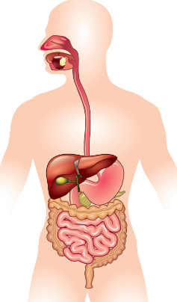  - Human digestive system  - Human respiratory and circulatory systems
Genetics and Evolution | 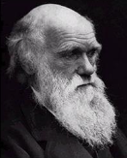  - Inheritance  - Natural selection and evolution  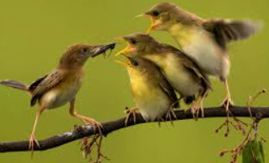  - Genetic modification
Biological molecules | 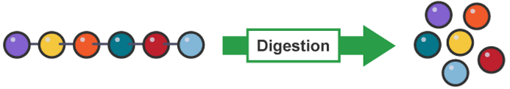  - DNA  - Digestive enzymes
Plant Biology | 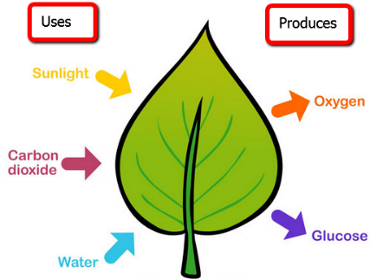  - Photosynthesis and plant mineral deficiencies  - Gas exchange in leaves  - Genetic modification of plants
Year 8 Biology
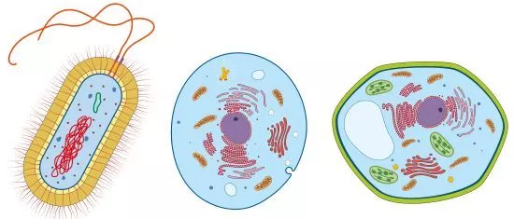
Year 9 Biology
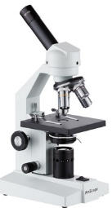  Cells | - Prokaryotic and eukaryotic cells  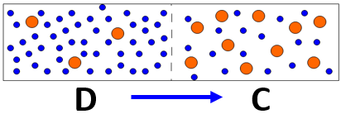  - Studying cell structure using microscopy  - Transport of substances in and out of cells  - Respiration and metabolism
Organ systems | - Effect of exercise on human respiratory, circulatory and muscular systems
Genetics and Evolution | 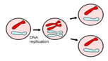  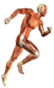  - Chromosomes, mitosis and the cell cycle  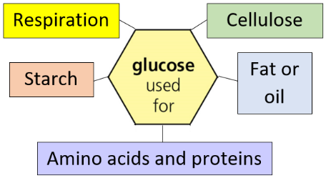  - Stem cells
Biological molecules | 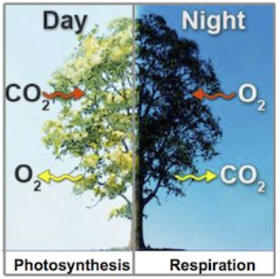  - Uses of glucose in plants
Plant Biology | - Plant cell structure and differentiation  - Movement of substances in roots and leaves  - Photosynthesis and respiration in plants
Year 10 Biology
Cells | 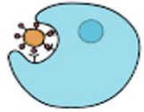  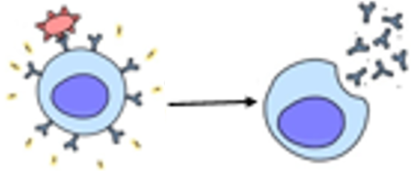  - Prokaryotic and eukaryotic pathogens  - Roles of white blood cells in the immune response
Organ systems | 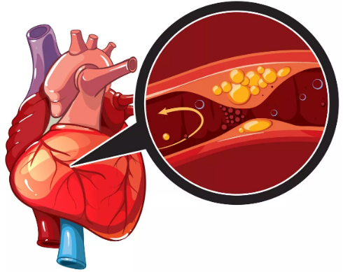  - Digestive system and enzyme function  - Respiratory system and gaseous exchange  - Circulatory system and coronary heart disease  - Immune system and vaccination
Genetics and Evolution | 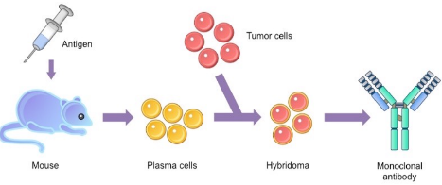  - Risk factors and cancer  - Antibiotic resistance in bacteria  - Monoclonal antibody production and application
Biological molecules | 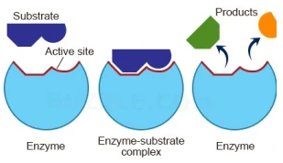  - Qualitative food tests for glucose, starch, proteins and lipids  - Digestive enzymes as biological catalysts  - Haemoglobin and oxygen transport  - Immunological proteins and antibiotics
Plant Biology | 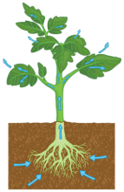  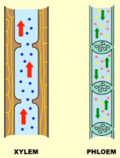  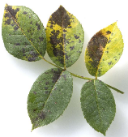  - Plant tissues, organs and the vascular system  - Viral and fungal plant diseases  - Plant mineral deficiencies and defence responses
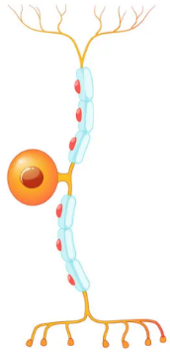
Year 11 Biology
Cells | - Roles of receptor cells in detecting different stimuli  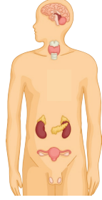  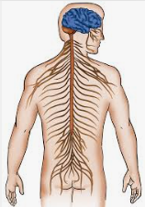  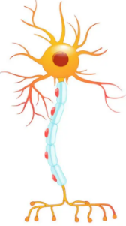  - Structure and roles of neurones in stimulus-response chain  - Comparing mitosis and meiosis
Organ systems | - Human nervous system  - Human endocrine and excretory systems
Genetics and Evolution | 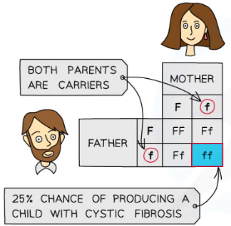  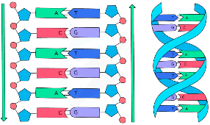  - Sexual and asexual reproduction  - DNA and the genome  - Genetic inheritance and inherited disorders  - Genetic engineering , variation and evolution
Biological molecules | 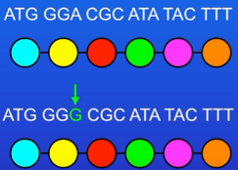  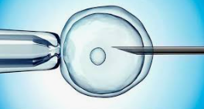  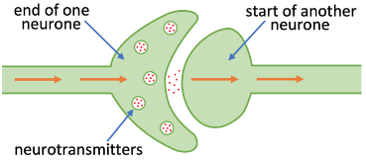  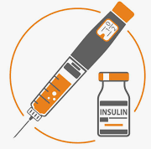  - Roles of hormones in the homeostasis, reproduction, contraception and fertility  - Protein synthesis  - Neurotransmitters in synaptic transmission
Plant Biology | 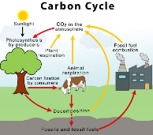  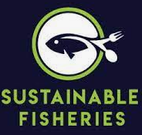  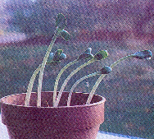  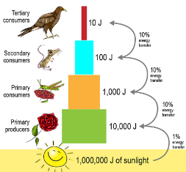  - Plant hormones and tropisms  - Ecosystems and recycling  - Trophic levels, biodiversity and food production

