Paper 2 Chemistry Key terms
In this booklet you will find key terms that you have used in science this year; these will be useful to learn for your Year 11 Mocks
You need to try and learn and remember all the key terms, with their definitions. One way of doing this is to make each one into a revision card, with the term on one side and its definition on the other – look at this example:
Write the key term on one side

Write what it means on the back

Use this table to record how many revision cards you have made, then practise using them – ask a friend to test you!
Chemistry  Topic | I have made revision cards | I have practised using the revision cards at least 10 times
C6 Part 1 – Rates of Reaction
C6 Part 2 – Equilibrium
C7 Part 1 – Hydrocarbons
C7 Part 2 – Organic
C8 Part 1 – Analysis
C8 Part 2 – Analysis (Triple)
C9 – Atmosphere
C10 Part 1 – Using Chemistry

Good luck – from Fulford School Science Department

Fulford School Science Department
Developing the next generation of Super Scientists

GCSE Science - Five key terms | Topic C6 Part 1 – Rates of Reaction

Rate of reaction | How fast reactants (starting materials) are turned into products. Always measured as a quantity (mass or volume) per second | 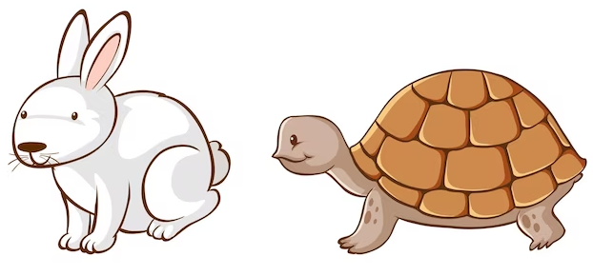
Collision | 2 particles making contact with each other. May result in a reaction, or may not. | 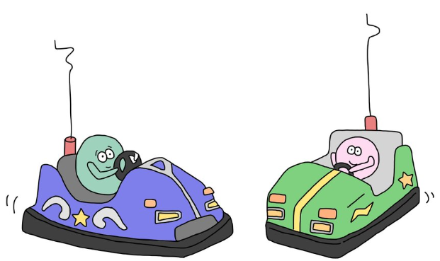
Activation energy | The minimum energy required to start a reaction. The energy particles require in order to react when they collide | 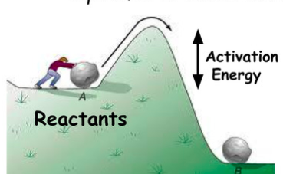
Concentration | The number of particles of a chemical in a given volume or space | 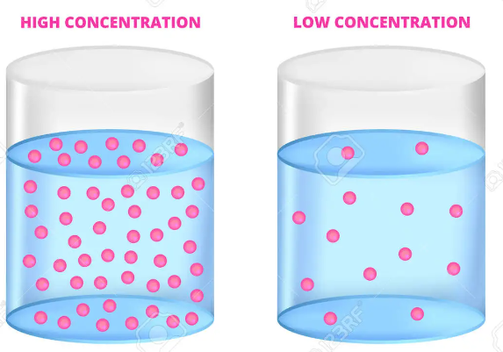
Surface Area | How much of a solid material is exposed on the outside and so available to react. Big chunks = small surface area. Fine powder = large surface area | 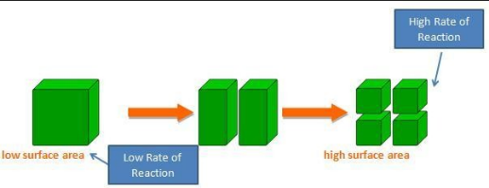

Five key ideas |  |  | Collision Theory  Particles in a reaction are constantly moving. When they collide there is a chance they could react, if they have sufficient energy (see activation energy above). To affect rate of reaction, either the number of collisions per second must change, or the success chance of collisions must change. | Factors affecting rate  Rate of reaction is controlled by:  - Temperature  - Surface Area  - Presence of a Catalyst  - Concentration/Pressure  Each property affects either the frequency or success of collisions, and therefore rate.
Catalysts  Catalysts speed up reactions by providing an alternative reaction pathway with a lower activation energy. Catalysts are not used up in reactions. |  |  | Calculating Rate  Rate of reaction = change in amount ÷ time taken. Rate is measured in either grams/second, cm³/second or moles/second. | Rate graphs  Data from experiments can be graphed with time on the x-axis and either mass or volume of gas on the y axis. These graphs are always curves and the gradient at any point (found by drawing a tangent) represents the rate of reaction.
Fulford School Science Department
Developing the next generation of Super Scientists

GCSE Science - Five key terms | Topic C6 Part 2 – Equilibrium

Equilibrium | Tells you the balance between how much products or reactants are made | 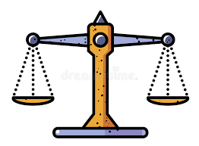
Closed system | No reactants or products are lost.
Conditions | This describes how the reaction is carried out (e.g. temperature, pressure, using a catalyst etc.) | 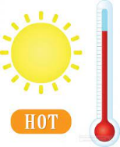
Yield | Describes how much product you get made.
Optimum | Means using the best possible conditions to maximise the amount of products made (e.g. in terms of rate, yield and cost). | 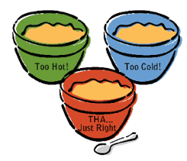

Five key ideas | Reversible reaction  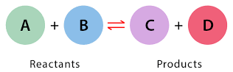  A type of reaction where reactants can join to make products. But at the same time, the products can join to make reactants. Shown with 2 arrows: | Dynamic equilibrium  This is reached where the forwards reaction and the backwards reaction:  - happen at the same time  - and the same rate  This means the concentration of reactants and products remains constant.
Le-Chatelier’s principle  The position of equilibrium shifts to oppose any change in conditions. We can change the reaction conditions to maximise the amount of product made. | Equilibrium shifts  This means the position of equilibrium moves to the left (more reactants) or right (more products). Usually we use Le-Chatelier’s principle to help us make more products. | Example of reversible reactions:  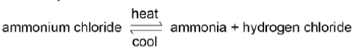  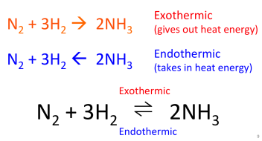

Fulford School Science Department
Developing the next generation of Super Scientists

GCSE Science - Five key terms | Topic C7 Part 1 – Hydrocarbons

Hydrocarbon | A compound made from hydrogen and carbon only. | 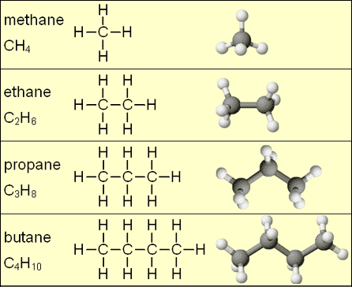
Alkanes | A type of hydrocarbon with single bonds between carbon atoms.  (Formula C_{n}H_{2n+2})
Crude oil | A mixture of hydrocarbons with different chain lengths | 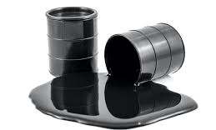
Distillation | Evaporation followed by condensation (liquid gas, then gas liquid) | 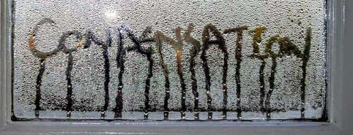
Catalyst | Speeds up the rate of a chemical reaction without being used up | 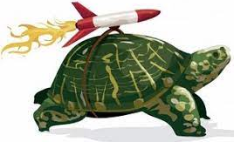

Five key ideas | How is crude oil made?  Tiny sea creatures (plankton) died and were covered by sediment in oceans. They couldn’t decay as there was no oxygen. Heat (from the core) and pressure (from above rock) changed the mixture into crude oil. | Fractional distillation  Crude oil is heated and evaporates (except for the bitumen).  As the molecules rise up the column they cool. The longer molecules condense at the bottom of the column where it is hotter.  This separates the crude oil into lots of very useful fractions.
Properties of hydrocarbons  Longer molecules are:  - Less flammable  - More viscous  - less volatile (evaporate less easily)  - have a higher boiling point | Burning hydrocarbons  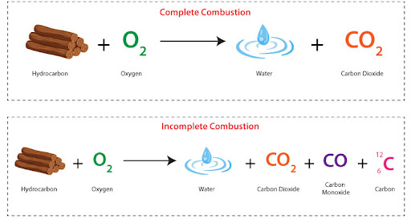  Complete combustion of hydrocarbons produces carbon dioxide and water. Incomplete combustion (where there isn’t neough oxygen) produces carbon monoxide and soot. | Catalytic cracking  Used to break long hydrocarbon molecules into shorter more useful molecules. This helps us match supply and demand. A catalyst and high temperature are needed.  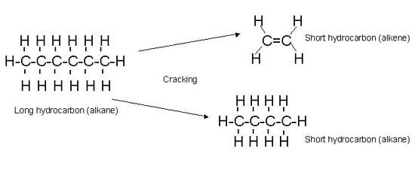  Short alkanes are used for fuels, short alkenes are used to make plastics.

Fulford School Science Department
Developing the next generation of Super Scientists

GCSE Science - Five key terms | Topic C7 Part 2 – Organic

Homologous series | A group of chemicals with similar chemical properties. Have the same general formula and same functional group (part of the molecule that determines reactions).
Alkene | Hydrocarbons with a double carbon-carbon bond. These decolourise bromine water (orange to colourless). General formula is C_{n}H_{2n.} | 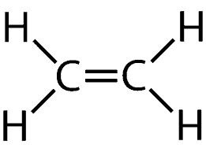
Alcohol | Homologous series of compounds that contain a hydroxyl functional group (-OH). Name ends with ‘-ol.’ | 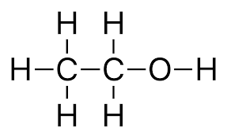
Carboxylic acid | Homologous series that contain the functional group: -COOH. Name ends with ‘-oic acid.’ | 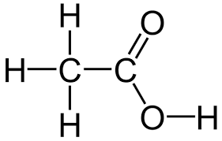
Ester | Homologous series that contain the functional group RCOOR. Made when a carboxylic acid reacts with an alcohol, with a strong acid catalyst. | 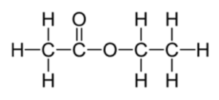

Five key ideas | Methods for making ethanol  Aqueous solutions of ethanol are produced when sugar solutions are fermented using yeast. Conditions for fermentation are 25-35ºC, enzyme catalysts (from yeast) and anaerobic (no oxygen). | Esterification  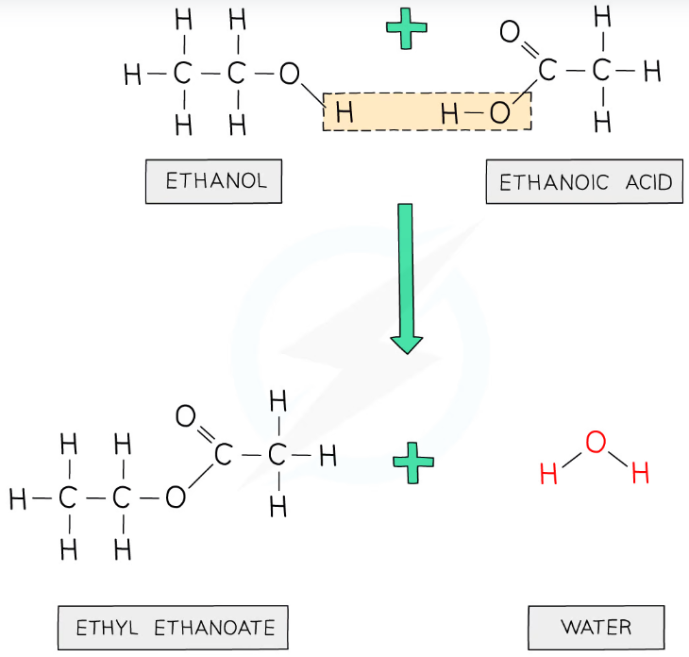
Addition polymerisation  In addition polymerisation reactions, many small molecules (monomers) join together to form very large molecules (polymers). For example:  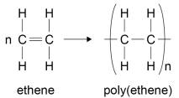 | Condensation polymerisation  This happens when a molecule containing an -OH group reacts with a molecule containing a -COOH group. A small molecule (water) is lost.  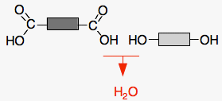 | Structure of DNA  Most DNA molecules are two polymer chains, made from four different monomers called nucleotides, in the form of a double helix. Other naturally occurring polymers important for life include proteins (made from amino acids), and starch and cellulose (made from glucose).

Fulford School Science Department
Developing the next generation of Super Scientists

GCSE Science - Five key terms | Topic C8 Part 1 – Analysis

Mixture | Contains two or more substances that are not chemically combined. | 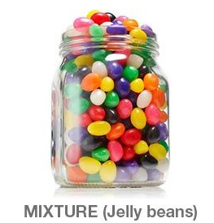
Pure substances | A single element or compound, not mixed with any other substance. | 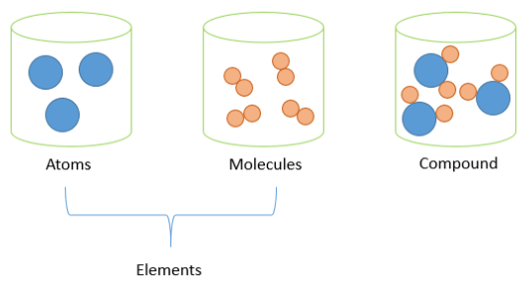
Formulation | A mixture with a set composition, designed for a specific purpose. The set composition ensures the mixture is safe. | 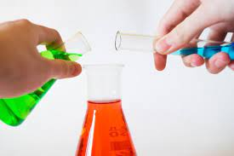
Chromatography | Used to separate a mixture of substances based on their solubility in a solvent. | 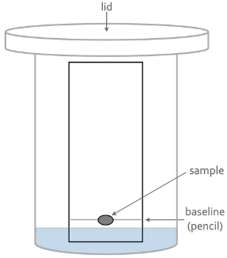
Mobile/ Stationary phase | In chromatography the stationary phase is the one that doesn’t move (e.g. paper). The solvent is usually the mobile phase (e.g. water moving up the paper).

Five key ideas | Testing for purity  Pure elements and compounds melt and boil at specific temperatures. This can be used to test for purity, e.g. pure water boils at 100ºC.  Impurities make lower the melting point, raise the boiling, and make it so these happen over a range of temperatures. | Examples of formulations  Some examples of useful formulations include:  - Baby milk  - Medicines  - Alloys  - Fertilisers  - Paint  - Fuels such as petrol/ diesel
Carrying out Chromatography  Several key points are:  - Pencil line (so it doesn’t dissolve)  - Solvent below pencil line  - Lid (so solvent doesn’t evaporate  - Small spot of solvent using a capillary (aids accuracy)  - Pencil line to mark where solvent and sample reach. | Calculating retention factor (R_{f})  Measure from the starting pencil line to the middle of the spot at the end and the place the solvent reaches. Use the equation below and compare R_{f} value with known compounds from a data book.  reaches. Use the equation:  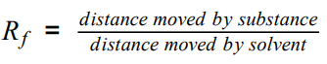 | Tests for gases  Oxygen: relights a glowing splint  Carbon dioxide: limewater goes cloudy  Hydrogen: makes a squeaky pop with a lit splint  Chlorine: bleaches damp indicator paper.

Fulford School Science Department
Developing the next generation of Super Scientists

GCSE Science - Five key terms | Topic C8 Part 2 – Analysis (Triple)

Cation | A positively charged ion. Metals form cations. | 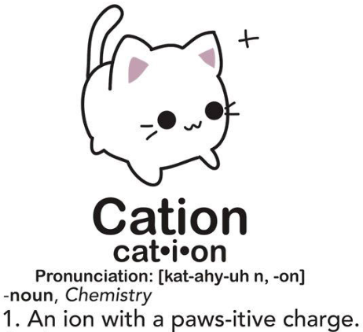
Anion | A negatively charged ion. These are usually non-metals. | 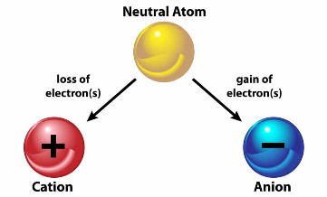
Flame tests | The characteristic flame colours of metal ions (from solution) are used to identify them. | 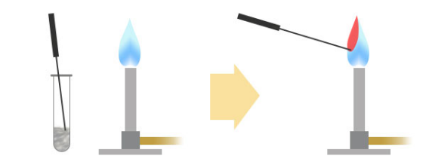
Precipitate | A solid formed when two aqueous solutions react. | 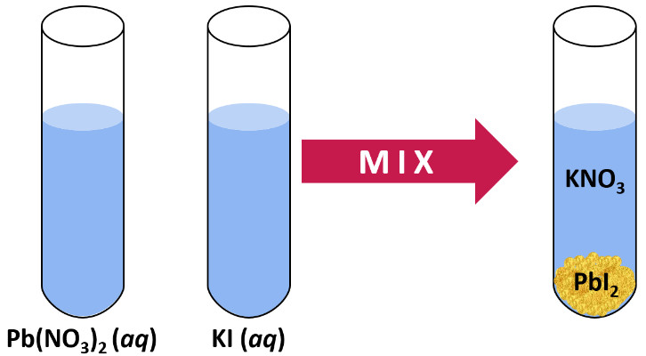
Emission spectrum | The frequencies of light given out when an electron falls from a higher energy level to a lower energy level. Unique for each element.

Five key ideas | How to carry out a flame test  - Heat a nichrome wire in a blue Bunsen flame.  - Dip in acid and repeat until all impurities have been removed.  - Dip into a solution containing the metal ions to be identified.  - Hold in Bunsen flame & use characteristic colour to identify. | Using NaOH to test for metal ions  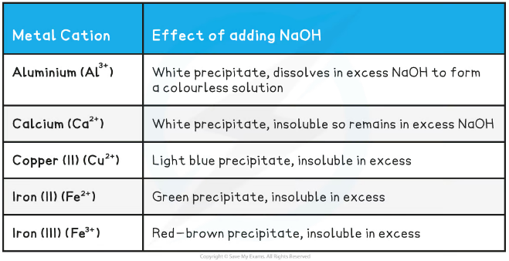
Tests for anions  Halides: Add acidified silver nitrate solution. (AgCl – white, AgBr – cream, AgI – yellow)  Sulphate: forms a white precipitate with BaCl_{2(aq)}.  Carbonate: when reacted with acid produces bubbles of CO₂ (which can be tested for with limewater). | Advantages of instrumental analysis  - Accurate  - Detect small amounts  - Quick  However, the instruments can be expensive and require training to use properly. | Flame emission spectroscopy  The sample is put into a flame and the light given out is passed through a spectroscope (contains a prism). The output is a line spectrum that is unique for a particular element. This can be compared with a database to find an exact match and identify the element.  The intensity of the line enables the concentration of a metal ion in solution to be determined.

Fulford School Science Department
Developing the next generation of Super Scientists

GCSE Science - Five key terms | Topic C9 – Atmosphere

Photosynthesis | Plants take in carbon dioxide and water, making oxygen and glucose. Important in developing the Earth’s atmosphere. | 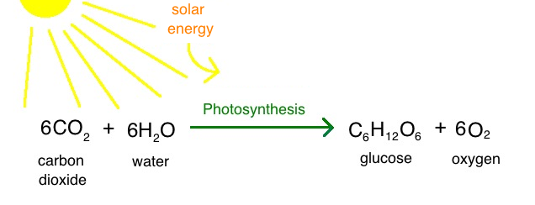
Sedimentary rocks | Carbon dioxide from the atmosphere dissolved in oceans. This was used in the shells of sea creatures that eventually became sedimentary rock. | 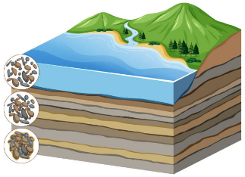
Greenhouse gases | Gases in the atmosphere that absorb heat (infra-red rays) so that it can’t escape back out to space. Methane, water and carbon dioxide are greenhouse gases. | 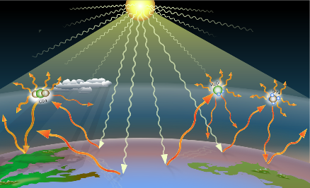
Carbon footprint | Total amount of carbon dioxide and other greenhouse gases emitted over the full life cycle of a product.
Incomplete combustion | This occurs when there is not enough oxygen for complete combustion. Carbon monoxide and soot are made instead of carbon dioxide. | 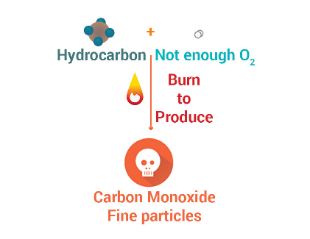

Five key ideas | Earth’s early atmosphere  Volcanic activity produced a mix of steam, methane (CH₄), ammonia (NH₃) and lots of carbon dioxide (CO₂).  As the earth cooled water condensed to form the oceans. CO₂ levels decreased as it dissolved in the oceans as became locked in sedimentary rocks/ fossil fuels. | How the early atmosphere changed  Algae photosynthesised producing oxygen. The oxygen reacted to remove methane and ammonia, increasing the amount of nitrogen in the atmosphere.  Now the atmosphere is around 80% nitrogen, 20% oxygen with small amounts of carbon dioxide and noble gases.
What is the greenhouse effect?  Short wave UV radiation from the sun is absorbed by the earth. This is then emitted as longer wavelength IR rays.  The IR waves are absorbed by greenhouse gases so that the heat is retained in the atmosphere, instead of going back out to space. | Burning fuels makes pollutants  Most fossil fuels contain carbon, hydrogen and some sulphur. So when they are burned they make CO₂, H₂O and SO₂.  If there isn’t enough oxygen carbon monoxide (CO) and soot (C) is made instead of carbon dioxide. | Effects of atmospheric pollutants  Sulphur dioxide/ NO_{x}: Acid rain, which kills trees, harms aquatic life and causes respiratory problems.  Carbon dioxide: greenhouse gas that leads to climate change.  Carbon monoxide: toxic gas.  Carbon particulates: global dimming and respiratory problems.

Fulford School Science Department
Developing the next generation of Super Scientists

GCSE Science - Five key terms | Topic C10 Part 1 – Using Chemistry

Finite resource | A resource that will run out (e.g. oil). Resources that can be replenished are called ‘renewable’ (e.g. wood). | 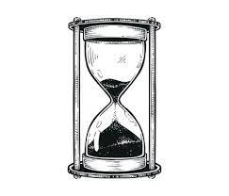
Sustainable development | Meets the needs of current generations without compromising the ability of future generations to meet their own needs.
Potable water | Water that is safe to drink.
Sterilising | Killing harmful microbes so that water is safe to drink (e.g. using chlorine or ozone). | 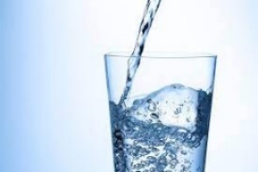
Phytomining Bioleaching (H) | Phytomining uses plants to absorb metal compounds. The plants are harvested and then burned to produce ash that contains metal compounds.  Bioleaching uses bacteria to produce solutions that contain metal compounds.

Five key ideas | Making potable water  - Screen water from reservoir.  - Add chemicals to precipitate impurities.  - Settlement tank to remove precipitate.  - Filter through filter beds  - Sterilise to kill harmful microbes (e.g. with chlorine). | Desalination  This involves removing salt from water. It is done where there is less fresh water, so sea water is used instead.  Either distillation or reverse osmosis can be used to remove salt. A disadvantage of this is that it takes lots of energy.
How is waste water treated?  Sewage treatment includes:  • screening and grit removal  • sedimentation to produce sewage sludge and effluent  • anaerobic digestion of sewage sludge  • aerobic biological treatment of effluent. | Life Cycle Assessments  Life cycle assessments (LCAs) are carried out to assess the environmental impact in each of these stages:  • extracting and processing raw materials  • manufacturing and packaging  • use and operation during its lifetime  • disposal at the end of its use  REMEMBER: emud! | Reducing materials used  Re-use: e.g. glass bottles  Recycle: e.g. some metals and plastic can be melted and made into a new product.  Reduce: wasting less materials (e.g. fast fashion) is another way to help save valuable resources.

Fulford School Science Department
Developing the next generation of Super Scientists

GCSE Science - Five key terms | Topic C8 Part 2 – Analysis (Triple)

Corrosion | Occurs when a metal reacts with oxygen from the air. This potentially weakens the metal over time. | 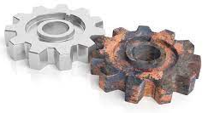
Alloy | Mixture of two or more elements, where at least one is a metal. | 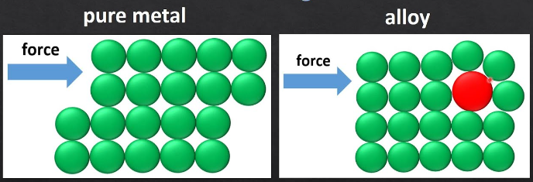
Thermoplastics | Thermosetting plastics char or burn when heated, unlike thermosoftening plastics which melt. | 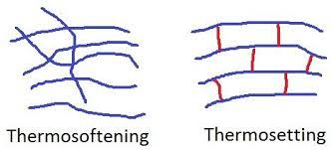
Composites | Usually made of two materials, a matrix/ binder holding together fibres or fragments of the other material (called the reinforcement). | 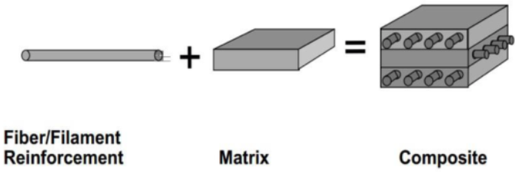
Optimum conditions | This is the best balance in making product, often in terms of rate, equilibrium position and cost of energy/ equipment. | 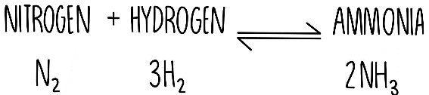

Five key ideas | Ways to reduce corrosion  The principle behind these is often to reduce contact with oxygen and water (e.g. painting or oiling).  Sacrificial protection involves coating with a more reactive metal that reacts instead (e.g. galvanising involves coating with zinc). | Using alloys  Bronze is an alloy of copper and tin. Brass is an alloy of copper and zinc. Gold is often alloyed with silver, copper and zinc (with 24 carat being pure gold).  High carbon steel is strong but brittle. Low carbon steel is softer and more easily shaped. Steels containing chromium and nickel (stainless steels) are hard and resistant to corrosion.
Properties of polymers  Depend on what monomers they are made from and the conditions when they are made. E.g. low density (LD) and high density (HD) poly(ethene) are produced from ethene but have different structures. | Making Ammonia (Haber process)  Nitrogen and hydrogen are passed over an iron catalyst at 450°C and 200 atm pressure. These conditionare are a compromise between rate/ yield/ cost. The reaction is reversible so the gas reaction mixture is cooled down to separate liquid ammonia. Remaining N₂ and H₂ are returned to the reactor vessel. | NPK fertilisers  These elements are crucial for plants to grow. Ammonia can be used to manufacture ammonium salts and nitric acid. Potassium chloride, potassium sulfate and phosphate rock are obtained by mining, but phosphate rock cannot be used directly as a fertiliser. Phosphate rock is treated with nitric acid or sulfuric acid to produce soluble salts that can be used as fertilisers.

