Paper 1 Chemistry Key terms
In this booklet you will find key terms that you have used in science this year; these will be useful to learn for your Year 11 Mock
You need to try and learn and remember all the key terms, with their definitions. One way of doing this is to make each one into a revision card, with the term on one side and its definition on the other – look at this example:
Write the key term on one side

Write what it means on the back

Use this table to record how many revision cards you have made, then practise using them – ask a friend to test you!
Chemistry  Topic | I have made revision cards | I have practised using the revision cards at least 10 times
Part 1 – Atomic Structure
C1 Part 2 – The Periodic Table
C2 – Structure & Bonding
C3 – Quantitative Chemistry
C4 – Chemical Changes part 1
C5 – Energy Changes

Good luck – from Fulford School Science Department

GCSE Science - Five key terms | Topic C1 Part 1 – Atomic Structure

Atom | A tiny particle that is the building block of everything. It is the smallest particle of an element. | 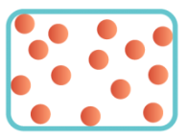
Element | A substance made up of a single type of atom. | 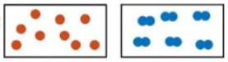
Compound | A substance made from two or more different types of atom, chemically joined together | 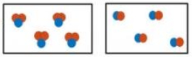
Mixture | A substance made from 2 or more different elements or compounds not joined together, so it can be separated | 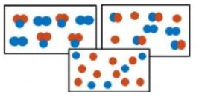
Subatomic particles | Smaller than an atom. Used to describe the particles: Protons, Neutrons and electrons. | Particle Mass Charge  Proton 1 +1  Neutron 1 0  Electron Negligible (nearly zero) -1

Five key ideas  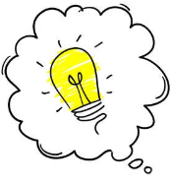 | 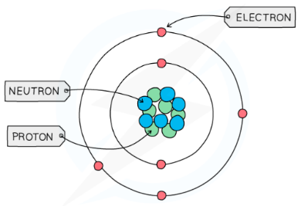  Structure of the Atom | Electron Configuration  Electrons are arranged in shells around the outside of the nucleus. Shell 1 holds only 2 electrons. All other shells hold 8 electrons. These shells must be filled from the lowest shell first.
Separating Mixtures  Since mixtures contain different substances not joined to each other, they can be separated by either filtering, evaporation, distillation, fractional distillation or chromatography. This relies on the substances having different properties such as different boiling points. | Models of the Atom  Over time, our understanding of what an atom is made from has changed, from Dalton’s spheres, to the Plum Pudding model, to the modern Nuclear model. These changes happened as new evidence was discovered that caused scientists to rethink their ideas. | Chemical Equations  All chemical reactions can be represented using equations. The symbols used represent elements and these can be found on the periodic table. The number of atoms on each side of an equation must be the same as atoms cannot be created or destroyed. This is called balancing an equation and is done by adding numbers at the start of an element. The small numbers after an atomic symbol cannot change.

 | Fulford School Science Department  Developing the next generation of Super Scientists | 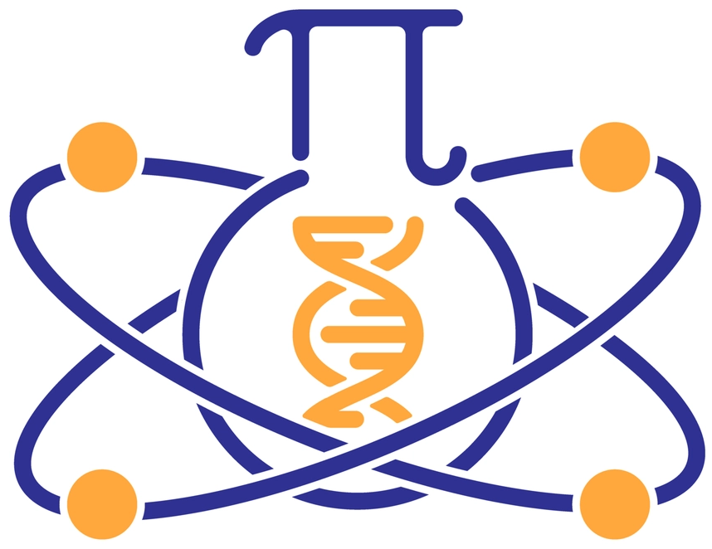

GCSE Science - Five key terms | Topic C1 Part 2 – The Periodic Table

Periodic Table | A list of all known elements, ordered according to atomic number | 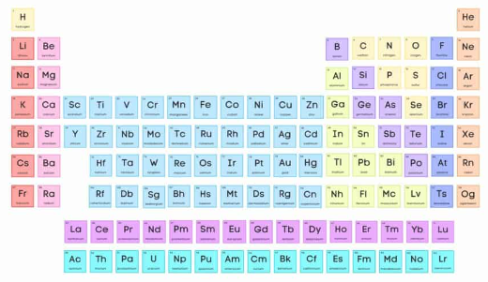
Group | A column of elements on the periodic table with similar properties | 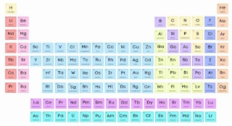
Halogen | An element from group 7 | 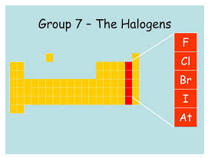
Alkali Metal | An element from group 1. Called alkali metals because they produce an alkali when reacted with water | 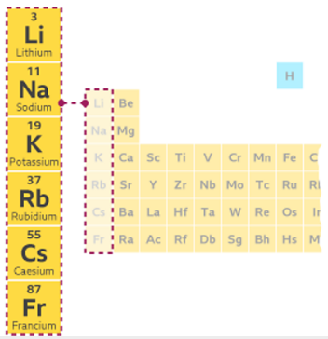
Noble Gas | An element from group 0. Called Noble Gases because they are all very unreactive (inert) | 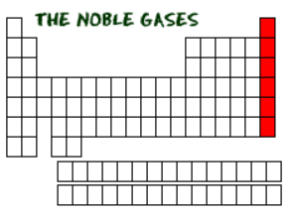

Five key ideas | Element Symbols  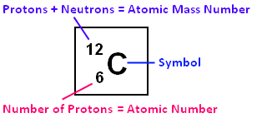 | Trends  Groups 1 elements get more reactive as you move down the group. Group 7 get less reactive moving down the group. There are other trends in terms of melting and boiling points for groups 1, 7 & 0 that need to be learnt.
Periodic Table Development  The periodic table has changed a lot over time – the earliest periodic table had just 2 columns! Many scientists have contributed to this over a long time period with the most prominent being Dmitri Mendeleev. | Outer Shell electrons  Reactivity depends on the outer shell of electrons – on how many electrons are in this shell and how far away from the nucleus this shell is. | Isotopes  An isotope of an element has the same number of protons in the nucleus, but a different number of neutrons.

Fulford School Science Department
Developing the next generation of Super Scientists

GCSE Science - Five key terms | Topic C2 – Structure & Bonding

Ionic Bond | A type of bond formed between a metal and a non-metal. The metal loses electrons to become a positive ion, the non-metal gains these electrons becoming a negative ion. | 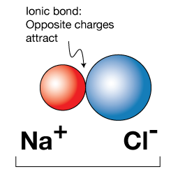
Covalent Bond | A type of bond formed between 2 non-metals. Involves the sharing of a pair of electrons. | 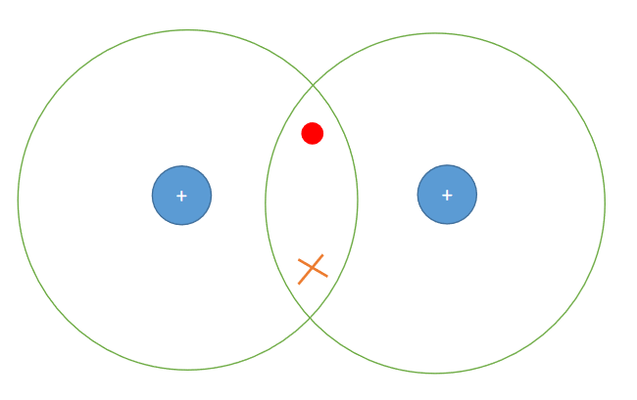
Metallic Bond | The bonding between metals. Made from rows of positive metal ions and delocalised electrons that move through the whole metal. | 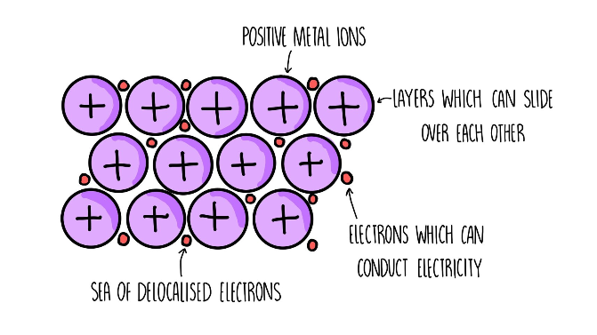
Intermolecular forces | Weak, temporary forces of attraction between small/simple covalent molecules. Takes little energy to break. | 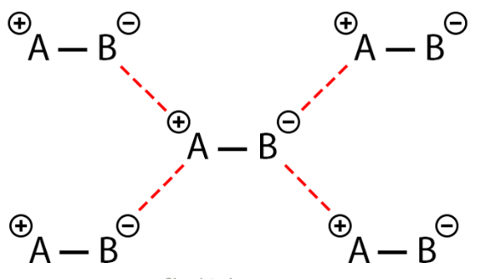
Giant ionic lattice | The name given to the giant 3-dimensional structure formed by repeating positive and negative ions. | 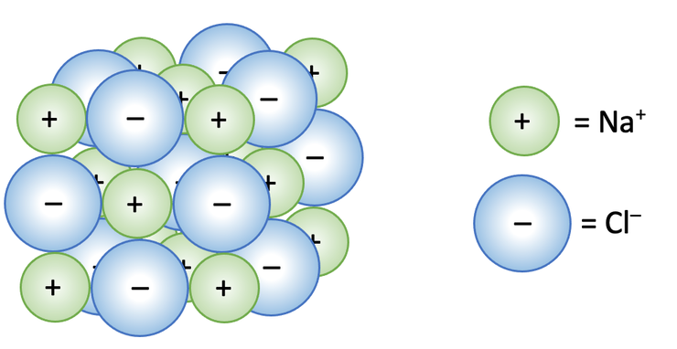

Five key ideas | Electrostatic Forces  The name given to the forces between positive and negative charges. Electrostatic attraction is what holds ionic bonds together. | Giant Covalent Structures  Diamond, Graphite, Graphene, Silicon Dioxide and fullerenes are all giant covalent structures made from millions of atoms all covalently bonded to each other. This gives them unique properties such as electrical conductivity or extreme hardness.
Simple Covalent Molecules  The name given to any non-metal substance that exists as a molecule (a group of atoms bonded together). Molecules are held to each other by weak intermolecular forces | States of matter  Matter exists either as a solid, liquid or gas. Moving between states requires a change in energy. The particle model explains the behaviour and properties of each state of matter. | Properties of substances  The melting/boiling point and electrical conductivity of a material is linked to its bonding. Bonding can be used to explain properties.

Fulford School Science Department
Developing the next generation of Super Scientists

GCSE Science - Five key terms | Topic C3 – Quantitative Chemistry (F)

Reactant | A starting material in a chemical reaction. Something that is used up in a reaction. | 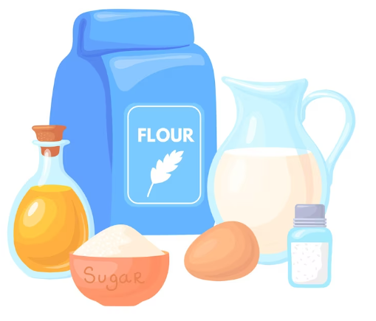
Product | Something that is made in a chemical reaction. | 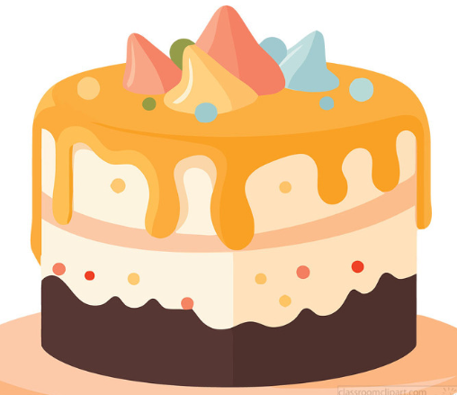
Balanced equation | A symbol equation for a reaction that has the same number of each type of atom on either side. | 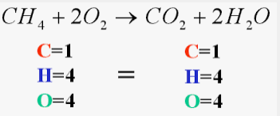
Concentration | The amount of something in a given space or volume. | 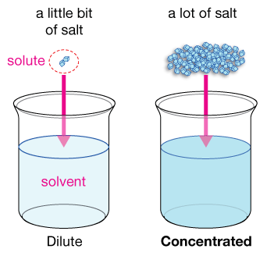
Solution | Made from a solute and a solvent. In saltwater, salt is the solute and water is the solvent. | 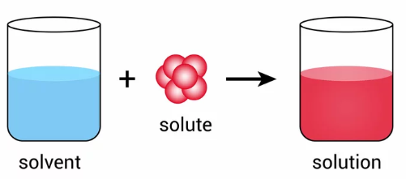

Five key ideas | Conservation of Mass  Mass and atoms cannot be created or destroyed. This means however many atoms of each element begin a reaction, the same number must end a reaction. This is why equations must be balanced. | Dilute vs Concentrated Solutions  A dilute solution has lots of solvent (water) and little solute (e.g. salt).  A concentrated solution has little solvent (water) and lots of solute (e.g. salt).  Concentrated solutions tend to be more hazardous.
Calculating Concentration  Concentration = mass (grams) ÷ volume (decimetres cubed) | Relative Formula Mass  The sum of each element’s atomic mass in a chemical formula. For example, in H₂O there are 2 atoms of Hydrogen (each of mass =1) and 1 atom of oxygen (mass =16) so the total relative formula mass = 1+1+16 = 18. | Decimetres cubed (dm³)  A common unit of volume in chemistry. 1 decimetre cubed (dm³) = 1 litre = 1000cm³.  To go from cm³ to dm³ you divide by 1000.

Fulford School Science Department
Developing the next generation of Super Scientists

GCSE Science - Five key terms | Topic C4 – Chemical Changes part 1 (F)

Acid | A substance that releases H⁺ ions when in a solution | 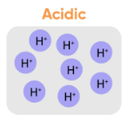
Base | A substance that will react with H⁺ ions to remove them from a solution. A soluble base is called an alkali. | 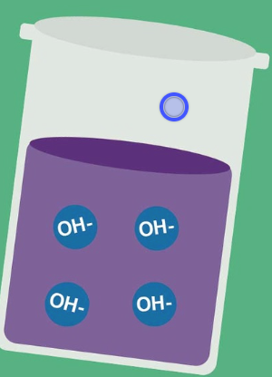
Displacement | Where a more reactive metal takes the place of a less reactive metal in a compound. | 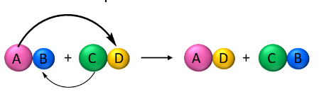
Oxidation | Where something in a reaction gains oxygen | 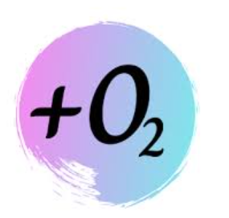
Reduction | Where something in a reaction loses oxygen | 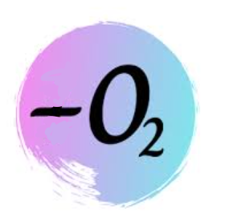

Five key ideas | Metal Reactivity  All metals react differently based on their electron configuration. A more reactive metal will bubble lots or even catch fire! Less reactive metals do nothing. | Reactions of Acids  Acid + Metal Salt + Hydrogen  Acid + Base Salt + Water  Acid + Metal Carbonate Salt + Water + Carbon Dioxide
pH  The scale that acidity is measured on. It goes from 1-14 where pH 1 is a strong acid, pH 7 is neutral and pH 14 is a strong alkali. | Naming Salts  Salts are formed from the reactions of acids. Their names are made from 2 words. The first work is from the metal involved in the reaction, the second word depends on the acid used. | Redox  In a redox reaction, one element will be oxidised and another reduced at the same time. It means the combination of reduction and oxidation.

Fulford School Science Department
Developing the next generation of Super Scientists

GCSE Science - Five key terms | Topic C5 – Energy Changes

Exothermic | A reaction that gets hotter. The energy moves from being stored in chemical bonds to the thermal energy store of the surroundings | 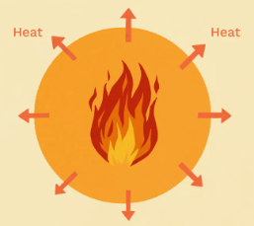
Endothermic | A reaction that gets colder. The energy moves from the thermal store of the surroundings to being stored in the chemical bonds. | 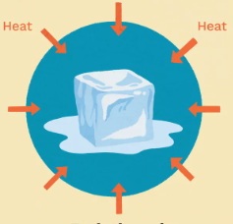
Activation Energy | The minimum energy required to start a reaction. | 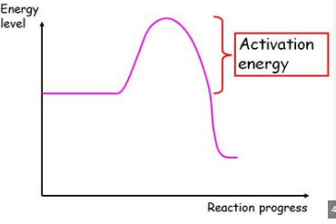
Reactant | A starting material in a chemical reaction. Something that is used up in a reaction.
Product | Something that is made in a chemical reaction.

Five key ideas | Conservation of Energy  Energy cannot be created or destroyed, only moved from one place to another. In chemical reactions it moves between being stored within chemical bonds to the surroundings in the form of heat | Energy Profiles  A diagram that shows how the energy stored within a chemical changes during the reaction. It can start high and decrease (exothermic) or start lower and increase (endothermic)
Energy Changes  All reactions involve a change in energy, some big and some small. This can be measured by recording the temperature change of a reaction | Recording Energy Changes  If recording a change in energy for an experiment, you would need to record the temperature before and after to see how it varied. | (HT) Bond Energy Calculations  The overall energy change in a reaction = total energy to break bonds – total energy released to make new bonds  This can be calculated from supplied data about individual mean bond energies

