Paper 2 Key terms
In this booklet you will find key terms that you have used in science this year; these will be useful to learn for your second Year 11 Mock.
You need to try and learn and remember all the key terms, with their definitions. One way of doing this is to make each one into a revision card, with the term on one side and its definition on the other – look at this example:
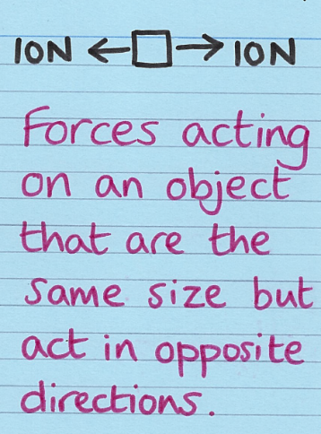
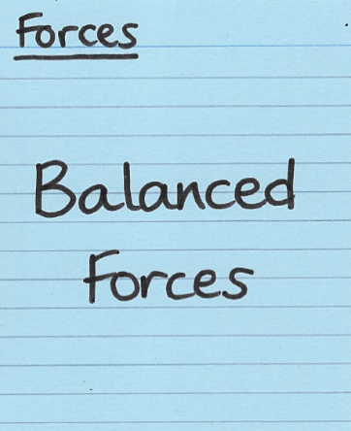
Write the key term on one side

Write what it means on the back

Use this table to record how many revision cards you have made, then
practise using them – ask a friend to test you!
Physics  Topic | I have made revision cards | I have practised using the revision cards at least 10 times
P5 Forces Part 1
P5 Forces Part 2
P6 Waves Part 1
P6 Waves Part 2
P7 Electromagnetism

Good luck – from Fulford School Science Department

Fulford School Science Department
Developing the next generation of Super Scientists

Physics | Topic P5 Forces – Part 1

Resultant force | Single force that can replace all the forces acting on an object and have the same effect. | 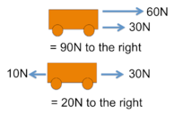
Speed | Speed is a measure of how fast an object travels: how far it goes in a given time.  Speed(m/s) = distance (m)/ time (s) | 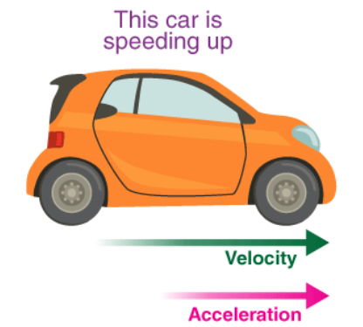
Velocity | The velocity of an object is its speed in a given direction.  Velocity is a vector quantity.
Acceleration | Rate of change of velocity  (in metres per second per second, m/s²).  Acceleration = change in velocity/ time
Newton’s First Law | If the resultant force acting on an object is zero and:  • the object is stationary; the object remains stationary  • the object is moving; the object continues to move at the  same speed and in the same direction. | 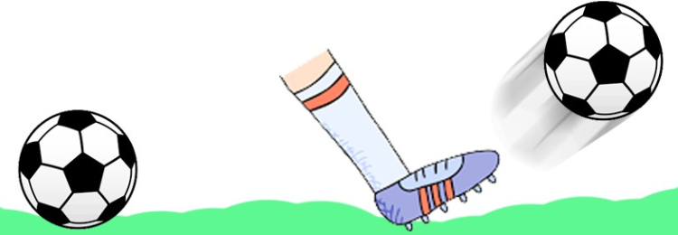

Five key ideas | Scalar quantities have magnitude only e.g. time, mass and speed. | Vector quantities have magnitude and direction e.g., force, displacement and velocity.
Contact forces: the objects are physically touching e.g friction.  Non-contact forces: the objects are physically separated e.g., the magnetic force. | 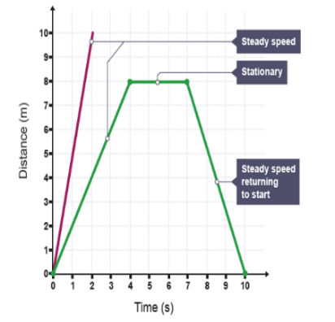  . | 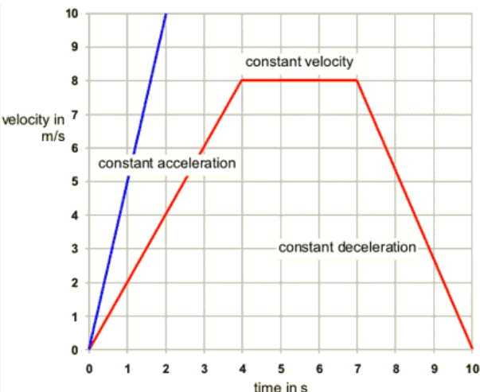

Fulford School Science Department
Developing the next generation of Super Scientists

Physics | Topic P5 Forces – Part 2

Newton’s Second Law | The acceleration of an object is proportional to the resultant force  acting on the object, and inversely proportional to the mass of the  object.  Force (N) = mass (kg) x acceleration (m/s²) | 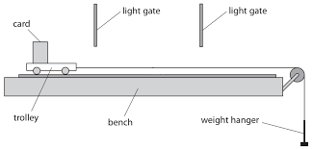
Newton’s Third Law | Whenever two objects interact, the forces they exert on each other  are equal and opposite. | 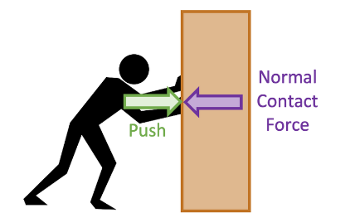
Thinking Distance | This is the distance that you travel while reacting to a stimulus until you get your foot onto the brake pedal. Thinking distance depends on drugs, alcohol, tiredness and distractions. | 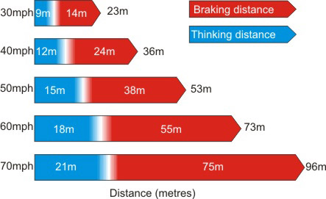
Braking Distance | This is the distance you travel from pressing the brake pedal until you come to a stop. Braking distance depends on condition of tyres/ brakes/ road and the speed and mass of the vehicle.
Stopping Distance | Stopping distance = Thinking distance + Braking distance

Five key ideas | When a spring is stretched, the spring may return to its original shape. In this case the deformation of the spring is said to be elastic. |  | The extension of a spring is directly proportional to the force acting on it provided that the limit of  proportionality is not exceeded  Force (N) = spring constant(N/m) x extension(m)
If the spring is stretched too far then the spring will never return to its original length. The deformation is said to be inelastic. | Weight is the force acting on an object due to gravity (in newtons, N).  Weight (N) = Mass (kg) x Gravitational field strength (N/kg)  W = m g |  | 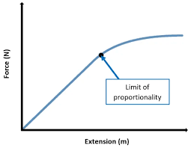  Limit of proportionality: When extension is no longer proportional to force

Fulford School Science Department
Developing the next generation of Super Scientists

Physics | Topic P6 Part 1 – Waves

Amplitude | The amplitude of a wave is the maximum displacement of a point  on a wave away from its undisturbed position. | 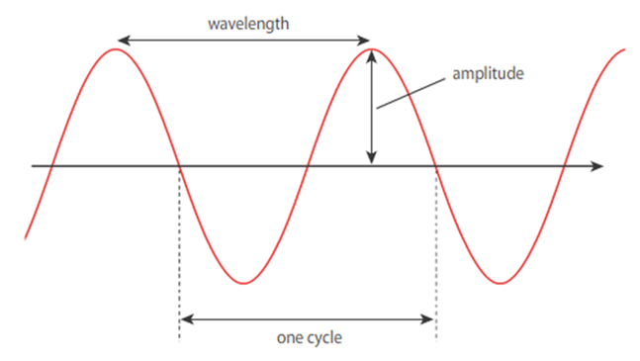
Wavelength, λ | The distance from one point to the identical point on the next wave. Measured in metres.
Frequency, f | The number of waves passing a point in one second, this is measured in Hertz (Hz). | 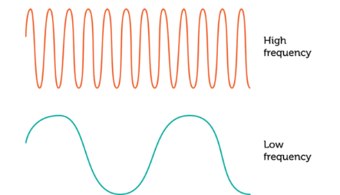
Longitudinal waves | Longitudinal waves are where the direction of vibration is parallel to that of the wave.  An example is a sound wave. | 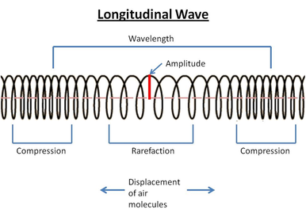
Transverse waves | The particles within the wave move perpendicular (at 90º) to the direction the wave is travelling. Examples are water waves and  electromagnetic wave. | 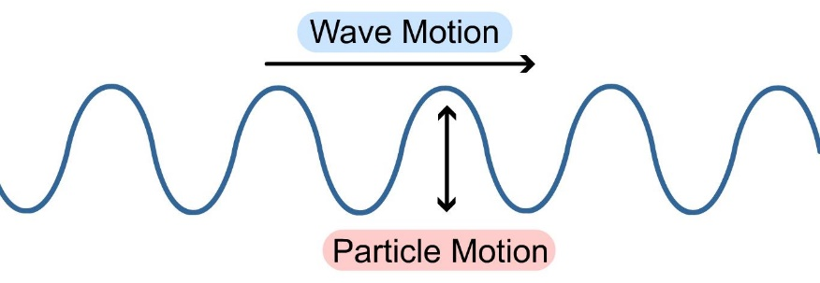

Five key ideas | Wave speed (m/s) = frequency (Hz) x wavelength (m)  V= f ʎ | T = 1/f  Time period (s) =$1÷frequency$(Hz)
Sound travels at 330m/s in air.  Light travels faster than sound. | A wave is vibrations that transport energy from place to place without transporting matter. | A ripple tank is used to measure the speed of ripples on a water  surface.

Fulford School Science department
Developing the next generation of Super Scientists

Physics | Topic P6 Waves - Part 2

Gamma Rays and X – rays. | These are ionising radiations that can cause mutations of genes which could result in cancer.  They are used in medical imaging and treatment. | 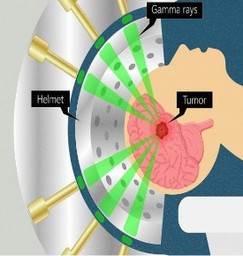
Ultra - violet waves | A type of electromagnetic wave that can be used for energy efficient lamps and sun tanning. They  can cause sunburn, ageing of the skin and skin cancer.
Visible light | The part of the electromagnetic spectrum that we can see with our eyes. It is used in fibre optic communication.
Infra – red radiation | A type of electromagnetic wave continually emitted and absorbed by all objects, that can be used in electrical heaters. | 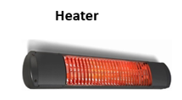
Microwave  and Radio waves | Microwave is a type of electromagnetic wave that can be used for cooking or satellite communication.  Radio waves are used for television and radio. | 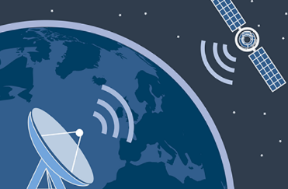

Five key ideas | Black surfaces absorb infrared waves better than white or shiny surfaces. Black surfaces emit infrared radiation quicker than light coloured surfaces. | 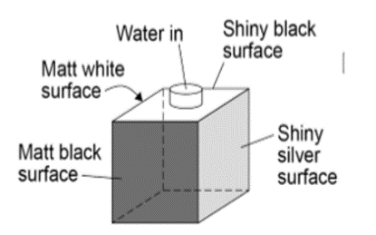  The Leslie cube is used to investigate how the amount of infrared radiation  radiated by a surface  depends on the surface.
All electromagnetic waves travel at the same velocity in a vacuum:  300 000 000m/s. | Ionising Radiation  Radiation that has enough energy to knock electrons off atoms. | 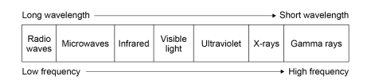  The Electromagnetic spectrum

Fulford School Science Department
Developing the next generation of Super Scientists

Physics | Topic P7 - Magnets and Electromagnetism

Permanent magnet | It produces its own magnetic field.  It can attract and repel other magnets and magnetic materials. | 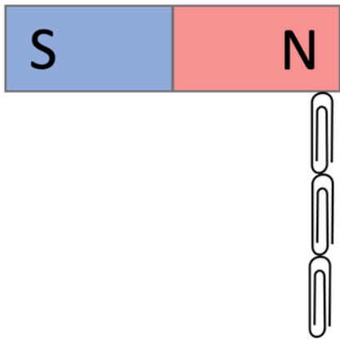
Induced Magnets | A material that becomes magnetic when placed in a magnetic field. Induced magnets can only attract.
Poles | The places where the magnetic forces are the strongest.
Electromagnet | A solenoid with an iron core is an electromagnet.  (A solenoid is a coil of wire used to produce a magnetic field). | 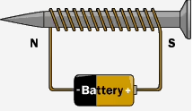
The motor effect (HT) | A current-carrying wire in a magnetic field experiences a force. | 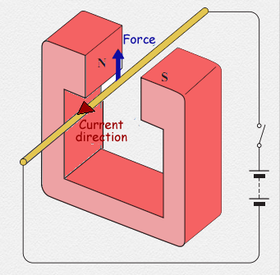

Five key ideas | 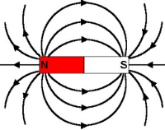  This is the magnetic field around a bar magnet | 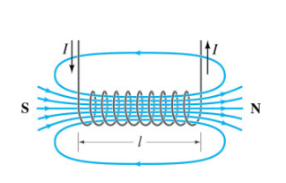  This is the magnetic field around a solenoid.
A magnetic field is an area around a magnetic where magnetic materials will experience a force.  Remember the 4 magnetic materials:  Steel, Iron, Nickel, Cobalt | 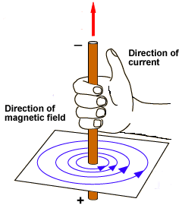  When a current flows through a conducting wire a magnetic field is produced around the wire.  The strength of the magnetic field depends on the current through the wire and the distance from the wire. | The strength of an electromagnet can be increased by:  - Increasing the current  - Increasing the number of turns  - Adding an iron core

