Year 8 Key terms
In this booklet you will find key terms that you have used in Science this year; these will be useful to learn for your end of year 8 test.
You need to try and learn and remember all the key terms, with their definitions. One way of doing this is to make each one into a revision card, with the term on one side and its definition on the other – look at this example:
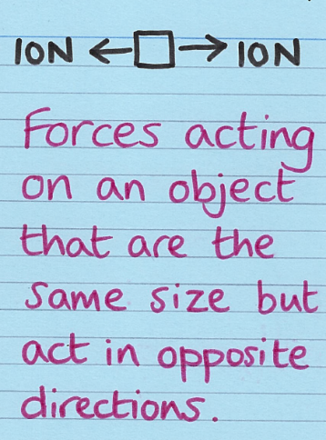
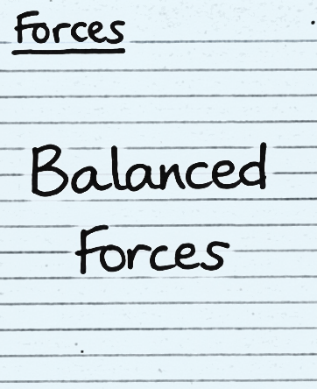

Write the key Write what
term on one it means on
side the back

Use this table to record how many revision cards you have made, then
practise using them – ask a friend to test you!
Year 8 Science Topic | I have made revision cards | I have practised using the revision cards at least 10 times
Forces
Electromagnets
Energy
Waves
Matter
Chemical Reactions
Earth (1 and 2)
Organisms
Ecosystems
Genes

Good luck – from Fulford School Science Department
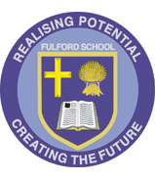 | Fulford School Science department  Developing the next generation of Super Scientists | 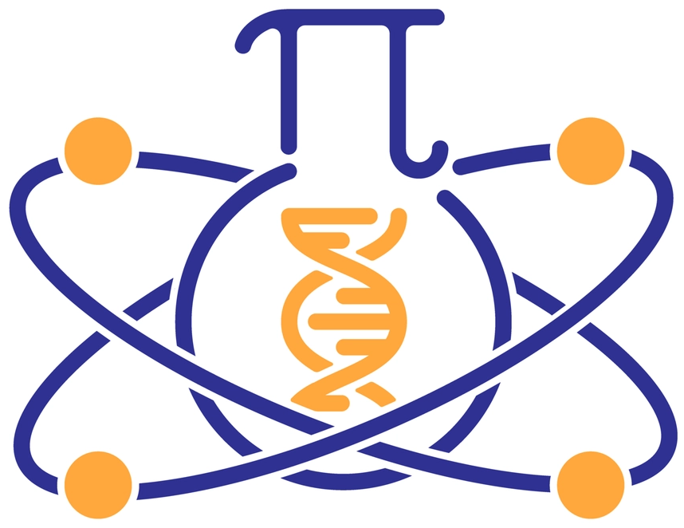

Year 8 Science | Topic 8.1 Forces

Five key terms
Balanced (forces) | Forces acting on an object that are the same size but act in opposite directions. | 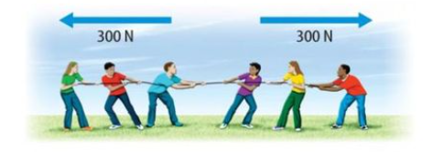
Resultant force | Single force that can replace all the forces acting on an object and have the same effect. | 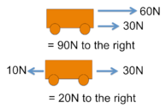
Deformation | When an object changes shape due to forces.
Gas pressure | The force exerted by air particles when they collide with a surface | 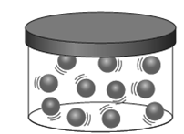
Atmospheric pressure | The pressure caused by the weight of the air above a surface | 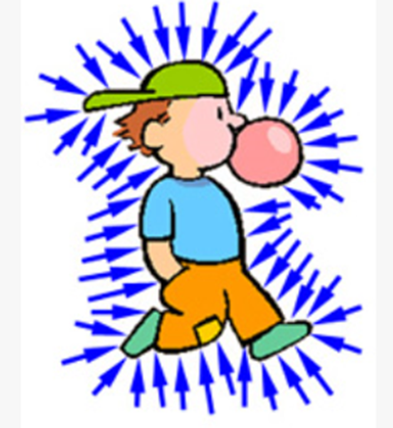

Five key ideas  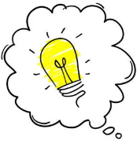 | Stress on a solid (N/m²)  = Force( N) / Area ( m²)  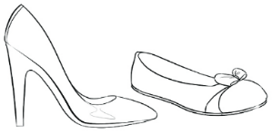  The greater the area the smaller the stress | Hooke’s Law - A law that says that if you double the force on an elastic object, the extension will double.
If forces are balanced (or in equilibrium) the resultant force is zero and the object must be stationary or moving at a constant speed. | A force makes things change: speed, direction and/or shape of an object. | The drag force on an object moving through a liquid or gas increases with its speed and can be reduced by making the object more streamlined.

Fulford School Science department
Developing the next generation of Super Scientists

Year 8 Science | Topic 8.2 Electromagnets

Five key terms
Current | Flow of electric charge, in Amperes (A).  I= Q/ t  ( Current = Charge/time) | 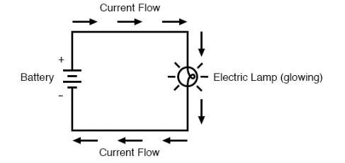
Series circuit. | When components are connected in a single branch of wire. ( The current is the same everywhere in a series circuit) | 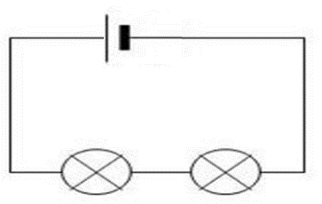
Parallel | When components in a circuit are on separate branches. | 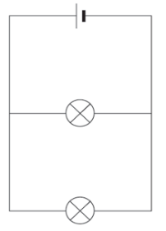
Resistance | Resistance is the property of a conductor by which it opposes the flow of electric current through it. | 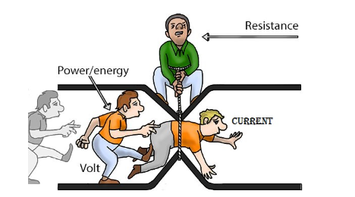
Electromagnet | A non-permanent magnet turned on and off by controlling the current through it | 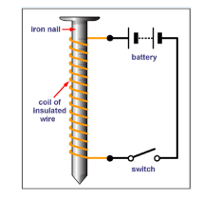

Five key ideas  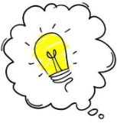 | 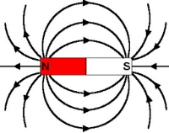  This is the magnetic field around a bar magnet | 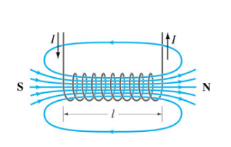  This is the magnetic field around an electromagnet
A magnetic field is an area around a magnetic where magnetic materials will experience a force. | Potential Difference: The amount of energy each coulomb of charge either gains from the power source or gives to a component. | The strength of an electromagnet can be increased by:  - Increasing the current  - Increasing the number of turns  - Increasing the size of the core

Fulford School Science department
Developing the next generation of Super Scientists

Year 8 Science | Topic 8.3 Energy

Five key terms
Thermal conductor | A material that transfers thermal energy easily e.g. metals.
Conduction | The transfer of thermal energy by the vibration of particles. | 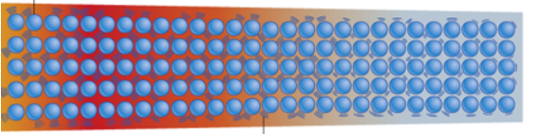
Convection | The transfer of thermal energy in a liquid or gas, by movement of particles. | 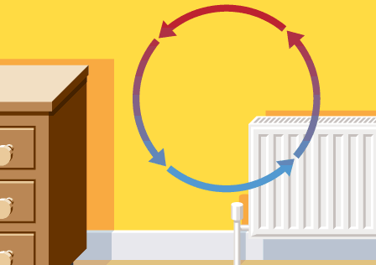
Thermal Radiation | A way of transferring energy without the need for particles. | 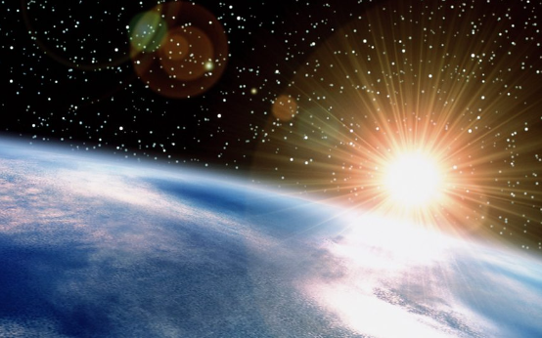
Temperature | A measure of how hot or cold something is measure in degrees Celsius (⁰C) | 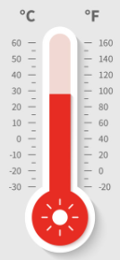

Five key ideas | Light from the sun reaches the Earth by thermal radiation | Metals are solids so their particles are close together and vibrating particles can transfer energy. In liquids and gases the particles are further apart so are not good at passing on energy, they are poorer thermal conductors (insulators).
Thermal Energy is always transferred from hotter to cooler objects | The unit for measuring energy and work done is the Joule. | Work done(J) = force (N) x distance ( m)

Fulford School Science department
Developing the next generation of Super Scientists

Year 8 Science | Topic 8.4 Waves

Five key terms
Amplitude | The height of the wave when measured from the peak to the middle | 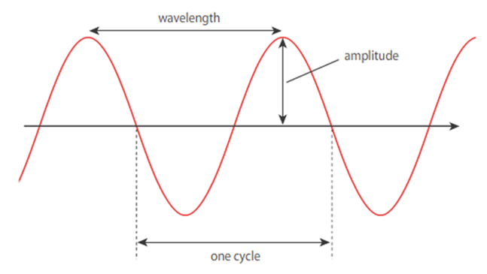
Wavelength | The distance from one point to the identical point on the next wave
Frequency | The number of waves passing a point in one second, this is measured in Hertz (Hz). | 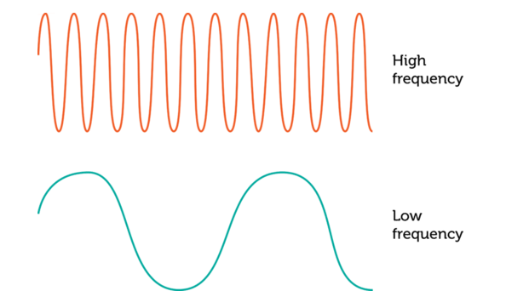
Electromagnetic spectrum | The range of wavelengths of radiation produced by the Sun and other sources | 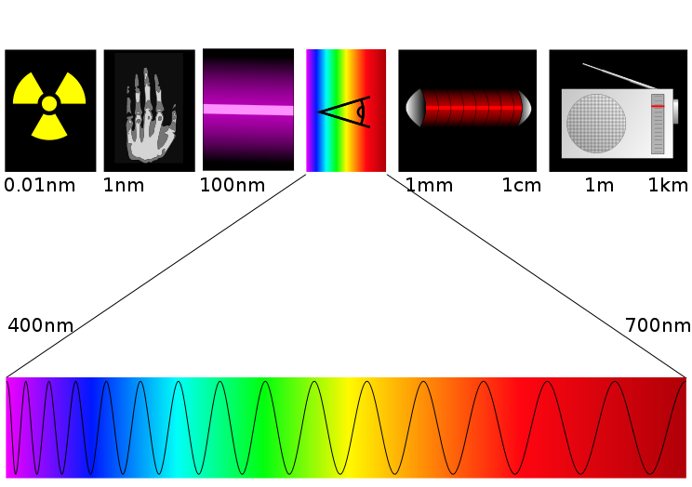
Ultrasound | Sound waves with frequencies higher than the human auditory range. ( Above 20000 Hz) | 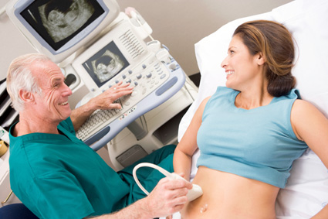

Five key ideas |  | Transverse waves are when the direction of vibration is perpendicular that of the wave. An example is light | Longitudinal waves are  where the direction of vibration is parallel to that of the wave.  An example is a sound wave
Sound travels at 330m/s.  Light travels faster than sound. |  | A wave is vibrations that transport energy from place to place without transporting matter. | The electromagnetic spectrum has many uses. For example  X –rays are used for broken bones. Gamma radiation is used for killing cancer cells.
Fulford School Science department
Developing the next generation of Super Scientists

Year 8 Science | Topic 8.5 Matter 2

Five key terms
Element | A substance made up from only one type of atom | 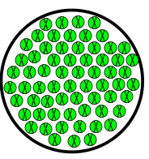
Compound | A substance made up from two or more different types of atom, chemically joined together | 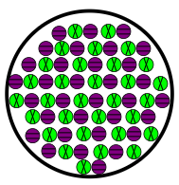
Periodic Table | An ordered list of all the known elements in the world. | 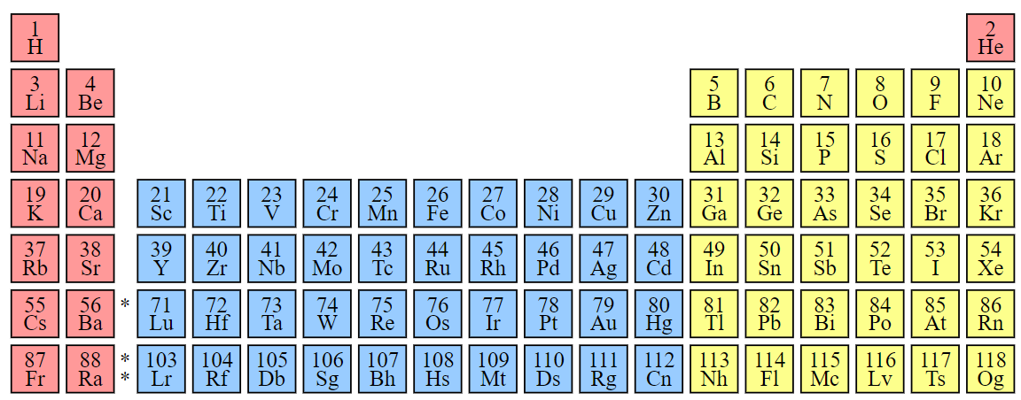
Group | A column in the periodic table of elements with similar properties
Atom | The smallest particle of something that can exist. The building blocks of everything around us.

Five key ideas | Periodic Table  This is a table showing all the elements known to exist. It helps us link the full name of an element to its symbol. | Chemical Formulae  A way of writing an element or compound using symbols and numbers. This tells us how many of each type of atom are in something. We use little numbers at the bottom of each element to show how many there are, and a new capital letter each time we have a new element.
Atoms  Atoms are the smallest building blocks of matter. There are lots of different types of atoms, these are the elements (for example oxygen atoms or gold atoms). | Groups  Groups are columns of elements on the periodic table that all behave in similar ways, react similarly and have similar properties. They often have special names. | Naming compounds  Compounds names are usually two words – the first being the metal element in the compound then the second word being related to the non-metal in the compound usually with a different ending. For example, Sodium Chloride is a compound of sodium and chlorine.

Fulford School Science department
Developing the next generation of Super Scientists

Year 8 Science | Topic 8.6 Reactions 2

Five key terms
Reactant | The starting material(s) for a chemical reaction | 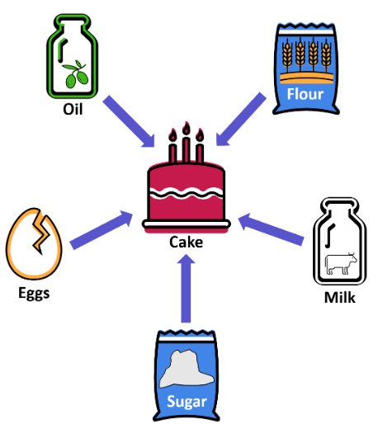
Product | The substance(s) made in a chemical reaction | 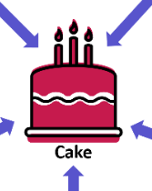
Exothermic | A chemical reaction that gets hotter | 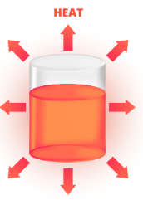
Endothermic | A chemical reaction that gets colder | 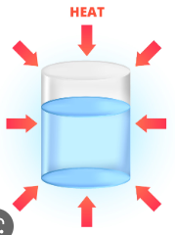
Compound | A substance made from two or more different elements, chemically joined together | 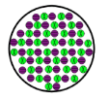

Five key ideas | Conservation of Mass  Atoms cannot be created or destroyed, which means the mass in a reaction cannot change. The mass at the start = the mass at the end | Combustion  The term for burning a fuel in oxygen. For most fuels this will always produce Carbon Dioxide & Water, This is an exothermic reaction
Thermal Decomposition  An endothermic reaction that requires energy (heat) to be put into the reactant to break it down into multiple products | Energy in reactions  All chemical reactions involve an energy change, Either from the chemical energy store to the thermal energy store, or the other way. | Models  Some parts of science are too complicated/hard to see to explain directly, so instead we use models to show what they are like. Some models are better than others, but all should help in explaining something.

Fulford School Science department
Developing the next generation of Super Scientists

Year 8 Science | Topic 7.7 Earth 1

Five key terms
Igneous Rock | A rock formed from the cooling of magma/lava. Can be extrusive (formed from lava from a volcano) or intrusive (cooled more slowly underground) | 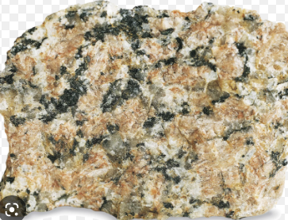
Sedimentary Rock | A rock formed from tiny fragments of other rocks that have been weathered, eroded, transported and deposited | 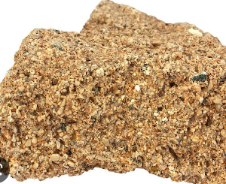
Metamorphic Rock | An igneous or sedimentary rock that has been heated and/or squashed underground for a long period of time | 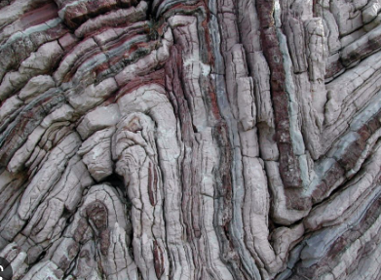
Planet | A large object in space that orbits a star and has a significant gravitational pull of its own | 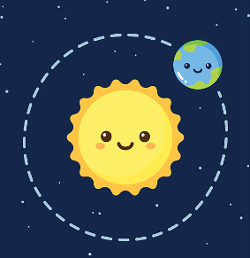
Solar System | The Sun and the 8 planets that orbit it (including Earth) | 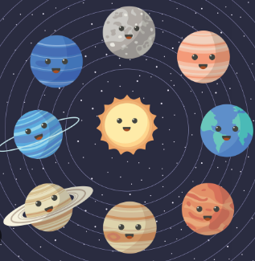

Five key ideas | Rock cycle  The idea that rocks constantly cycle between the 3 different types, as well as lava and sediments | Earth Structure  The Earth is made of several layers that have different properties. The crust, the mantle, the outer core then inner core.
Orbits  In space, most objects orbit stars due to gravity. Stars have very large masses and therefore a very large gravitational pull which holds other objects in place orbiting around them | Seasons  Seasons are caused by the tilt of the Earth’s rotational axis. NOT because our distance from the Sun changes. It’s due to how the Sun’s energy is dispersed over a smaller/larger area | Space  Space is a vacuum with nothing in it. It is vastly huge. Light travels through it because it is a wave. Sound does not. It takes 8.3 minutes for the light from the Sun to reach us. Other stars’ light can take millions of years to reach us

Fulford School Science department
Developing the next generation of Super Scientists
Year 8 Science |  | Topic 8.7 Earth 2

Five key terms
Greenhouse gas | Compounds in the Earth’s atmosphere that absorb (trap) thermal energy,  e.g. carbon dioxide and methane | 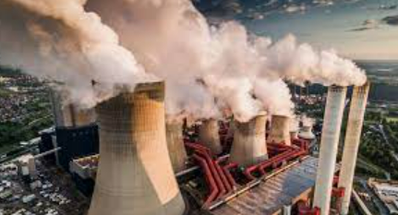
Global warming | The gradual increase in the surface temperature of the Earth. | 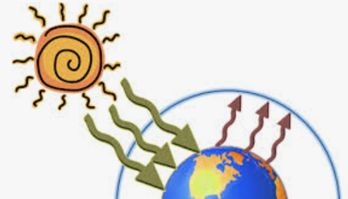
Carbon cycle | Carbon is constantly removed from, and returned to, the environment. Photosynthesis removes carbon from the atmosphere and respiration is  one way it returns. | 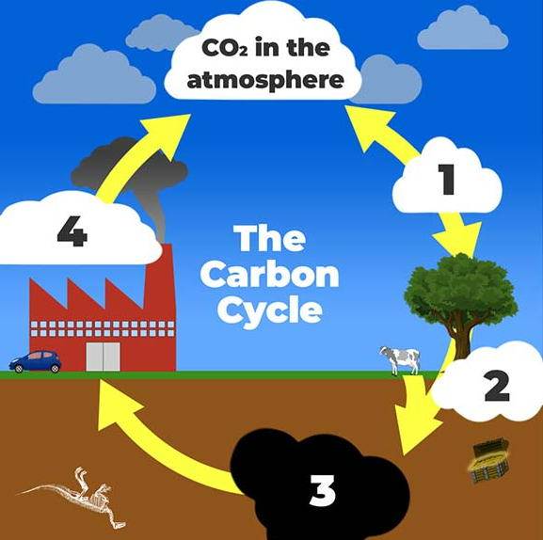
Ore | A naturally occurring rock that contains a useful metal, combined with  other elements. | 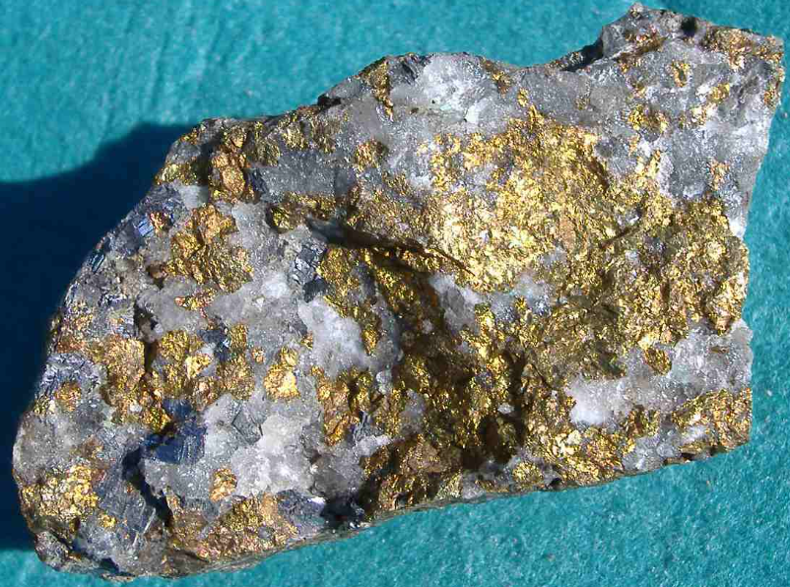
Extraction | Separation of a metal from a metal compound, e.g. extracting (taking out the) iron from iron oxide. | 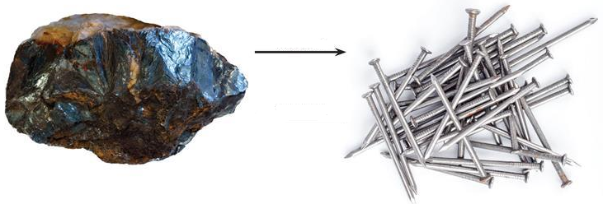

Five key ideas | Metals are found in rocks in the Earth’s crust. The way of getting the pure metal out is called extraction and the process involves different chemical reactions. | The average weather conditions in a certain place is called its climate; different areas of the world have different climates. Human activities, including burning lots of fossil fuels, is causing climate change.
Resources we get from the Earth’s crust , oceans and atmosphere, which provide useful materials and energy stores, will run out one day – we say they are finite resources. | There is only a certain quantity of any resource on Earth, so the faster it is extracted, the sooner it will run out. Recycling reduces the need to extract resources. | Atoms are recycled in the environment. Atoms of carbon exist in different compounds at different times. For example, carbon may be in the air (part of carbon dioxide) or in an organism (e.g. in a carbohydrate).

Fulford School Science department
Developing the next generation of Super Scientists

Year 8 Science | Topic 8.8 Organisms

Five key terms
Breathing | Moving air in and out of the lungs. Breathing happens because of the action of rib muscles and the diaphragm. | 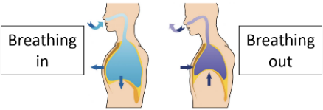  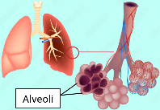
Alveoli | Small air sacs found at the end of each bronchiole where gas exchange happens between the air and the blood. | 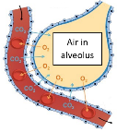
Enzyme | Substances that speed up (catalyse) chemical reactions inside organisms, including the reactions of digestion. | 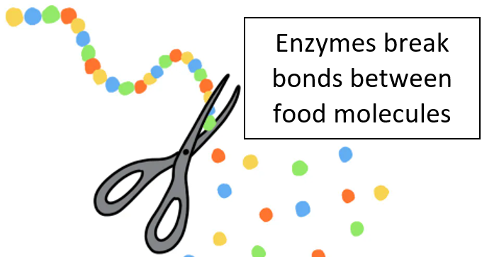
Digestion | The breaking down of large insoluble food molecules into  small soluble food molecules. | 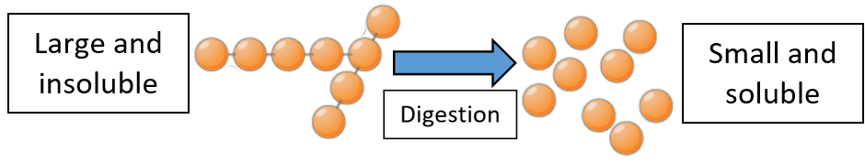
Absorption | The movement of small soluble food molecules from the small intestine into the bloodstream. | 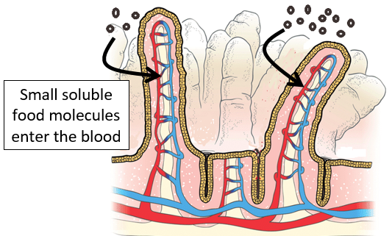

Five key ideas | We breathe air in and out of the lungs so that gas exchange (swapping) can happen in the alveoli; oxygen and carbon dioxide diffuse between the air in the lungs and the blood. | Breathing and respiration are not the same. Breathing is a physical process, involving muscle contraction and relaxation, to change the volume of the lungs. Respiration is a chemical reaction that happens in all cells.
The rate of breathing changes depending on the volume of oxygen required by body cells. For example, during exercise we breathe faster to obtain more oxygen, so that our muscle cells can release more energy from glucose for muscle contraction. | The body needs a balanced diet with carbohydrates (including glucose and starch), lipids, proteins, vitamins, minerals, fibre and water. Each type of nutrient is needed by our cells for different roles, including growth, energy and maintenance. | Organs in the digestive system are adapted to break down large insoluble food molecules into small soluble food molecules; only small soluble food can be absorbed into the blood and then transported to body cells. Food that can’t be absorbed passes out of the body in faeces.

Fulford School Science department
Developing the next generation of Super Scientists

Year 8 Science | Topic 8.9 Ecosystems

Five key terms
Respiration | A chemical reaction that happens in all cells and releases energy from glucose | 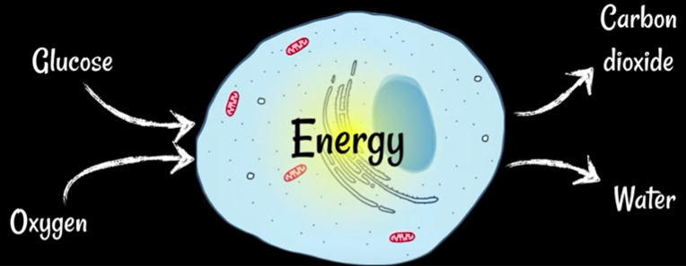
Aerobic respiration | A chemical reaction that uses oxygen to release energy from glucose | 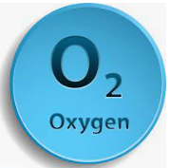
Anaerobic respiration | A chemical reaction that releases energy from glucose without using oxygen | 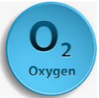
Photosynthesis | Using light energy, together with carbon dioxide and water, to make glucose (food). This chemical reaction happens in plants and algae. | 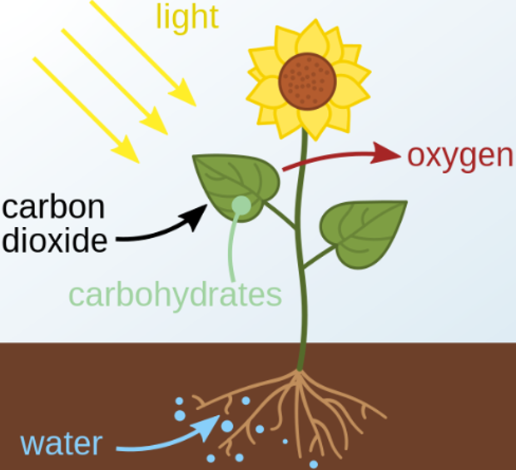
Chlorophyll | A green pigment in plants and algae which absorbs light energy for photosynthesis. | 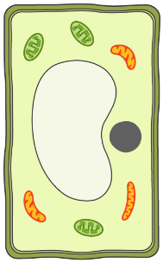 | Chlorophyll is found inside chloroplasts

Five key ideas |  | During exercise, respiration happens faster in muscle cells, releasing energy more quickly so they can contract more. For this to occur, oxygen and glucose are supplied to muscle cells faster, via an increased heart rate. The breathing rate increases to supply more oxygen and get rid of more carbon dioxide. | Leaves are adapted to carry out photosynthesis. Pores in the bottom of leaves, called stomata, can open and close to let gases in and out. During the day, when photosynthesis occurs, carbon dioxide diffuses into leaves and oxygen diffuses out. Stomata can close if the plant is losing too much water.
All organisms respire, including plants. Plants don’t eat, but instead make their own glucose during photosynthesis; during respiration, energy stored in the glucose is released in a usable form. |  | The reactions of photosynthesis and respiration happen inside organelles (also called ‘sub-cellular structures’) of cells. Aerobic respiration reactions happen inside mitochondria. Photosynthesis reactions happen inside chloroplasts. | Plants use the glucose they make in photosynthesis for many things. Firstly, glucose is used in respiration, to release energy for the plant. Some glucose is stored as starch, for later use. Proteins and fats are also made using glucose.
Fulford School Science department
Developing the next generation of Super Scientists

Year 8 Science | Topic 8.10 Genes

Five key terms
DNA | A molecule found in the nucleus of cells that contains genetic information | 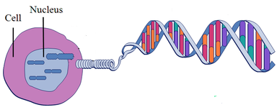 |  | DNA
Chromosome | Thread-like structures in the nucleus of cells containing tightly coiled DNA | 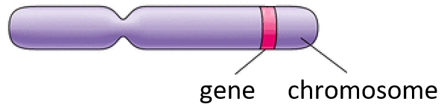
Gene | A section of DNA that determines an inherited characteristic
Population | A group of organisms of the same kind living in the same place |  | a human population
Evolution | The animal and plant species living today descended from species that existed in the past, that have changed over long periods of time | 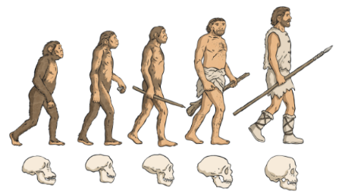

Five key ideas  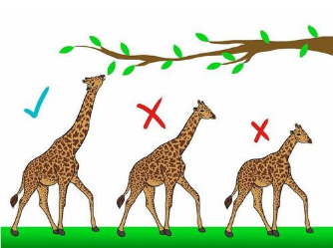 | Chromosomes are long pieces of DNA that contain many genes. In order of size: |  | Inherited characteristics are features passed from parents to offspring during reproduction. Gametes, have half the total number of chromosomes; their nuclei join during fertilisation.
 | Gene  Chromosome  Nucleus  Cell | smallest  largest
Natural selection is a theory that explains how species evolve (change) over time. Changes in characteristics, due to changes in DNA, can make some organisms better adapted to survive in their environment. | Within a species there is lots of variation between organisms. This helps a species to survive if the environment changes, avoiding extinction.  If a species becomes extinct, no more individuals survive on Earth. |  | Organisms compete with each other for resources in their environment. Having many different species in an area ensures that more resources are available for other populations, e.g. there is more food available.

