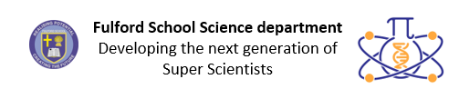

Year 7 Key terms
In this booklet you will find key terms that you have used in Science this year; these will be useful to learn for your end of year 7 test.
You need to try and learn and remember all the key terms, with their definitions. One way of doing this is to make each one into a revision card, with the term on one side and its definition on the other – look at this example:
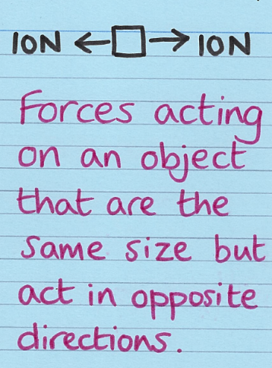
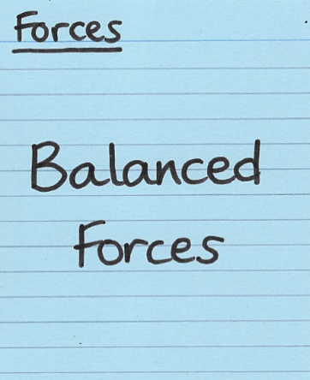

Write the key Write what
term on one it means on
side the back

Use this table to record how many revision cards you have made, then
practise using them – ask a friend to test you!
Year 7 Science Topic | I have made revision cards | I have practised using the revision cards at least 10 times
Forces
Electromagnets
Energy
Waves
Matter
Chemical Reactions
Earth
Organisms
Ecosystems
Genes

Good luck – from Fulford School Science Department
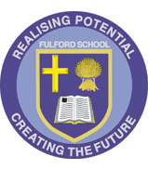 | Fulford School Science department  Developing the next generation of Super Scientists | 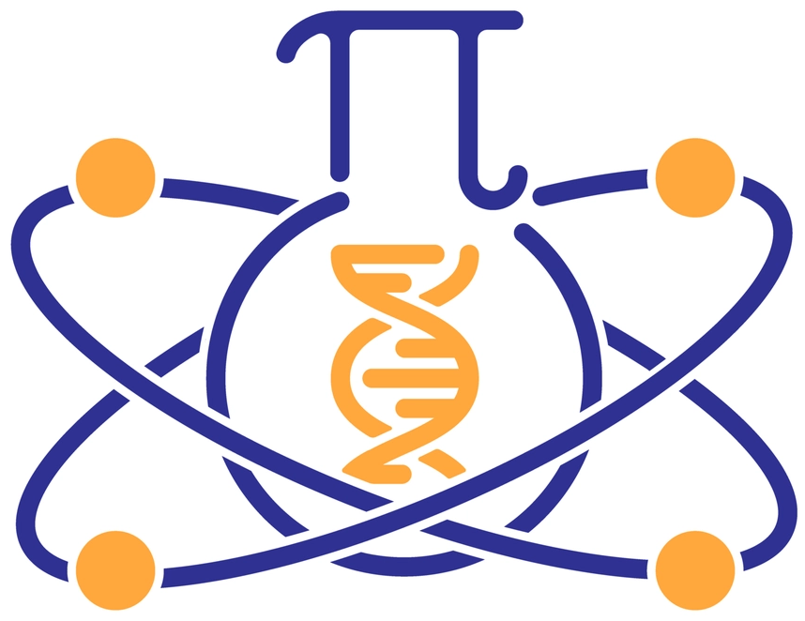

Year 7 Science | Topic 7.1 Forces

Five key terms
Resultant force | Single force that can replace all the forces acting on an object and have the same effect. | 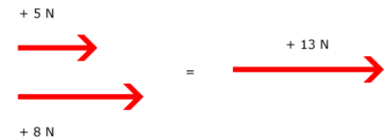
Balanced (forces) | Forces acting on an object that are the same size but act in opposite directions. | 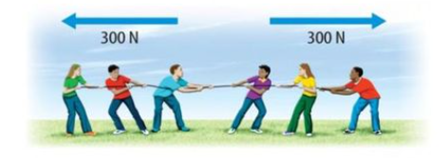
Weight | The force of gravity due to the Earth (or other planet or moon) on an object (N). | 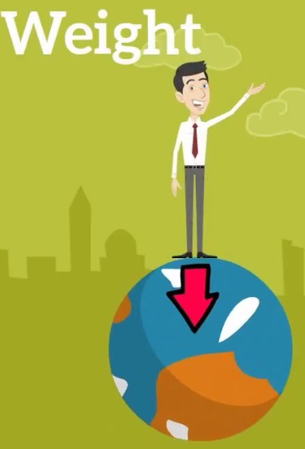
Mass | The amount of matter in an object (kg). | 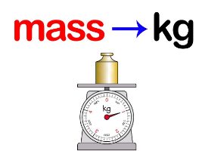
Friction | Force opposing motion which is caused by surfaces moving over one another. | 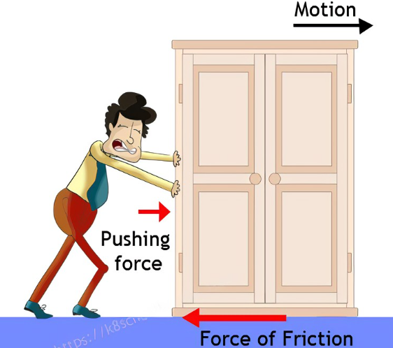

Five key ideas  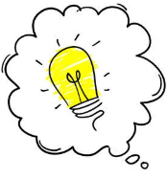 | When two objects have to be touching for a force to act, that force is called a contact force. Example: Friction  If the two objects do not need to be touching for the force to act, the force is a non - contact force. Example: gravitational force | Force arrows indicate the size, direction and location of each force.  Forces are measured in Newtons.
If forces are balanced (or in equilibrium) the resultant force is zero and the object must be stationary or moving at a constant speed. | A force makes things change: the speed, direction and/or shape of an object. | Speed is a measure of how fast an object travels: how far it goes in a given time.  Speed(m/s) = distance (m)/ time (s)

Fulford School Science department
Developing the next generation of Super Scientists

Year 7 Science | Topic 7.2 Electromagnets

Five key terms
Charge | A property of some particles which causes them to interact with other particles which also have this property, in Coulombs (C). | 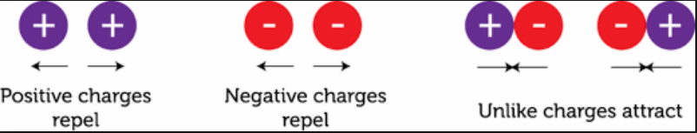
Current | Flow of electric charge, in Amperes (A). | 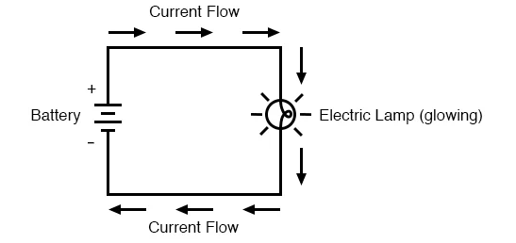
Series circuit. | When components are connected in a single branch of wire. | 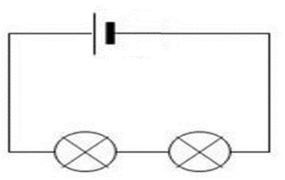
Parallel | When components in a circuit are on separate branches. | 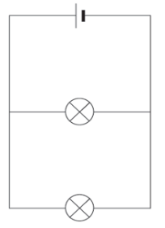
Permanent magnet | An object that is magnetic all of the time | 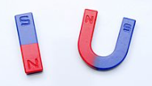

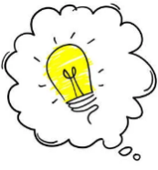  Five key ideas | There are two types of charge – positive charge and negative charge  If two of the same charged objects are near each other, they will repel each other  If two different charged objects are near each other, they will attract each other. | In magnets two similar poles placed near each other feel a repulsive force that pushes them away from each other  Opposite poles feel an attractive force that pushes them towards each other
Remember the 4 magnetic materials:  Steel  Iron  Nickel  Cobalt | An ammeter is used to measure current | A magnetic field is an area around a magnetic where magnetic materials will experience a force.

Fulford School Science department
Developing the next generation of Super Scientists

Year 7 Science | Topic 7.3 Energy

Five key terms
Useful energy | The energy that is transferred to its intended store. | 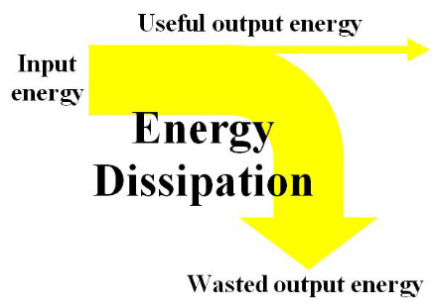
Wasted energy | Energy that is transferred to unwanted stores.
Dissipated | Energy spread out wastefully.
Renewable energy | An energy resource that can be replenished. | 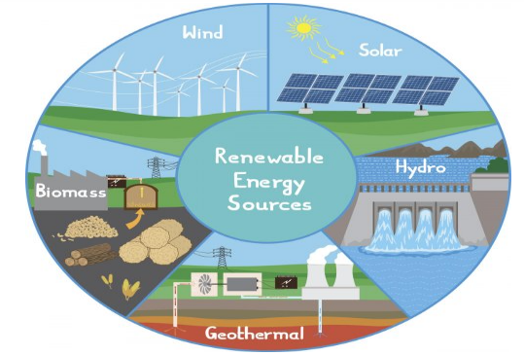
Non-renewable energy | An energy resource that cannot be replenished when used. | 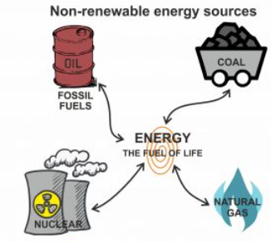

Five key ideas | The 8 types of energy store are:  - Chemical store  - Gravitational store  - Kinetic store  - Thermal store  - Elastic store  - Electrical store  - Magnetic store  - Nuclear store | Energy is transferred between stores in four main ways  - Mechanically  - Electrically (by a current flowing in a circuit)  - By heating  - By radiation ( light/soundwaves)
Fossil fuels are non-renewable energy source formed over millions of years from dead plants and animals. Examples are: coal, oil and gas | The unit for measuring energy is the Joule | Law of conservation of energy:  Energy cannot be created or destroyed, only transferred between stores

Fulford School Science department
Developing the next generation of Super Scientists

Year 7 Science | Topic 7.4 Waves

Five key terms
Amplitude | The height of the wave when measured from the peak to the middle | 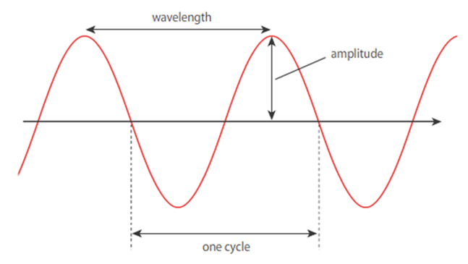
Wavelength | The distance from one point to the identical point on the next wave.
Frequency | The number of waves passing a point in one second, this is measured in Hertz (Hz). | 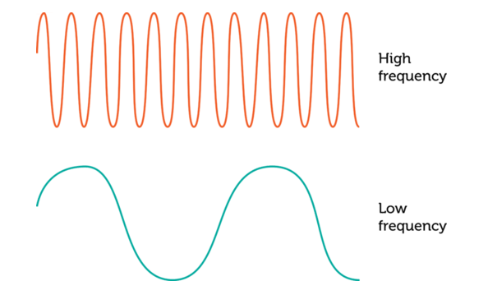
Refraction | When a waves changes direction as it moves from one material into another (at an angle). | 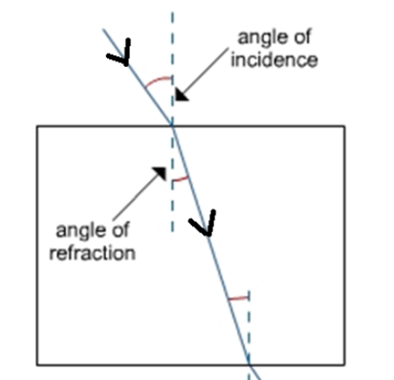
Reflection | When a wave bounces at the boundary between two materials. | 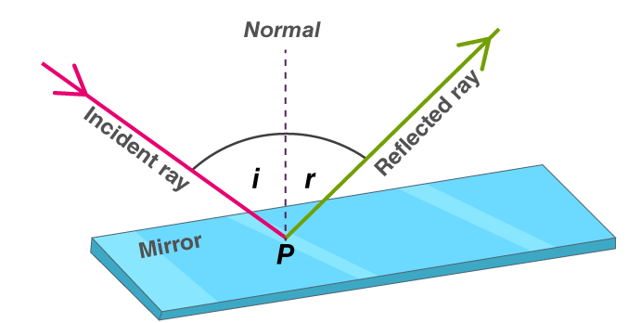

Five key ideas | Light travels in straight lines  The law of reflection states that the angle of incidence = the angle of reflection | Longitudinal waves are where the direction of vibration is parallel to that of the wave.  An example is a sound wave
Refraction occurs because light slows down when it goes from air to glass. | The larger the amplitude of a sound wave the louder the sound. | Transverse waves are where the direction of vibration is perpendicular to that of the wave.  An example is a light wave

Fulford School Science department
Developing the next generation of Super Scientists

Year 7 Science | Topic 7.5 Matter 1

Five key terms
State | A form that things can take, either solid, liquid or gas | 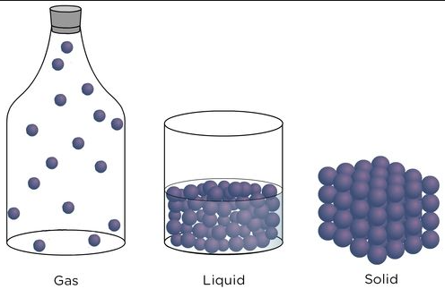
Diffusion | Where particles spread out from an area where there are lots, to where there are less | 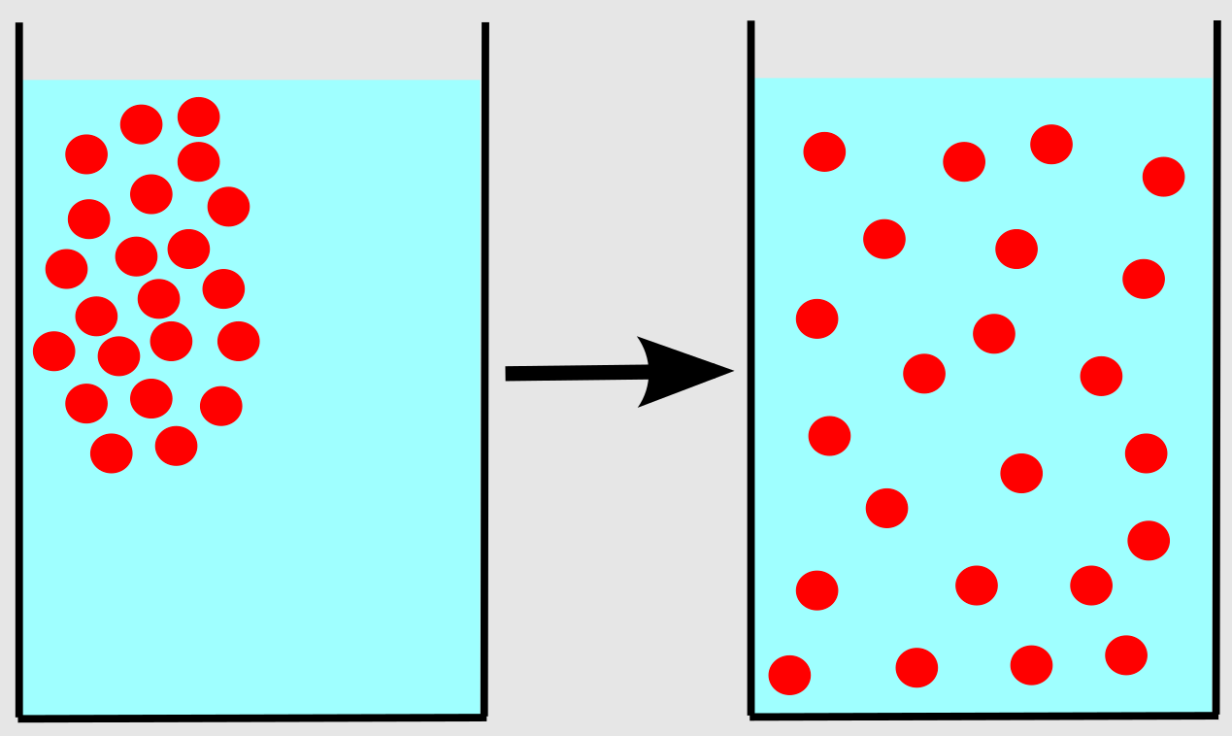
Solubility | The ability of a solid to dissolve in a liquid | 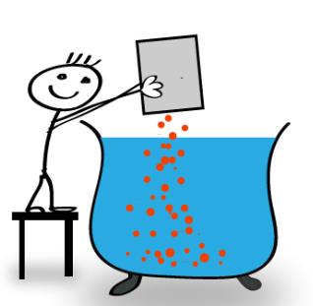
Mixture | Different types of substance or particle mixed together. It can be separated back out | 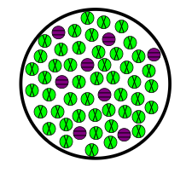
Pure substance | A substance made of only one type of particle. | 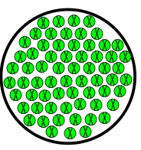

Five key ideas | Solids/liquids/gases  Matter exists in these 3 states. The arrangement of the particles in each state gives a material its properties | Particles and energy  To change state, there must be a change in energy of the particles. As they gain energy, they vibrate faster and may melt or boil. As they lose energy they vibrate slower and may condense or freeze.
Mixtures & Pure substances  All matter is either pure (all made from only one type of particle) or a mixture (made from lots of different particles). For example, pure water is just made from water particles, but salt water is a mixture because it also has salt in it. | Separating mixtures  Mixtures can be separated into their different parts using lots of different methods such as filtration, evaporation, distillation and chromatography. | Solute/Solvent/Solution  A solution is made from a solute and a solvent. The solute is the solid that is dissolved. The solvent is the liquid that the solute dissolves in.  Solute + Solvent = Solution

Fulford School Science department
Developing the next generation of Super Scientists

Year 7 Science | Topic 7.6 Reactions 1

Five key terms
Reactant | The starting material(s) for a chemical reaction | 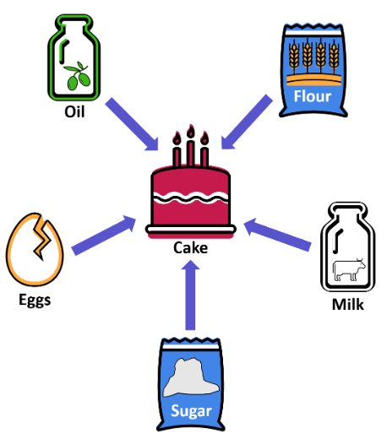
Product | The substance(s) made in a chemical reaction | 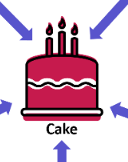
Indicator | A chemical that changes colour to show how acidic or alkaline something is | 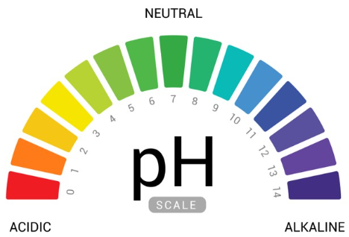
Chemical Change | A permanent, irreversible change caused by a chemical reaction. It produces something new. | 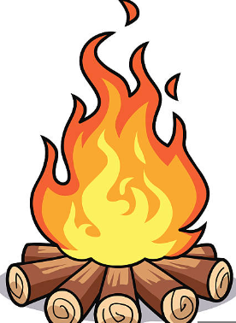
Physical Change | A reversible change such as a change of state | 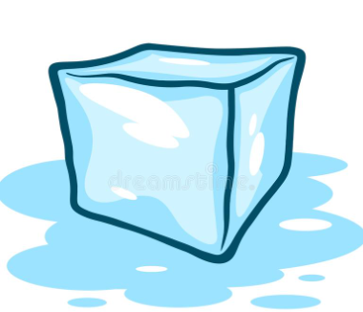

Five key ideas | pH  Chemicals exist on a pH scale, from 1-14. Where pH 1 is strongly acidic, pH 7 is neutral (water) and pH 14 is strongly alkaline. We can test the pH of a substance using an indicator. | Reactions  A chemical reaction is a permanent change caused by the rearrangement of atoms. The starting materials are called reactants and the end result(s) are known as products. We represent equations using arrows to show that they only go in one direction.  Reactants Products
Indicators  .These are chemicals we can use to test the pH of an unknown substance. They change colour depending on the pH. The most common is Universal Indicator. | Metals & Non-metals  All materials are either as metals or non-metals. Metals are generally shiny, hard, solid at room temperature, dense and good conductors. Non-metals are the opposite of these properties. | Elements/Compounds  All matter is made from elements. Elements are substances made from only one type of particle. Compounds occur when you join different types of element together.

Fulford School Science department
Developing the next generation of Super Scientists

Year 7 Science | Topic 7.7 Earth 1

Five key terms
Igneous Rock | A rock formed from the cooling of magma/lava. Can be extrusive (formed from lava from a volcano) or intrusive (cooled more slowly underground) | 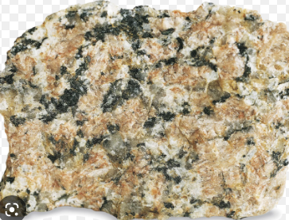
Sedimentary Rock | A rock formed from tiny fragments of other rocks that have been weathered, eroded, transported and deposited | 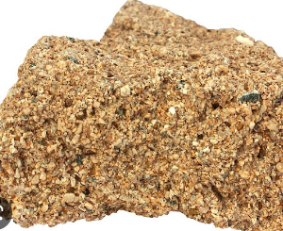
Metamorphic Rock | An igneous or sedimentary rock that has been heated and/or squashed underground for a long period of time | 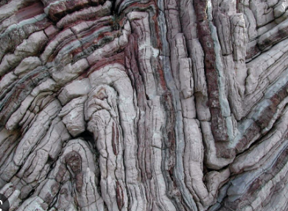
Planet | A large object in space that orbits a star and has a significant gravitational pull of its own | 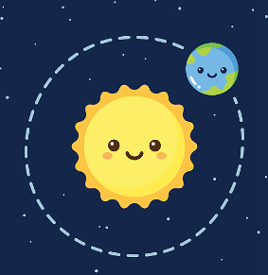
Solar System | The Sun and the 8 planets that orbit it (including Earth) | 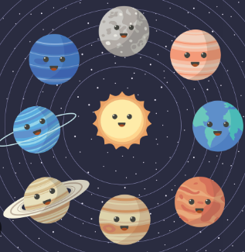

Five key ideas  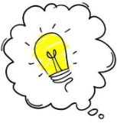 | Rock cycle  The idea that rocks constantly cycle between the 3 different types, as well as lava and sediments | Earth Structure  The Earth is made of several layers that have different properties. The crust, the mantle, the outer core then inner core.
Orbits  In space, most objects orbit stars due to gravity. Stars have very large masses and therefore a very large gravitational pull which holds other objects in place orbiting around them | Seasons  Seasons are caused by the tilt of the Earth’s rotational axis. NOT because our distance from the Sun changes. It’s due to how the Sun’s energy is dispersed over a smaller/larger area | Space  Space is a vacuum with nothing in it. It is vastly huge. Light travels through it because it is a wave. Sound does not. It takes 8.3 minutes for the light from the Sun to reach us. Other stars’ light can take millions of years to reach us

Fulford School Science department
Developing the next generation of Super Scientists

Year 7 Science | Topic 7.8 Organisms (living things)

Five key terms
Cell | Basic building block of organisms (living things). All cells have a membrane and some have a cell wall on the outside too. | 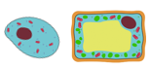
Tissue | A group of similar cells that are  working together. | 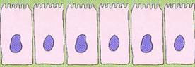
Nucleus | Part of a cell that contains genetic information (DNA) to control the activities of the cell. | 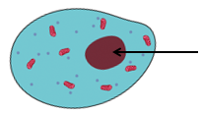
Cell membrane | A layer that surrounds a cell and controls the substances that move in and out. | 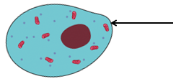
Microscope | An instrument used to see things, e.g. cells, which are too small to see with just our eyes. Microscopes magnify cells. | 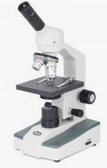

Five key ideas | Cells are very different. Most cells have special adaptations that help them do their job, so we call them specialised cells. | 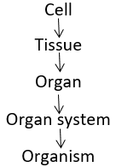
The word control is important when describing the jobs of parts of a cell; the nucleus controls the whole cell and the cell membrane controls what enters and leaves it. | All organisms can do these 7 life processes:  - Movement  - Respiration  - Sensitivity  - Growth  - Reproduction  - Excretion  - Nutrition | Respiration is a chemical reaction that happens inside all cells. Respiration RELEASES ENERGY from glucose; cells need energy to do all their jobs.  In plant and animal cells respiration happens inside mitochondria.

Fulford School Science department
Developing the next generation of Super Scientists

Year 7 Science | Topic 7.9 Ecosystems  This is a food chain

Five key terms
Producer | A plant (or alga) that uses light energy to make their own food – we call this photosynthesis | 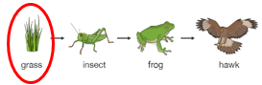
Consumer | An animal that has to eat other animals or plants to get energy | 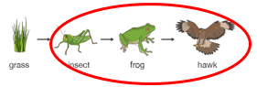
Predator | An animal that hunts, kills and eats other animals for food | 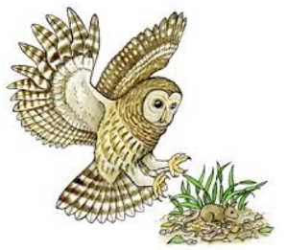  The mouse is the prey  The owl is the predator
Prey | An animal that is eaten by  another animal
Pollination | The transfer of pollen from the male part of a flower to the female part of a flower (on the same or another plant) | 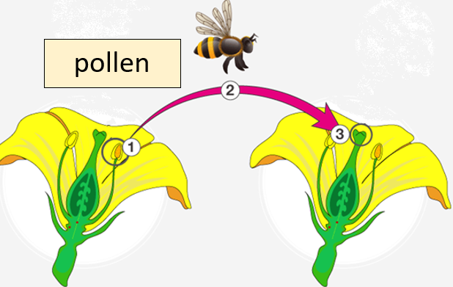

Five key ideas | Food chains show what eats what (‘feeding relationships’). Arrows point from what is being eaten to the organism doing the eating. Arrows show the transfer of energy that is stored in food. | Organisms of one species (e.g. rabbits) live in groups called populations. The size of a population can change if factors in the ecosystem change, e.g. if rabbits have more food, the size of the population will increase.
Food chains are joined to form food webs. Food webs show that organisms depend on each other for nutrients and a change in one population leads to changes in others. | 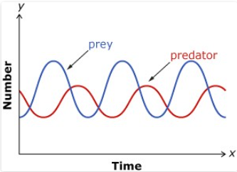  The size of a population will change if the numbers of its predators or prey changes. | 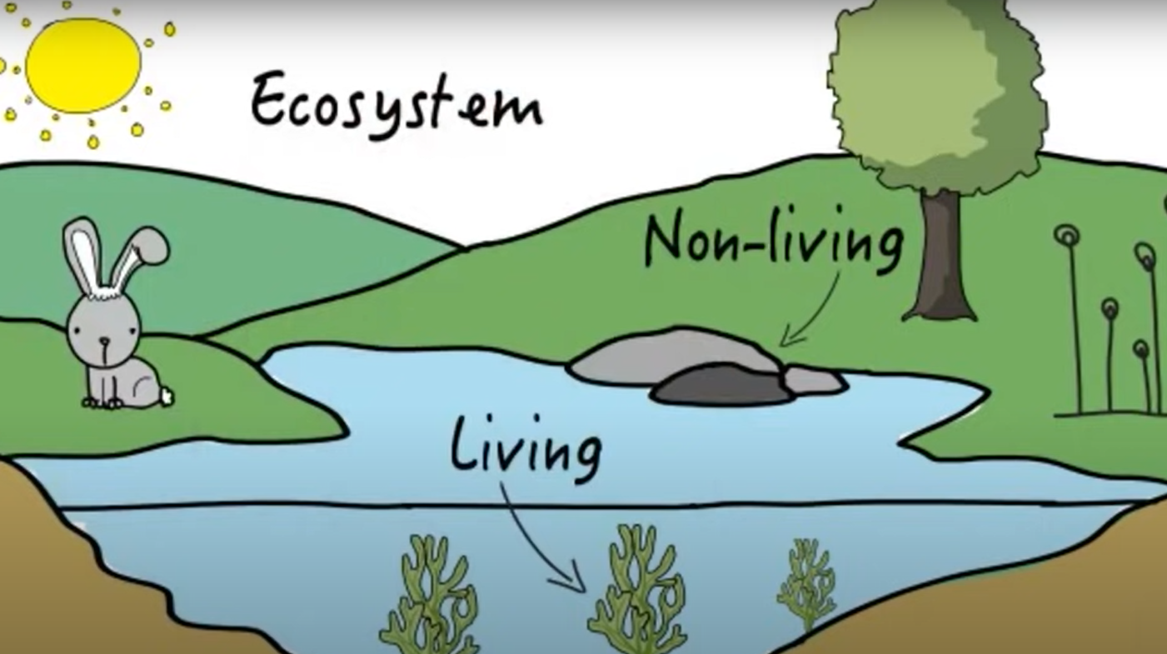  Organisms live in ecosystems, like deserts or forests. Ecosystems have both living and non-living factors.

Fulford School Science department
Developing the next generation of Super Scientists

Year 7 Science | Topic 7.10 Genes

Five key terms
Species | A group of organisms that have more in common with each other than with other groups. Males and females of a species can produce fertile offspring (babies). | 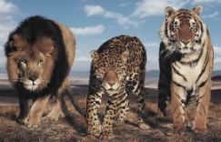 | Lions, jaguars and lions are different wild cat species
Variation | Differences between organisms, within or between species. Variation can be in organisms of the same species or different species. | 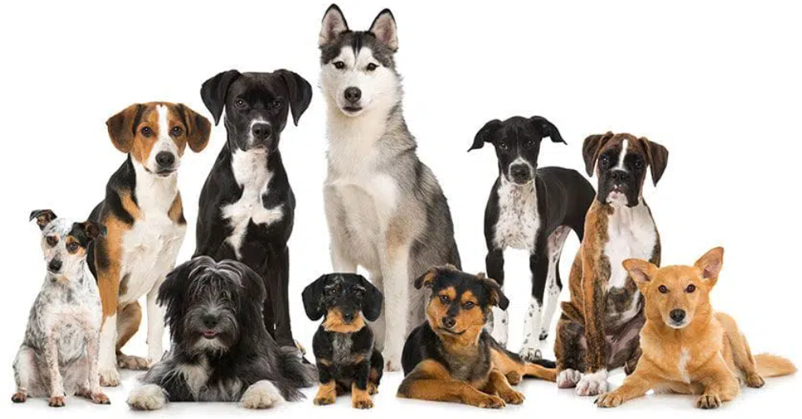
Gamete | A sex cell. The male gamete in animals is a sperm and the female gamete is an egg. | 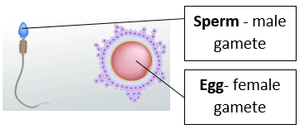
Fertilisation | The joining of the nucleus from a  male sex cell with the nucleus from a female sex cell. | 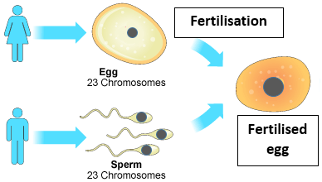
Uterus | Where a baby develops in a pregnant woman. Also called the womb. | 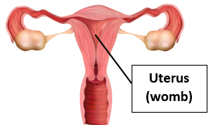

Five key ideas | There is variation between individuals of the same species. Some variation is inherited from the parents, some is caused by the environment and some is a combination of the two. | Variation between individuals is important for the survival of a species, helping it to avoid extinction in an always changing environment.
Gametes have half the number of chromosomes. Human eggs and sperm only have 23 chromosomes in their nuclei. Fertilisation joins together the chromosomes from the mother and father, making 46 chromosomes in total. | The menstrual cycle prepares the female for pregnancy. During the cycle the lining of the uterus breaks down and leaves the body – this is called menstruation.  The cycle stops if an egg is fertilised by a sperm. | The developing foetus (baby) relies on the mother to provide it with oxygen and nutrients, to remove waste and protect it against harmful substances. Exchanges between the mother and the foetus happen via the placenta.

