Paper 1 Key terms
In this booklet you will find key terms that you have used in science this year; these will be useful to learn for your Year 11 Mock
You need to try and learn and remember all the key terms, with their definitions. One way of doing this is to make each one into a revision card, with the term on one side and its definition on the other – look at this example:
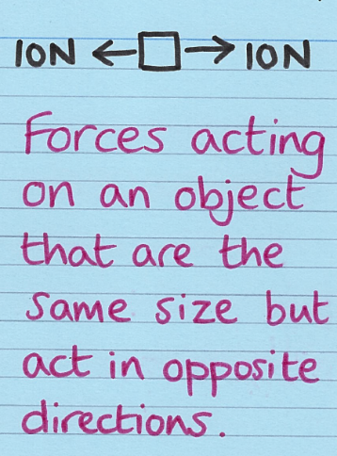
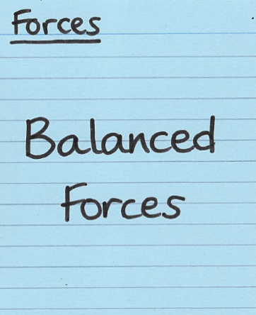
Write the key term on one side

Write what it means on the back

Use this table to record how many revision cards you have made, then
practise using them – ask a friend to test you!
Physics  Topic | I have made revision cards | I have practised using the revision cards at least 10 times
P1 Energy Part 1
P1 Energy Part 2
P2 Electricity Part 1
P2 Electricity Part 2
P3 Particle Model of Matter
P4 Atomic Structure Part 1
P4 Atomic Structure Part 2

Good luck – from Fulford School Science Department

GSCE Physics | Topic P1 Energy - Part 1

Five key terms
Renewable energy resource | A renewable energy resource is one that can be replaced or replenished. | 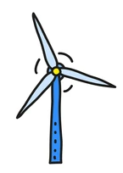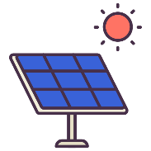
Non-renewable energy resource | A non-renewable energy resource is one that cannot be replaced or replenished. | 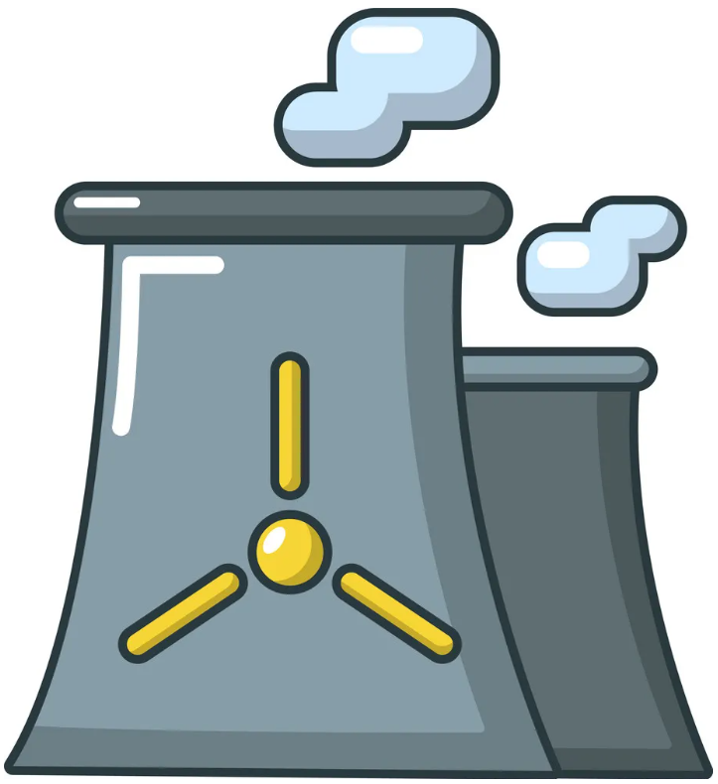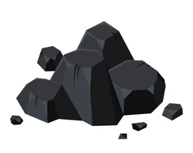
Biofuel | Renewable energy resources created from either plant products (e.g. wood) or animal dung.  Burnt to produce electricity like fossil fuels. | 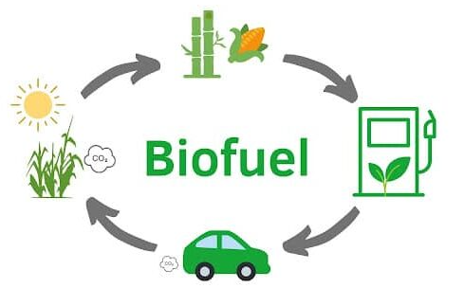
Joule | The unit of energy stored by an object (J). | 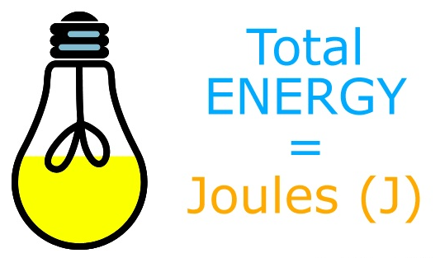
Carbon dioxide | Greenhouse gas that contributes to global warming. Emitted as a product of combustion of fossil fuels and biofuels. | 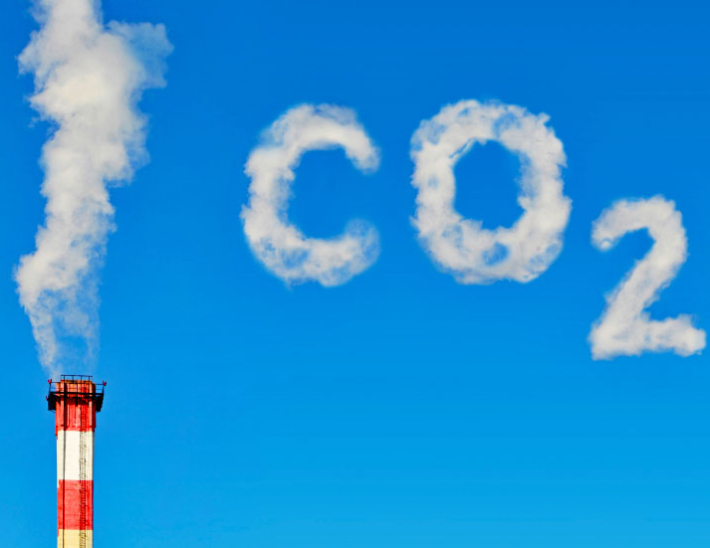

Five key ideas  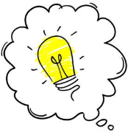 |  | Energy cannot be created or destroyed, only transferred from one place to another. Energy stores are locations where energy can be said to be stored.  This is known as the conservation of energy law. | Energy pathways are the physical processes which cause the energy stores to empty and fill:  - Mechanically - an object accelerates or deforms due to a force acting on it  - Electrically - work done by moving charges  - By heating - energy transferred from a hotter to a colder object, when distorted by forces or when an electric current is passed through them  - By radiation – all objects emit and absorb radiation – e.g. as they emit radiation their thermal energy store decreases.
Elastic potential energy is associated with objects which are compressed (squashed) or extended (stretched)  E_{E} = ½ x spring constant (N/m) x extension² (m) |  | Kinetic energy is the energy associated with a moving object  E_{K} = ½ x mass (kg) x velocity² (m/s) | Gravitational potential energy is the energy associated with anything that has mass and is inside a gravitational field.  E_{P} = mass (kg) x gravitational field strength (N/kg) x height (m)
Fulford School Science Department
Developing the next generation of Super Scientists

GSCE Physics | Topic P1 Energy - Part 2

Five key terms
Specific Heat Capacity | The energy required to raise the temperature of 1kg of a material by 1ºC | E = m x c x Δθ
Power | The rate of energy transfer, measured in Watts. | Power = Energy transferred  time
Watt | The unit of power for an object (W).  1 W = 1 J/s | 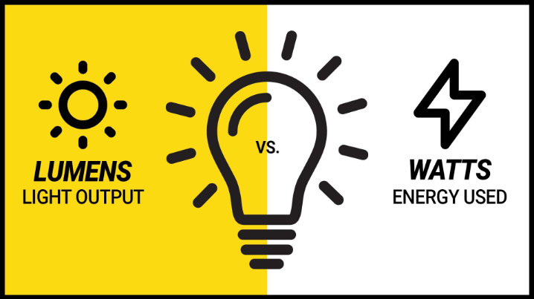
Efficiency | A measure of how much energy (or power) is usefully transferred in a system. | Effic. = Useful energy out  Total energy in
Insulator | Materials with a low rate of thermal conductivity (or rate of energy transfer) | 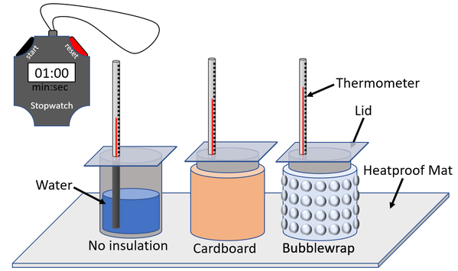

Five key ideas | The total energy output from an object will be the same as the energy input, but energy can be transferred out usefully or not usefully (wasted).  Less usefully transferred or wasted energy is often dissipated (spreads out) into the thermal energy stores of the surroundings. | The specific heat capacity of materials can be found practically. For any practical investigation the variables involved fit in to three categories;  Independent variable =  The variable that I will change  Dependent variable =  The variable that I will measure  Control variable(s) =  The variable(s) that I will keep the same
Efficiency is a measure of how much useful energy is transferred out of an object from the total amount of energy you transferred into it.  Efficient devices transfer more energy to where we want it to go and transfer less heating up the surroundings. | Thermal conductivity is a measure of how quickly energy is transferred through a material by conduction.  Thermal conductors are materials with a high thermal conductivity.  Thermal insulators are materials with a low thermal conductivity. | Methods of thermal energy transfer;  - Conduction: Vibrating particles collide with their neighbours and transfer energy.  - Convection: Warm fluids (faster moving molecules) becomes less dense and rise.  - Radiation: The transfer of thermal energy by waves that can travel through air or even through empty space.

Fulford School Science Department
Developing the next generation of Super Scientists

GSCE Physics | Topic P2 Electricity - Part 1

Five key terms
Charge, Q | A material property, measured in Coulombs (C). | 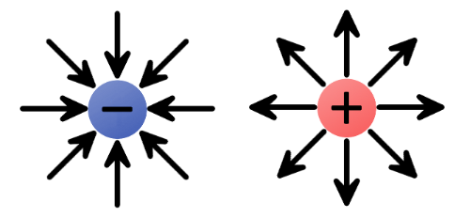
Current, I | The flow of charge, measured in Amps (A) | 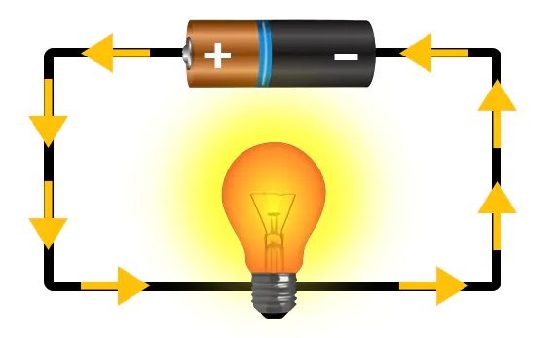
Potential difference, V | The difference in potential energy per unit of charge between two points in a circuit, measured in Volts (V) | 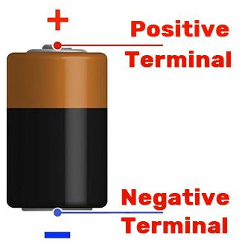
Resistance, R | A measure of how difficult it is for charge to flow around a circuit. | 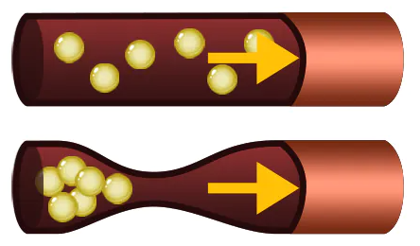
Series & Parallel | Two methods for connecting components together in a circuit | 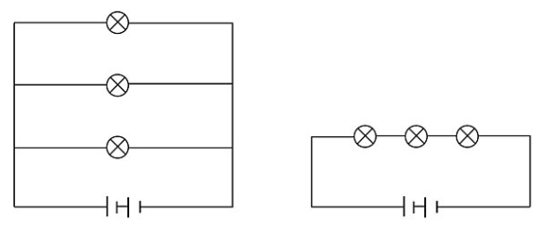

Five key ideas | We use symbols to represent circuit components rather than drawings of what the components look like, this is to keep the diagram simple, for example;  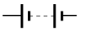  Battery  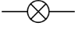  Bulb  Resistor | When components are connected in a single loop of wire, we call it a series circuit.  When components are connected in multiple branches of wires, we call it a parallel circuit.
The total resistance in a series combination is the sum of the individual resistances.  R_{T} = R₁ + R₂ + R₃ + …  The total resistance in a parallel combination is less than the smallest individual resistance in the combination.  R_{T} < R₁ R_{T} < R₂ R_{T} < R₃ | Current is the same everywhere along a series combination;  I_{T} = I₁ = I₂ = I₃ = …  Current splits among branches of parallel combinations.  The total current flowing into a junction is equal to the total current flowing out of a junction;  I_{T} = I₁ + I₂ + I₃ + … | The total potential difference from the power supply is shared across the components in a series combination;  V_{T} = V₁ + V₂ + V₃ + …  Potential difference on each branch is the same as the total power supply in a parallel combination.  V_{T} = V₁ = V₂ = V₃ = …

Fulford School Science department
Developing the next generation of Super Scientists

GSCE Physics | Topic P2 Electricity - Part 2

Five key terms
Electrical power | The power rating of an appliance is given on the back of the appliance.  Power rating is the rate at which an appliance transfers energy. | Power = Energy  Time
National Grid | The National Grid is the system of cables, transformers and pylons that carry electricity from power stations all across the country | 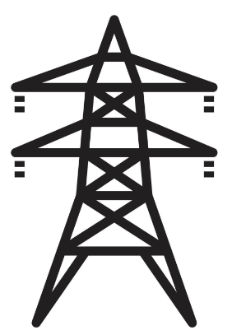
Transformers | The potential difference of an alternating current (a.c.) can be changed using a device called a transformer | 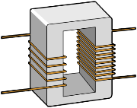
Fuse | Part of a plug that is designed to break under high current as a safety precaution.
Alternating current | AC stands for “Alternating Current” – The current is constantly changing direction. | 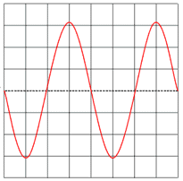

Five key ideas | In electric circuits, the components are being used to transfer energy.  All electrical devices transfer energy from one store to another via an electrical pathway.  Electrical power is the rate at which a component transfers energy, the power rating of an appliance is given on the back of the appliance. | A transformer contains two coils that are wound around a soft iron core  A step-up transformer has more turns on the secondary coil and so increases potential difference.  A step-down transformer has fewer turns on the secondary coil and so decreases potential difference.
Cells and batteries direct current (D.C.) is current which always passes in the same direction. This is supplied by cells and batteries.  An alternating current (A.C.) is one which is constantly changing direction. Mains electricity is an A.C. supply.  In the UK it has a frequency of 50 cycles per second (50 hertz) and a p.d. of about 230 volts. | The National Grid is the system of cables, transformers and pylons that carry electricity from power stations all across the country.  A step-up transformer raises the voltage, but the current doesn’t go up as much.  Current makes wires hot so reducing the current reduces the wasted energy, improving the efficiency of the national grid system.  The step-down transformer reduces the voltage to a safe working level used in our home. | Earth wires create a safe route for the current to flow through if the live wire touches the metal casing of an appliance.  You would get an electric shock if the live wire inside an appliance came loose and touched the metal casing.  The earth terminal is connected to the metal casing so that the current goes through the earth wire instead of causing an electric shock.  A strong current surges through the earth wire because it has a very low resistance. This breaks the fuse and disconnects the appliance.

Fulford School Science department
Developing the next generation of Super Scientists

GSCE Physics | Topic P3 Particle Model of Matter

Five key terms
Density | Density is defined as the mass per unit volume of a material. | 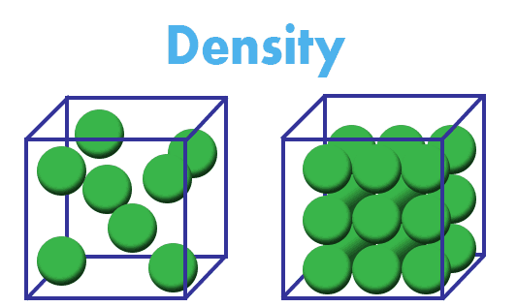
Specific Heat Capacity, c | The specific heat capacity of a substance is the amount of energy required to raise the temperature of 1 kg of a material by 1 °C. | E = m c Δθ
Specific Latent Heat, L | The specific latent heat of a substance is the amount of energy required to change the state of 1 kg of the substance with no change in temperature. | E = m L
Internal energy | The internal energy of a system is the total kinetic energy and potential energy of all the particles in the system.
Gas pressure | Gas pressure is the force exerted by a gas on a specific area. | 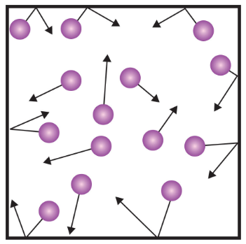

Five key ideas |  | The particles in solids, liquids and gases have kinetic energy because they are always moving. If you increase the temperature, you increase the mean kinetic energy of the particles.  They also have potential energy because their motion keeps them separated. This opposes the forces trying to pull them together. The particles in gases have the most potential energy because they are furthest apart.  The internal energy of a system is the total kinetic energy and potential energy of all the particles in the system. | Particles in a gas move in random directions at all times.  The particles in a gas collide with each other and the walls of their container without losing any of their kinetic energy.  The temperature of the gas is related to the average kinetic energy of the molecules. As the kinetic energy of the molecules increases, so does the temperature of the gas.
Each substance has a value called its specific latent heat, describing how much energy is needed to change state of 1kg of the substance.  When a change of state occurs, any heat energy supplied breaks the bonds between molecules.  No change in temperature occurs during this time. |  | The greater the temperature the greater the average kinetic energy and hence the speed of the particles (Kinetic energy = ½ m v²).  Increased temperature of the gas increases average kinetic energy and increases speed of the particles, which increases the collisions of the particles with the cylinder wall.  There is more force on the container over a certain area and therefore a greater pressure. | 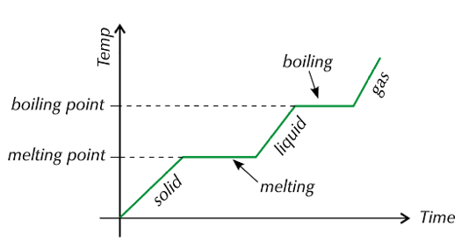
Fulford School Science department
Developing the next generation of Super Scientists

GSCE Physics | Topic P4 Atomic Structure - Part 1

Five key terms
Ion | An ion is formed when an atom either loses or gains an electron. | 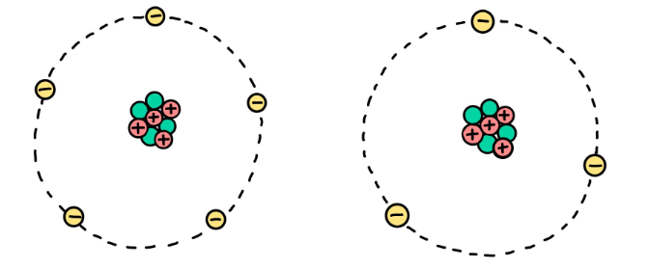
Isotope | Atoms with the same number of protons but a different number of neutrons are called isotopes. | 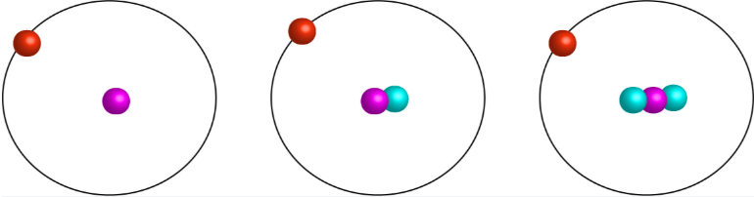
Alpha | 2 protons and 2 neutrons. High ionising power, low penetration.
Beta | A high-energy electron. Medium ionising power, medium penetration.
Gamma | An electromagnetic wave. Low ionising power, high penetration.

Five key ideas | Half-life is the average time it takes for the number of nuclei (and the activity) of a radioactive sample to halve. | 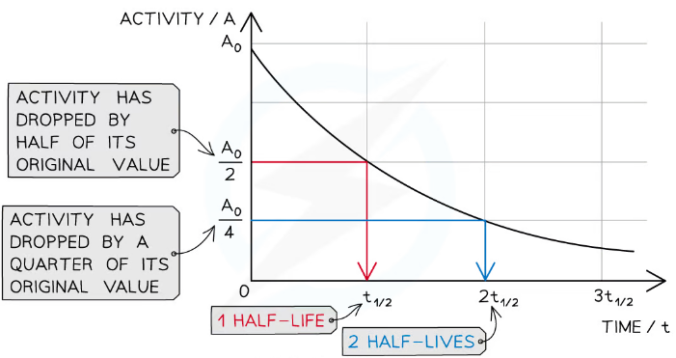
Radioactive elements have an unstable nucleus.  The atoms give off radiation in a random process called radioactive decay.  Activity is the rate at which a source of unstable nuclei decays.  Activity is measured in Becquerels (Bq). | Radiation can ionise cells (electrons get knocked off atoms, leaving ions) which causes cellular damage. | Rutherford fired alpha particles at gold foil and made the following conclusions from his observations;  Observation Conclusion  Most alpha particles went straight through the foil Atoms are mostly empty space  A few were deflected through large angles The nucleus is positively charged, very small compared to the size of the atom and contains most of the mass  Very few were reflected straight back

Fulford School Science department
Developing the next generation of Super Scientists

GSCE Physics | Topic P4 Atomic Structure - Part 2

Five key terms
Background radiation  (PHY only) | Background radiation is the radiation that is around us all the time at a safe level. | 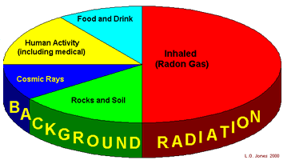
Irradiation | Irradiation is the process of exposing an object to nuclear radiation.  The irradiated object does not become radioactive.
Contamination | Radioactive contamination is the unwanted presence of radioactive atoms on other materials and usually comes from touching or handling radioactive substances. | 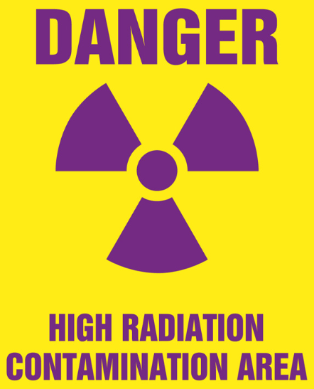
Fission  (PHY only) | Nuclear fission is a reaction where a large unstable nucleus (e.g Uranium or Plutonium) splits into smaller nuclei releasing large amounts of energy. | 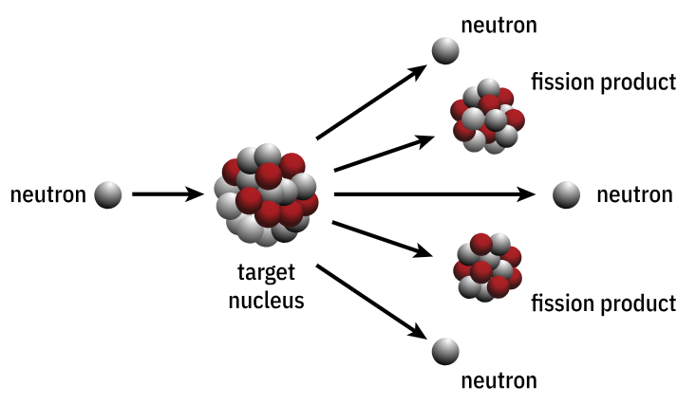
Fusion  (PHY only) | Nuclear fusion is the joining together of two small, light nuclei to create one heavy nucleus, releasing large amounts of energy | 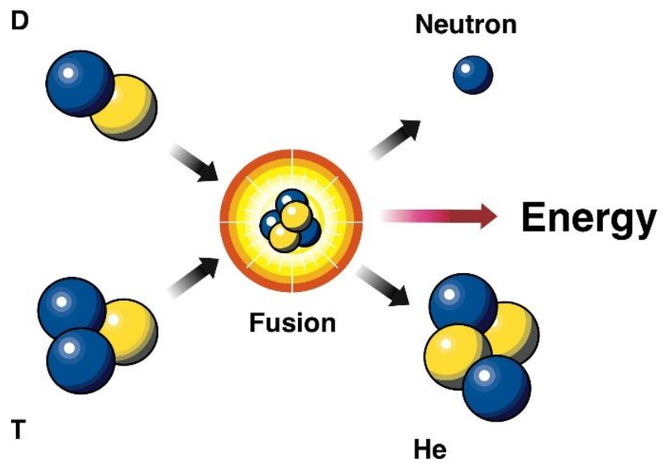

Five key ideas | The risk of contamination can be reduced by avoiding touching the source.  The risk of irradiation can be reduced by increasing distance from the source. | Radiotherapy is the treatment of cancer using ionising radiation. This could be in the form of a gamma source outside the body which would be targeted at a tumour inside the body.  To avoid damaging healthy cells up to 200 different beams of gamma radiation are carefully directed onto the tumour, at the correct dosage, thereby reducing the risk of damaging healthy cells.
Peer-review is where other scientists check results and scientific explanations to make sure the experiments have been done in a sensible way before the results are published.  This helps to prevent false claims being published. The findings are then shared in peer-reviewed journals or at conferences. | Atoms contain huge amounts of energy, and there are two ways in which this energy can be released. Einstein predicted this with his famous equation E=mc²  One way is to split large atomic nuclei in a process called nuclear fission.  Another way is to join smaller nuclei together in a process called nuclear fusion. | When radiation enters living cells it can ionise atoms an molecules within them (removes electrons to form ions). This can lead to tissue damage.  - Lower doses cause minor damage, which doesn’t kill the cells but DNA is often susceptible to damage and mutant cells can then divide uncontrollably – which is cancer.  Higher doses tends to kill the cells completely causing radiation sickness, vomiting, tiredness and hair loss.

