Fulford School Science Department
Developing the next generation of Super Scientists

GCSE Science – Five key terms | Topic B5 Part 1 – Homeostasis & Response

Homeostasis | The regulation of the internal conditions of a cell or organism, to maintain optimum conditions for function, in response to internal and external changes. Optimum conditions maintained for enzyme action. | 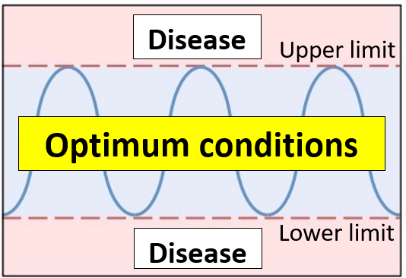
Stimuli | Changes in the (internal or external) environment, which are detected by specialised cells called receptors; many receptors are found in our  sense organs. | 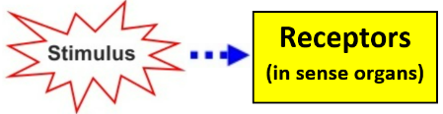  e.g. high blood glucose  e.g. low blood glucose
Effectors | Organs which bring about responses to the original stimulus, restoring optimum conditions in the body. Muscles respond by contracting and glands respond by secreting hormones. | 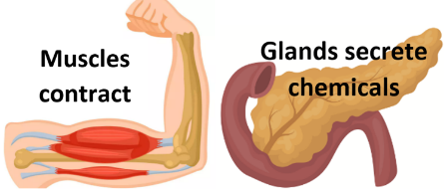
Reflex actions | Automatic and rapid responses, coordinated by the part of the CNS closest to the stimulus; if this is the brain, the conscious part is not involved. Their rapid nature is because only three neurones, hence two synapses, are involved. Many reflexes are protective, preventing tissue damage. | 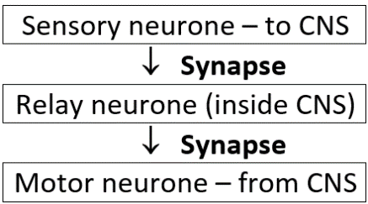
Synapse | A junction between two neurones. The first neurone releases a chemical that diffuses across the synapse and binds to the second neurone; binding causes an electrical nerve impulse in the second neurone. | 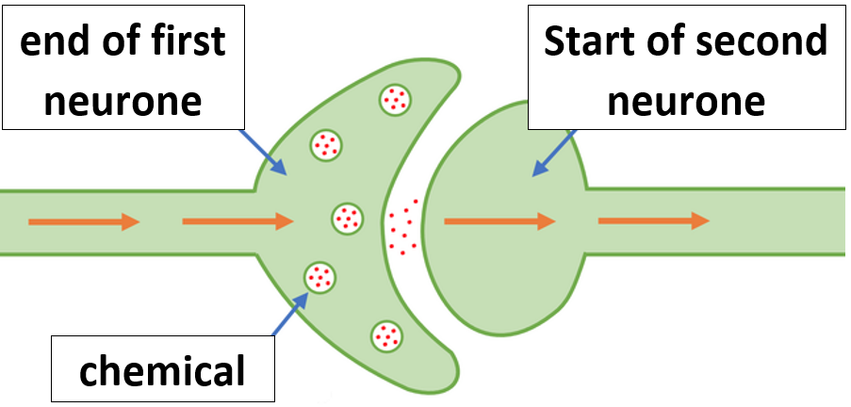

Five key ideas  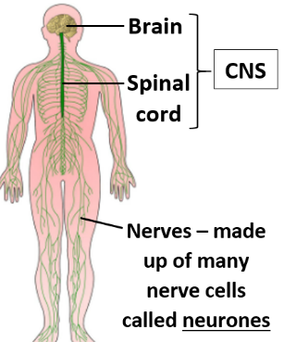  Impulses do not diffuse across synapses |  |  | Coordination sequence  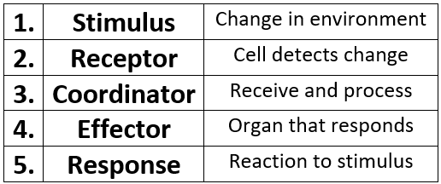 | Automatic control systems involve nervous and chemical responses |  | 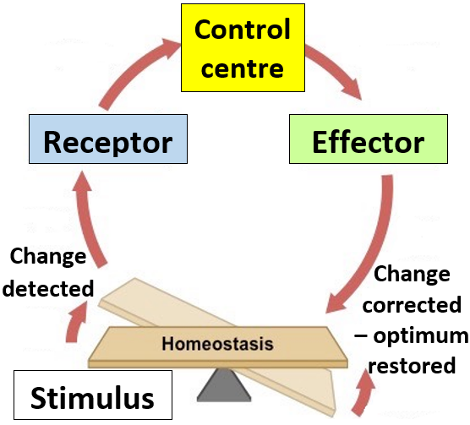
 |  |  | Reflex arc – arrangement of neurones that coordinate reflexes  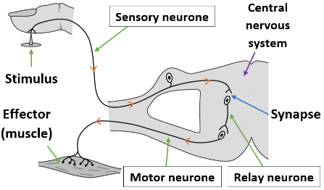 | Information passage from receptor  to effector in the nervous system  rapidly along neurones as  electrical nerve impulses  more slowly by diffusion across  synapses  So, the more neurones involved,  the more synapses present = slower  responses, as in voluntary responses
Fulford School Science Department
Developing the next generation of Super Scientists

GCSE Science – Five key terms | Topic B5 Part 2 – Homeostasis & Response

Hormone | Chemical messenger secreted by an endocrine gland, transported through the bloodstream to a target organ, where it produces an effect. | 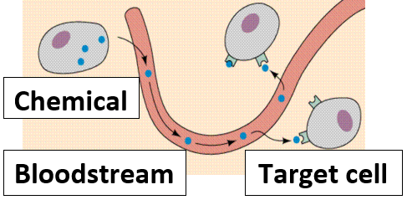
Pituitary gland | Master gland (at the base of the brain) that secretes several hormones into the blood, which act on other endocrine glands to stimulate their hormones to be released and bring about effects. | 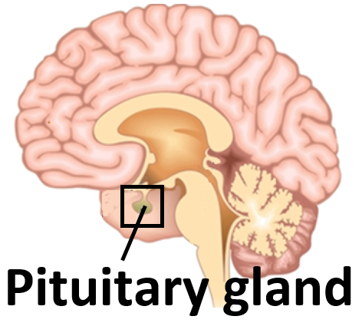
Diabetes | Disease resulting in high blood glucose levels, which a patient can’t naturally control within optimum range. Insufficient insulin is produced in type 1 and can be controlled with insulin injections. Cells have stopped responding to insulin in type 2, which is treated by a carbohydrate controlled diet and more exercise. | 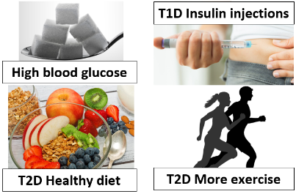
Menstrual cycle | Monthly cycle of events in the female reproductive system, coordinated by FSH, LH (from pituitary), oestrogen and progesterone (from ovaries). Includes loss and build up of uterus lining and maturation of an egg; ovulation (release of mature egg) occurs half way through the cycle (e.g. day 14 of a 28 day cycle) | 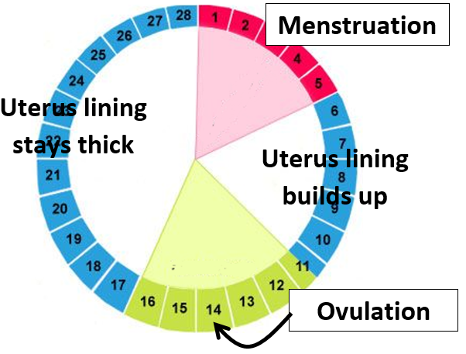
Negative feedback | (HT) Control mechanism that reverses the effect of the original stimulus; if a condition changes, responses return it to the optimum level. E.g. thyroxine (stimulates the basal metabolic rate and growth), is controlled this way. | 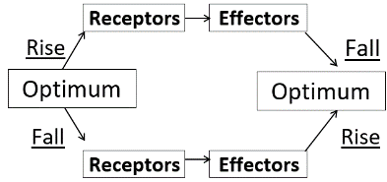

Five key ideas  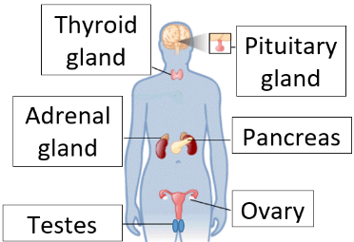  Effects of the endocrine system are slower, but  act for longer than nervous system | 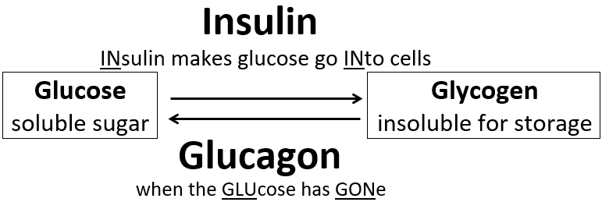  Pancreas monitors and controls blood glucose | In vitro fertilisation (HT)  - FSH and LH given to mother – eggs mature in ovaries  - Eggs collected  - Eggs fertilised in lab by sperm from father  - Fertilised eggs develop into embryos – monitored using microscopy and may be genetically tested  - One or two are inserted into mother’s uterus for development
 | 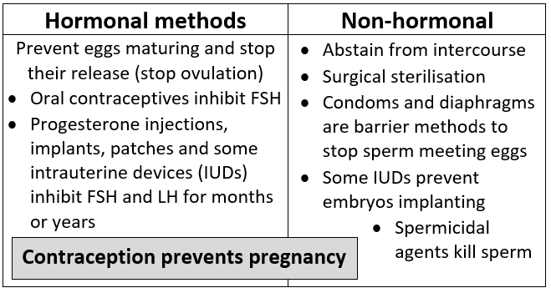

Fulford School Science Department
Developing the next generation of Super Scientists

GCSE Science – Five key terms | Topic B5 Part 3 – Separate award only
Not the same
Accommodation | Reflex that adjusts the shape of the lens to focus light onto the retina, from distant or near objects – describe roles of ciliary muscles (and their diameter around the lens) and suspensory ligaments, with change in lens shape and its degree of refraction. | 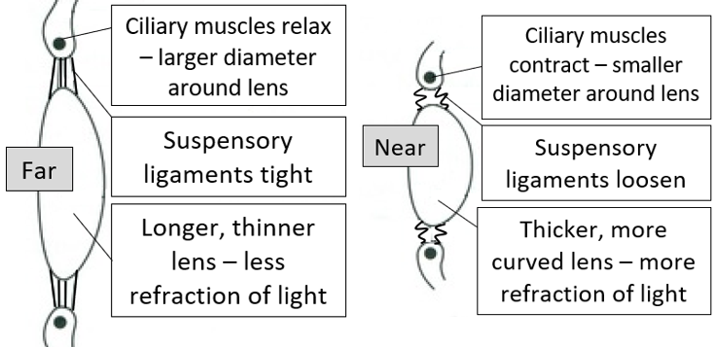
Pupil reflex  not ciliary muscles or suspensory ligaments | This is not the same as accommodation –The diameter of the pupil adapts to light intensity, to ensure sufficient light stimulates receptors in retina. Inner circular and outer radial muscles of the iris are antagonistic, with opposing effects. | 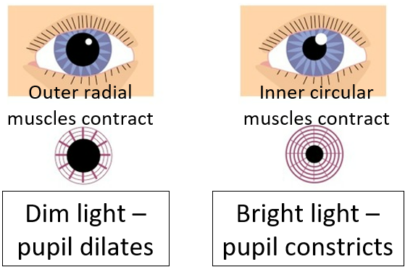
Deamination | Excess amino acids from protein digestion need to be excreted. These amino acids are deaminated to form ammonia in the liver. Ammonia is toxic and converted to urea for safe excretion by the kidneys. | 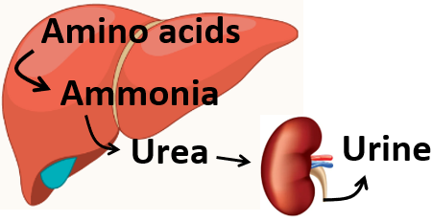
Filtration | Kidneys filter blood under high pressure (red blood cells and proteins remain in capillaries), before selectively reabsorbing all of the glucose, some ions and some water, making urine. ADH from pituitary, causes more water be reabsorbed into blood. | 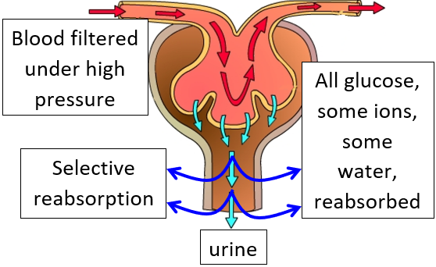
Auxin | Plant hormone made in tip of shoots (where it stimulates growth) and tip of roots (where it inhibits growth). Unequal distributions of auxin cause unequal growth rates in shoots and roots.  Ethene and gibberellins are also plant hormones. | 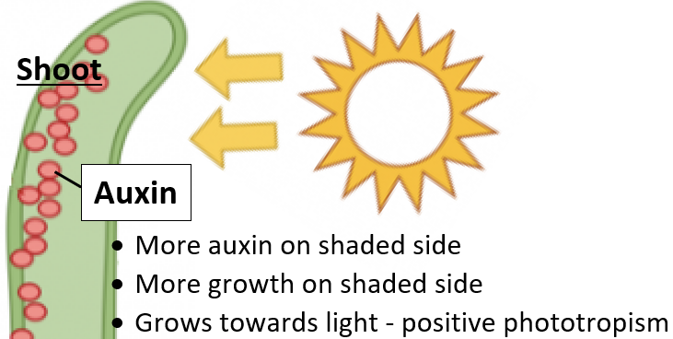

Five key ideas  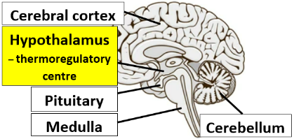  Brain – billions of interconnected neurones  Brain has been mapped by studying brain-damaged patients, electrically stimulating different parts and using MRI scans |  |  | Thermoregulatory centre in hypothalamus of brain - temperature control  Receptors (skin and brain) detect temperature change – responses include:  - Vadodilation – muscles in small arteries relax - more blood flows through skin capillaries - more heat loss by radiation and evaporation of sweat.  - Vasoconstriction – muscles in small arteries contract - less blood flows through skin capillaries - less heat lost by radiation - heat retained in body.
 |  |  | 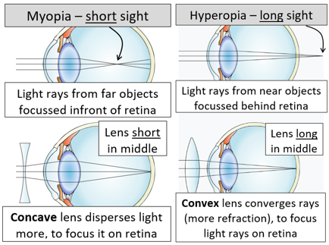 | Plant hormones coordinate  plant growth responses:  - Phototropisms  - Gravitropisms / geotropisms  - Hydrotropisms
Uses of plant hormones
- Auxins – selective weedkillers
- Gibberellins – seed germination
- Ethene – fruit ripening
Fulford School Science Department
Developing the next generation of Super Scientists

GCSE Science – Five key terms | Topic B6 Part 1 - Inheritance

Meiosis | Cell division in reproductive organs to form gametes. After DNA is copied, a cell divides twice to form four gametes, each with half the species’ chromosome number; all gametes are genetically different. Fertilisation restores chromosome number when the nuclei of male and female gametes fuse together. | 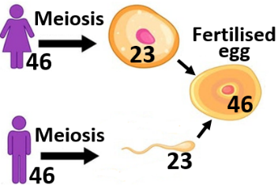
Gene | A small section of DNA on a chromosome. Each codes for a particular sequence of amino acids, to make a specific protein. Genes and chromosomes are made of DNA – a two-stranded polymer called the double helix. | Small  Larger | Gene  Chromosome  Nucleus  Cell
Alleles | Different forms of a gene. The two alleles present for a gene are called the genotype, whereas the visible characteristic that develops is called the phenotype. | 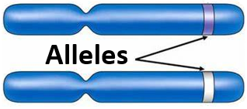
Dominant | The allele that is always expressed, even if  only one copy is present.  The dominant allele is shown by a capital letter. | 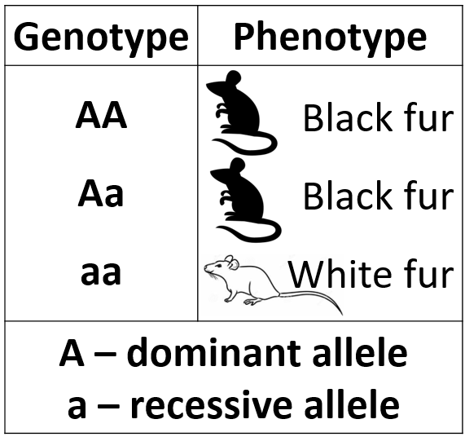
Recessive | The allele is only expressed if two copies are present; one copy is inherited from each parent.  The recessive allele is shown by a lower case letter.

Five key ideas  Human  genome studies  - Search for genes linked to disease  - Understanding and treatment of inherited disorders  - Trace human migration patterns.  - Pair 23 of human genome controls the inheritance of sex (XX female /XY male) |  |  | Types of reproduction |  | Genetic cross example
 |  |  | Sexual – mixing of genetic info. when male and female gametes fuse; leads to variation in offspring | Asexual – no mixing of genetic info., one parent, no gamete fusion; forms genetically identical clones. | 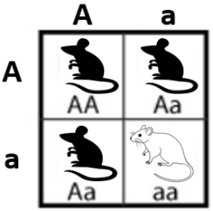  Punnett |  | Square  75%  black  25%  white
 |  |  | Two alleles are inherited for each gene |  | Inherited disorders  - Polydactyly (extra fingers or toes) – dominant allele.  - Cystic fibrosis (cell membrane disorder causing thick mucus) – recessive allele.
 |  |  | Homozygous – two alleles for a trait are the same:  - AA (homozygous dominant) or  - aa (homozygous recessive) | Heterozygous – two alleles for a trait are different:  Aa - the dominant  allele will be  expressed
Fulford School Science Department
Developing the next generation of Super Scientists

GCSE Science – Five key terms | Topic B6 Part 2 – Variation & evolution

Variation | Differences in characteristics of individuals in a population, due to genetic causes, environmental causes, as well as a combination of the two. The interaction of the genome and environment influences the development of a phenotype. | 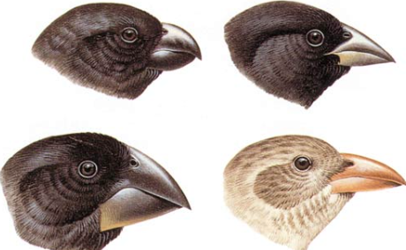
Mutations | Changes in DNA that occur continuously. All genetic variants arise from mutations (most have no effect on the phenotype); very rarely a mutation leads to a new phenotype, which is better suited to the environment. | 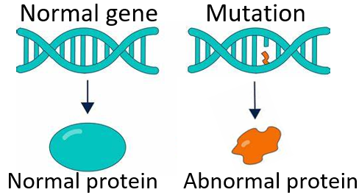
Evolution | Change in the inherited characteristics of a population over time, through a process of natural selection. All species have evolved from simple life forms that first developed more than three billion years ago. Charles Darwin proposed this theory. | 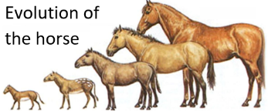
Selective breeding | Humans breed plants and animals for particular genetic characteristics, over many generations. Parents with desired characteristics (usefulness or appearance) are bred together, before their offspring with desired characteristics are bred together. Selective breeding can lead to inbreeding, where some breeds are prone to disease or inherited defects. | 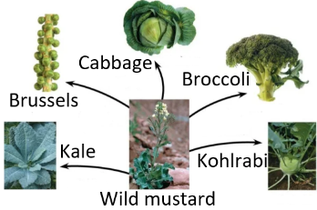
Genetic engineering | Modifying the genome of an organism by introducing a gene from another organism to give a desired characteristic, e.g. disease-resistant plants and insulin-producing bacteria.  (HT) Enzymes are used to ‘cut-out’ genes from DNA and insert into a vector, which carries the gene into the required cell. | 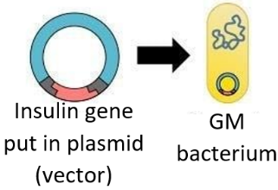

Five key ideas  New species  If two populations of one species become so different in phenotype that they can  no longer interbreed to produce fertile offspring, they have formed a new species. | Evidence for evolution  - Fossils – remains of organisms from millions of years ago, found in rocks (show how life has developed on Earth).  - Resistant bacteria e.g. MRSA – resistant strains (arising by mutation) are not killed by antibiotics, survive and reproduce, so a population of the resistant strain arises. | Characteristics chosen for selective breeding  - Disease resistance in food crops  - Animals that produce more meat or milk  - Gentle natured dogs  - Large/unusual flowers
 | Organisms are classified into groups  - Carl Linnaeus: Kingdom – Phylum – Class – Order – Family – Genus – Species.  - Carl Woese’s three-domain system: archaea (primitive bacteria, including extremophiles), bacteria and eukaryotes. | Extinction  There are no remaining individuals of a species still alive, e.g. caused by loss of habitat.

Fulford School Science Department
Developing the next generation of Super Scientists

GCSE Science – Five key terms | Topic B6 Part 3 – Separate Biology only

Nucleotide | Monomer of the polymer DNA, consisting of a phosphate group and a common sugar, which has one of four different bases attached. The two complementary strands of DNA are joined by pairs of bases; C links to G and A links to T.  A sequence of 3 bases is the code for a particular amino acid. | 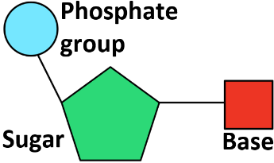
Non-coding DNA | Not all parts of DNA code for proteins. Non-coding parts can switch genes on and off, so variations in these areas of DNA may affect how genes are expressed. | 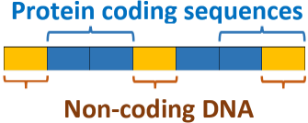
Embryo transplants | Splitting apart cells from a developing animal embryo before they become specialised, then transplanting the identical embryos into the uterus of host mothers. This is an example of cloning; producing genetically identical organisms through asexual reproduction, which involves mitosis. | 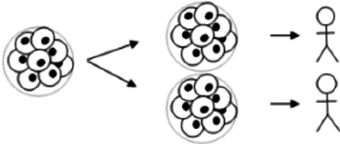
Adult cell cloning | A nucleus from an adult body cell is inserted into an enucleated, unfertilised egg cell, before electric shocks stimulate it to form an embryo. The embryo is inserted into the uterus of an adult female to continue its development. | 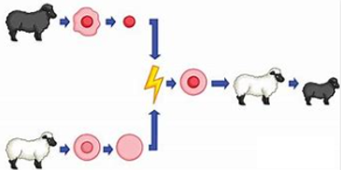
Speciation | New species arise from pre-existing ones after two populations are separated, e.g. by a geographical barrier. In different environments, natural selection occurs in each population over a period of time. If re-united, organisms are no longer able to breed to produce fertile offspring. | 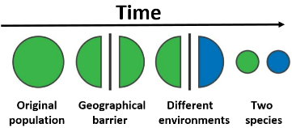

Five key ideas  Gregor Mendel  Plant breeding experiments  (mid-19th century) revealed that the inheritance of each characteristic is determined by ‘units’ (now called genes) that are passed on the offspring unchanged. |  | Cloning in plants |  | Darwin and Wallace  In 1858 joint writings by Darwin and Wallace were published, before Darwin’s On the Origin of Species in 1859. Wallace is best known for his work on warning colouration in animals and his theory of speciation.
 |  | Tissue culture uses small groups of cells from part of a plant to grow identical new plants. Used to preserve rare species or commercially. | Taking cuttings from plants with useful characteristics produces many identical new plants from a parent plant. Water loss must be reduced until roots have grown.
 |  | Protein synthesis  The order of bases on DNA controls the order that amino acids are assembled, to make a particular protein. Carrier molecules bring specific amino acids to ribosomes in the correct order, to add to the growing protein chain. A change in DNA may result in a change in the protein synthesised by a gene. |  | Gradual acceptance for theory of evolution  - Challenged idea that God made all life on Earth  - Insufficient evidence present at the time  - Mechanism of inheritance was not known at the time
Fulford School Science Department
Developing the next generation of Super Scientists

GCSE Science – Five key terms | Topic B7 Part 1 – Ecosystems

Ecosystem | The interaction of a community of living organisms (biotic) with the non-living (abiotic) parts of their environment. | Biotic + Abiotic
Population | All of the organisms of the same species living in a habitat at the same time. Animals in a population often compete with each other for food, mates and territory. Plants often compete for light, space, water and soil minerals. | 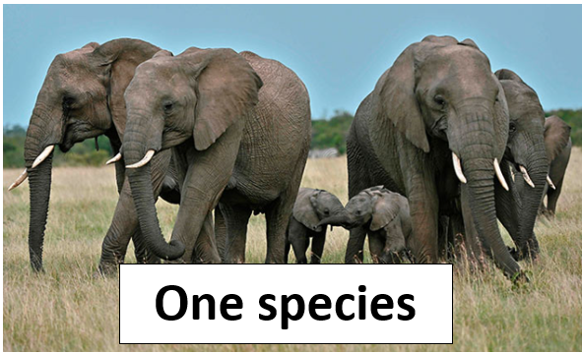
Community | All of the organisms of all of the different species living in a habitat at the same time. A stable community is one where all the species and environmental factors are in balance so that population sizes remain fairly constant. | 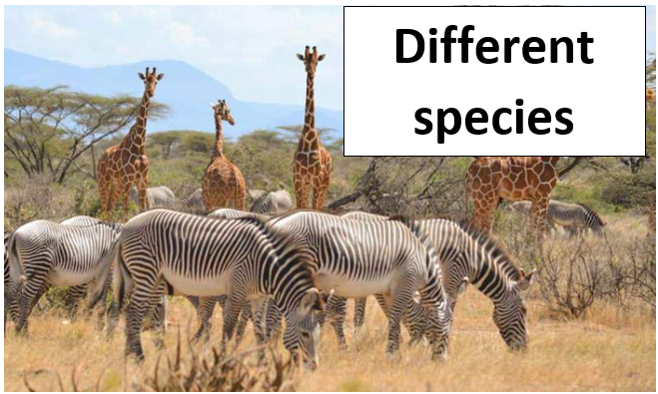
Food chain | Show feeding relationships in a community, with an arrow pointing away from the organism being eaten. All food chains start with producers; plants or algae make glucose by photosynthesis so are the producers of biomass for life on Earth. Producers are eaten by primary consumers, which are eaten by secondary then tertiary consumers. | 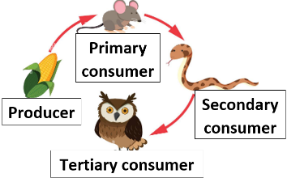
Adaptation | Features that enable organisms to survive in the conditions in which they normally live. These may be structural, behavioural or functional. Extremophiles have adaptations that allow them to live in extreme environments. | 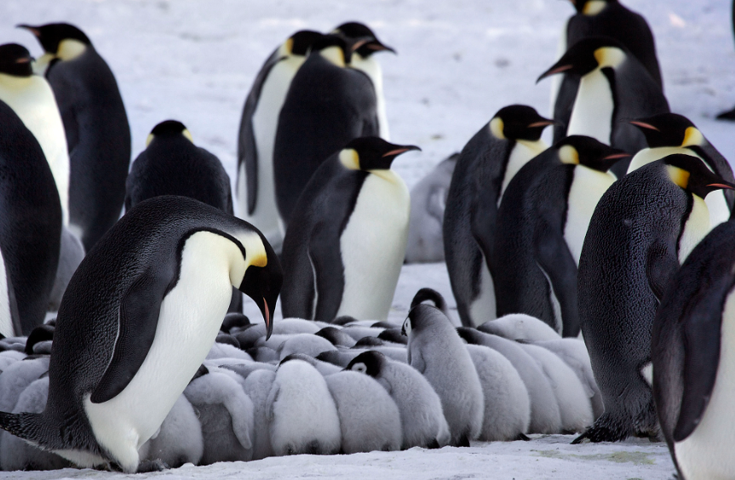

Five key ideas  Sampling  It is difficult to investigate all factors in an ecosystem, so representative samples are taken.  - Random samples remove bias when studying species abundance  - Systematic sampling assesses distribution of a species |  | Factors in ecosystems  Biotic (FOPP)  - Food  - Outcompeting other species  - Predators  - Pathogens | Abiotic (SITCOMM)  - Soil pH  - Intensity of light  - Temperature  - CO₂ levels (plants)  - O₂ levels (aquatic)  - Moisture levels  - Minerals (soil) | Interdependence  Within a community each species depends on other species for food, shelter, pollination, seed dispersal etc. If a species is removed it can affect the whole community.
 |  | Cycling - To survive and reproduce, organisms require a supply of materials from their environment. Materials are recycled to provide the building blocks for organisms. |  | Microorganisms  Bacteria and fungi are decomposers which play a vital role in cycling materials through an ecosystem by returning:  - Carbon to the atmosphere as CO₂  - Mineral ions to the soil
 |  | Water is continuously evaporated and precipitated in the water cycle. | Respiration returns carbon to the atmosphere as CO₂, before it is used by plants in photosynthesis during the carbon cycle.
Fulford School Science Department
Developing the next generation of Super Scientists

GCSE Science – Five key terms | Topic B7 Part 2 – Biodiversity

Biodiversity | The variety of all the different species of organisms on Earth, or within an ecosystem. High biodiversity ensures the stability of ecosystems by reducing the dependence of one species on another species for food and shelter.  Many human activities are reducing biodiversity. | 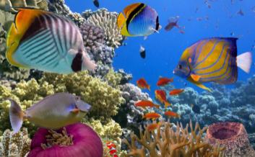
Deforestation | The large scale removal of trees (especially in tropical areas), which occurs to provide land for cattle and rice fields, or to grow crops for biofuels. | 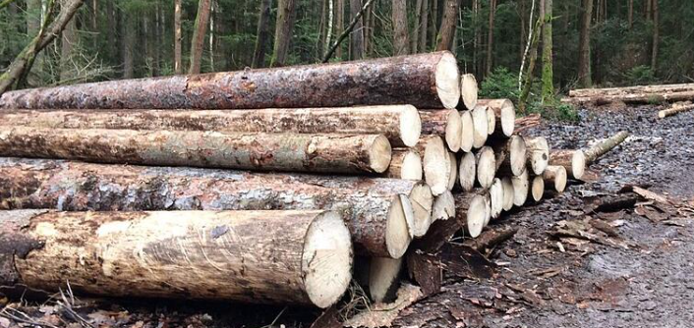
Global warming | The average global temperature of the Earth and its atmosphere is increasing, due to increasing levels of atmospheric CO₂ and methane (which absorb thermal energy that would normally radiate back into space). | 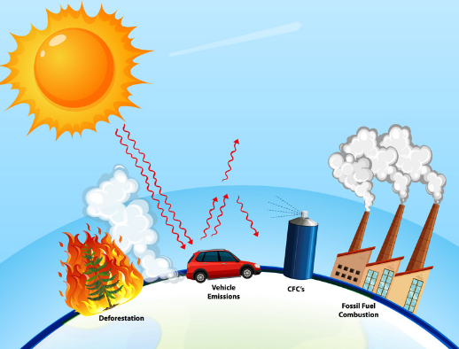
Peat bogs | Ground containing partially decayed plant matter called peat, which stores chemical energy. Decay of unearthed peat, or burning of peat releases carbon dioxide into the atmosphere. Destruction of peat bogs reduces the area of this unique habitat, decreasing biodiversity. | 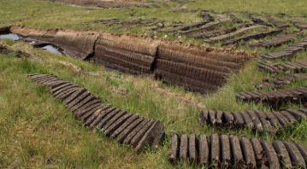
Pollution | The introduction of harmful materials into the environment (these can be new materials or excess materials already present). Pollution kills plants and animals, which can reduce biodiversity. | 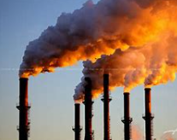

Five key  ideas  Sources of pollution  - From sewage, fertiliser or toxic chemicals in water  - From smoke and acidic gases in air  - From landfill and from toxic chemicals on land  Pollution levels are rising due to the rapid growth of the human population. |  | Biological consequences of global warming  - Rising sea levels due to melting polar ice caps, causing flooding and habitat loss  - Changes in migration patterns due to temperature changes and food shortages  - Changes in species distribution  - Extinction of species unable to survive climate change, reducing biodiversity | High biodiversity  - Many successful species  - Many interactions  - Complex community  - Variety of food  - Less susceptible to climatic change  - More stable ecosystem
 |  | Maintaining biodiversity  - Breeding programmes for endangered species  - Protection / regeneration of rare habitats  - Reintroduction of field margins and hedges where farmers grow one crop  - Reduce deforestation and CO₂ emissions  - Recycling resources instead of landfill | Land use - Humans reduce the land available for other species by:  - Building and quarrying  - Farming  - Dumping waste  - Deforestation  - Destruction of peat bogs
Fulford School Science Department
Developing the next generation of Super Scientists

GCSE Science – Five key terms | Topic B7 Part 3 – Separate Award only

Decomposition  (also called decay) | Breaking down of waste biological material, by bacteria and fungi, which secrete enzymes onto the matter to break it down, before soluble molecules are absorbed by diffusion. Temperature, water and O₂ levels affect rate of decay; gardeners provide optimum conditions for rapid decay. | 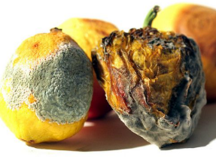
Biogas | Flammable mixture of gases, including methane – this gas is produced by the anaerobic decay of biological waste. Animal or plant matter are added to a biogas generator and the methane produced can be used as a fuel. | 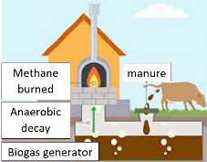
Pyramids of biomass | Symmetrical graph to show amount of biomass (dry mass of organisms) in each trophic level of a food chain; producers are at the base of the pyramid. The length of each box  (x-axis) represents biomass. (Can be ‘inverted’ if producer population has declined at the time of sampling). | 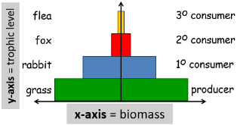  Always add labels
Food security | Having enough food to feed a population. Threatened by rising birth rate, changing diets, new pests and pathogens, changing climate, cost of agricultural inputs and human conflict. Sustainable methods must be found to feed everyone – food must be available, affordable and useable. | 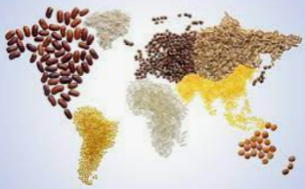
Sustainable fishing | Fish populations do not decline over time because fish stocks remain at a level where breeding continues and the habitat is favourable for survival. Fishing quotas and control of net size are important to conserve fish stocks. | 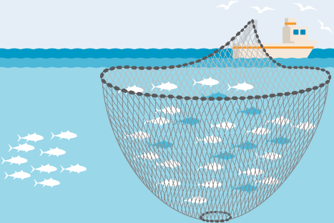

Five key  ideas  Trophic levels  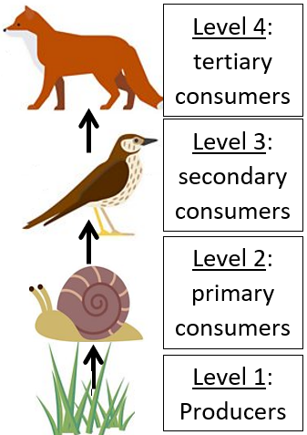 | Biomass is lost between trophic levels  Producers only transfer 1% of the light energy into glucose during photosynthesis. About 90% of biomass from each level is lost to the environment:  - Not all ingested material is absorbed, so energy is lost from a food chain in faeces and urine (decomposers break down this waste)  - Respiration is exothermic so heat energy is lost to the environment at each trophic level | Farming techniques  Energy losses from food chains are reduced by:  - Limit movement -keep animals in cages  - Control temperature  - Feed high protein diet, so more growth and less waste
 | Biotechnology and agricultural solutions  - Fusarium fungus (aerobic) used to make vegetarian protein-rich mycoprotein  - GM bacteria produce human insulin, which is harvested and purified to treat type 1 diabetes  - GM crops could provide food with improved nutritional value, e.g. golden rice could help combat Vitamin A deficiency in some countries | Impact of environmental change  Species’ distribution is affected by changes to  - Temperature  - Water availability  - Atmospheric gases

