 | Fulford School Science Department  Developing the next generation of Super Scientists | 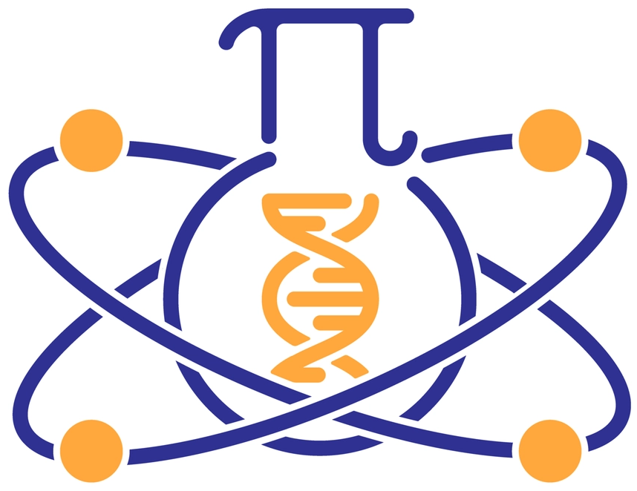

GCSE Science – Five key terms | Topic B1 Part 1 - Cell Biology

Eukaryotic cell | Large, complex cells (including animal and plant cells) with a cell membrane, cytoplasm and genetic material enclosed in a nucleus. | Nucleus Nucleus  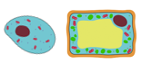
Prokaryotic cell | Small, simple cells (including bacteria) with cytoplasm and a cell membrane surrounded by a cell wall. Their genetic material (a single DNA loop) is not enclosed in a nucleus. They may have small rings of DNA called plasmids. | No nucleus  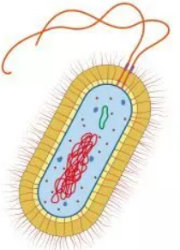
Differentiation | A cell acquires different sub-cellular structures to allow it to perform a certain function. (Differentiation results in the development of specialised cells). | 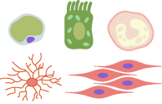
Electron microscope | A microscope which uses an electron beam (instead of light) to study cells in much finer detail. They have a much higher magnification and resolving power than a light microscope. | 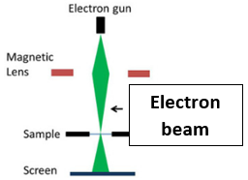
Resolution / resolving power (of a microscope) | The ability to see clear detail by distinguishing between two close points on an image. | 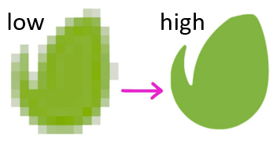

Five key ideas  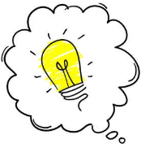  All cells contain DNA, a cell membrane (controls movement of substances) and ribosomes (for protein synthesis) | Sub-cellular structures are ‘parts inside a cell’. Sub-cellular structures in animal cells include the nucleus, cytoplasm, cell membrane, mitochondria and ribosomes. Plant cells also have a cellulose cell wall, permanent vacuole and some have chloroplasts. |  | Specialised cells in animals include sperm, nerve and muscle cells. In plants, these include root hair cells, xylem and phloem cells.
 | Magnification = | size of image_  size of real object | Microscopy techniques have developed over time, increasing our understanding of sub-cellular structures.

Fulford School Science Department
Developing the next generation of Super Scientists

GCSE Science – Five key terms | Topic B1 Part 2 - Cell Biology

Mitosis | One copy of each chromosome (a chromatid) is pulled to each end of the cell and the nucleus divides. This is followed by the cytoplasm and cell membrane dividing to form two genetically identical cells. | 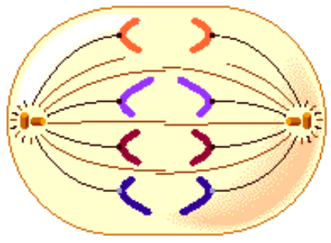
Stem cell | An undifferentiated cell of an organism, which is capable of giving rise to many more cells of the same type, and from which certain other cells can arise from differentiation. | 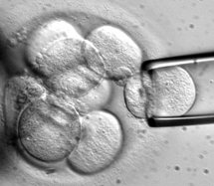
Diffusion | The net movement of particles (of any substance in solution, or particles of a gas) from an area of higher concentration to an area of lower concentration. Diffusion occurs down a concentration gradient. | 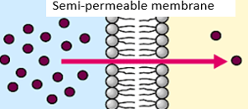
Osmosis | The diffusion of water molecules from a dilute solution to a concentrated solution, through a partially permeable membrane. | 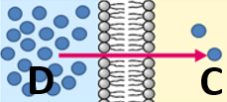
Active transport | Particles move from a dilute solution (lower concentration of particles) to a more concentrated solution (higher concentration of particles), through a partially permeable membrane. Particles move against a concentration gradient - this needs energy from respiration. | 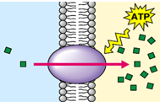

Five key ideas  All cells contain DNA, a cell membrane (which controls the movement of substances) and ribosomes (for making proteins) |  |  | Before a cell can divide (during interphase) it replicates its DNA to form two copies of each chromosome (the copies are called chromatids). The cell also needs to grow and increase the number of sub-cellular structures, e.g. mitochondria and ribosomes. These events happen during the cell cycle, before mitosis. | Stem cells from human embryos (‘embryonic stem cells’) can be cloned and made to differentiate into different types of human cells. Stem cells from adult bone marrow (‘adult stem cells’) can only form different blood cells.
 |  |  | The rate of diffusion is faster if there is:  - a steeper concentration gradient;  - a higher temperature;  - a larger surface area;  - a short diffusion pathway | Exchange surfaces (e.g. alveoli in the lungs and villi in the small intestine) have large surface areas, short diffusion pathways and rich blood supplies.
Fulford School Science Department
Developing the next generation of Super Scientists

GCSE Science – Five key terms | Topic B2 Part 1 - Organisation

Enzyme | A biological catalyst that controls the rate of a chemical reaction inside a cell. Enzymes have an active site with a unique shape so that it can bind to a specific substrate molecule. | 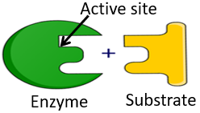
Denature | The shape of the active site of an enzyme has changed so that the enzyme no longer functions, because it can’t bind to its substrate. | 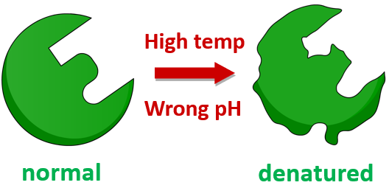
Carbohydrase | Carbohydrases digest (break down) carbohydrates into simple sugars. Amylase is a carbohydrase which digests starch. Carbohydrases work in the mouth and small intestine. | 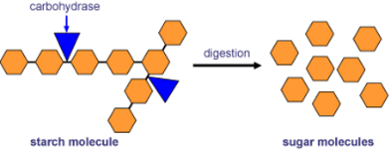
Protease | Proteases digest (break down) proteins into amino acids. Proteases work in the stomach and small intestine. | 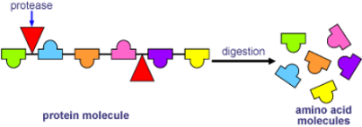
Lipase | Lipases digest (break down) lipids (fats) into one glycerol and three fatty acids.  Lipases work in the small intestine. | 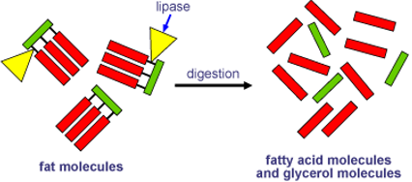

Five key ideas  The digestive system is an example of an organ system in which several organs work together to digest and absorb food |  |  | Temperature affects enzyme-controlled reactions. The optimum (best) temperature for human enzymes is 37^{O}C.  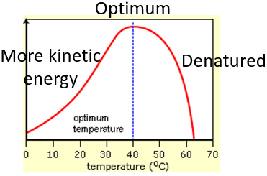 | pH affects enzyme-controlled reactions. Low pH (acidic) and high pH (alkaline) can denature enzymes.  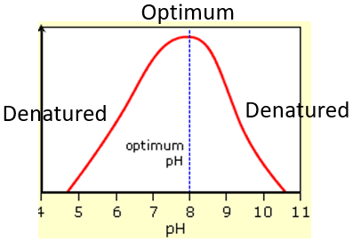
 |  |  | Colour changes in food tests:  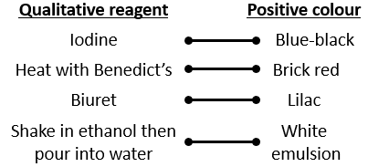 | Lock and key theory:  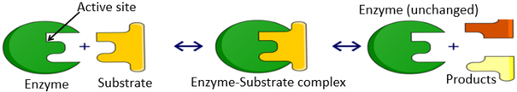  The shape of the active site mirrors the shape of the substrate, so the two can bind together; the two are complementary.
Fulford School Science Department
Developing the next generation of Super Scientists

GCSE Science – Five key terms | Topic B2 Part 2 - Organisation

Blood | Blood is a tissue made up of plasma, which carries red blood cells (for oxygen transport), white blood cells (to kill pathogens) and platelets (for blood clotting). | 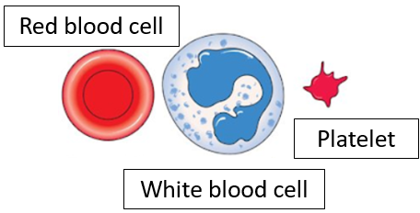
Double circulatory system | Blood passes through the heart twice; the right ventricle pumps blood to the lungs (for gas exchange) and the left ventricle pumps blood around the rest of the body. | 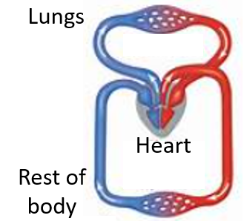
Coronary heart disease (CHD) | In CHD layers of fatty material build up inside the coronary arteries, narrowing them. This reduces blood flow through the coronary arteries, so less oxygen reaches heart muscle cells for respiration. | 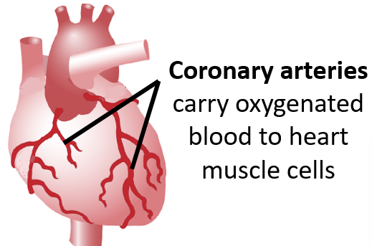
Cancer | Cancer results from changes in cells that lead to uncontrolled growth and division (by mitosis).  DNA mutations may cause cancer. | 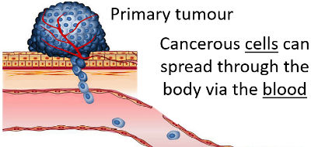
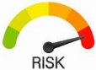  Risk factors | These increase the chances of developing a disease. There is enough evidence to show that some risk factors cause certain diseases (causal mechanism), e.g. smoking increases the chance of developing lung cancer | 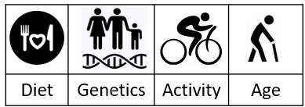

Five key ideas  Valves in the circulatory system stop blood flowing backwards. Valves are found in veins and inside the heart. | Heart structure  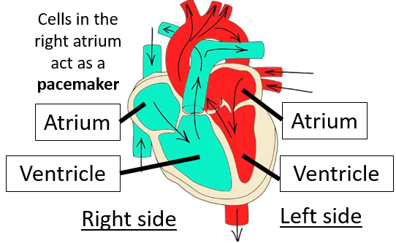 | Tumours are masses of abnormal cells. Benign tumours stay in one area and do not invade other parts of the body. Malignant tumours are cancers – their cells can spread to different parts of the body via the blood.
 | Blood vessels. Arteries carry blood away from the heart. Veins carry blood towards the heart. Exchanges happen in the semi-permeable capillaries. Blood vessels associated with the heart are the aorta, vena cava, pulmonary artery and pulmonary vein. | Health is the state of physical and mental well-being. Diseases, both communicable (can spread) and non-communicable (can’t spread), are major causes of ill health.

Fulford School Science Department
Developing the next generation of Super Scientists

GCSE Science – Five key terms | Topic B2 Part 3 - Organisation

Tissue | A group of cells with a  similar structure and function. | 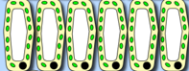
Palisade mesophyll | Cells near the top of a leaf, which contain many chloroplasts; these are below the transparent epidermis and absorb most of the light energy that falls on a leaf, hence do most photosynthesis. | 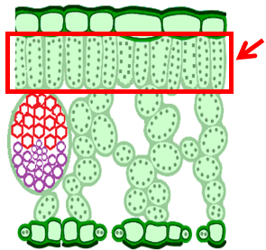
Xylem | Transports water and mineral ions from the roots to the stems and leaves. Xylem vessels are hollow tubes strengthened by lignin, which are adapted for the transport of water in the transpiration stream. | 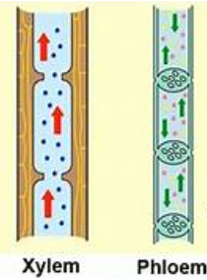
Phloem | Transports dissolved sugars from the leaves to the rest of the plant (up or down), a movement called translocation. Cell sap can move from one phloem cell to the next through pores in the end walls.
Stomata | Pores found on the bottom of leaves where gas exchange occurs with the atmosphere.  Stomata and surrounding guard cells control  gas exchange and water loss. | 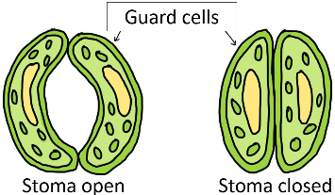

Five key ideas  Transpiration speeds up if it is:  - warmer  - sunnier  - less humid  - windy  Its rate can be measured with a potometer | Transpiration stream: one-way movement of water from the roots to the leaves, through xylem vessels in the stem | 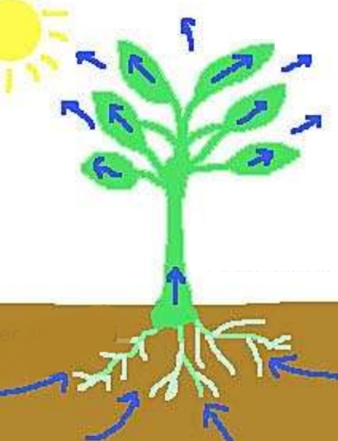 | 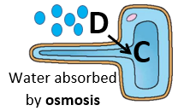
 | Leaf structure  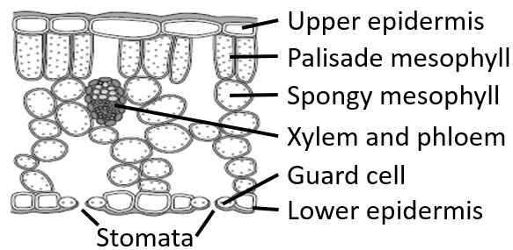 |  | 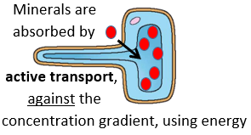

Fulford School Science Department
Developing the next generation of Super Scientists

GCSE Science – Five key terms | Topic B3 Part 1 – Infection and Response

Pathogen | Microorganisms that cause infectious (communicable) disease and reproduce rapidly inside the body. Pathogens can be viruses, bacteria, protists or fungi (spread by direct contact, water or air). | 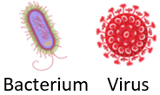
White blood cell | Cells that help defend against pathogens by phagocytosis (engulf and digest pathogens), antibody production and antitoxin production. | 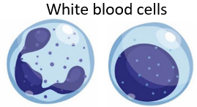
Antibody | A protein made by some white blood cells that destroys specific pathogens.  (Antibodies have a unique shape so they can bind to specific antigens on the surface of pathogens). | 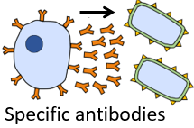
Toxin | Poisons made by bacteria that damage tissues and make us feel ill (give us symptoms of disease) | 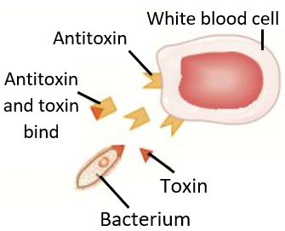
Antitoxin | A protein made by some white blood cells that bind to bacterial toxins, to neutralise their effects. (Antitoxins have a unique shape so they can bind to specific toxin molecules and counteract them).

Five key ideas  Non-specific  defence systems  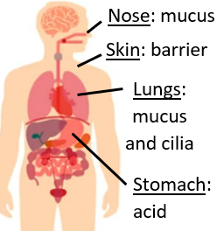 |  |  | 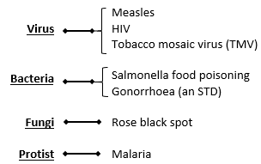 | Viral reproduction  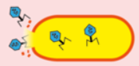  Viruses live and reproduce inside cells, causing cell damage
 |  |  | HIV is a virus that attacks the body’s immune cells (white blood cells).  If AIDS develops, this means the immune system has been so badly damaged by the HIV virus that it can’t deal with other infections or cancers. | Malaria causes recurrent episodes of fever. The malarial protist is spread by mosquito vectors; prevention involves stopping mosquitoes from biting, e.g. sleeping under nets.
Fulford School Science Department
Developing the next generation of Super Scientists

GCSE Science – Five key terms | Topic B3 Part 2 – Infection and Response

Immune | Memory white blood cells are present in the body (from infection or vaccination) and can respond quickly to produce many correct antibodies, killing pathogens and preventing symptoms | 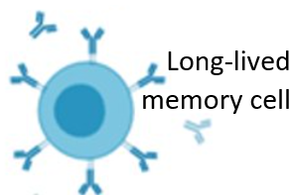
Vaccination | Introducing small quantities of dead or inactive forms of a pathogen into the body to stimulate white blood cells to produce antibodies. Memory white blood cells stay in the body afterwards. | 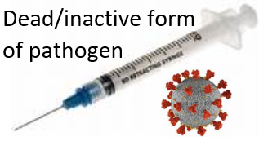
Antibiotics | Medicines that help cure bacterial disease by killing infective bacteria inside the body – it is important that specific bacteria are treated with specific antibiotics. Penicillin was the first discovered. | 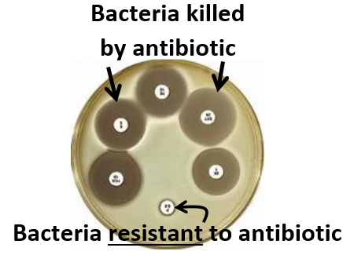
Resistant | A word used to describe bacteria that are not killed by an antibiotic. Note: bacteria can’t be ‘immune’.
Placebo | A fake or dummy drug that is taken in the same way as the new drug being trialled, e.g. tablet or injection with no drug. Used for comparisons to see psychological effect and if the new drug works. | 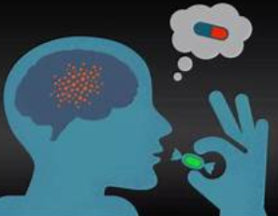

Five key ideas  Double-blind drug trials remove bias, allowing valid data to be collected; neither the patients nor the doctors know who has taken the new drug or a placebo. |  |  | Initial stages of drug trials are preclinical (before used in humans); these tests are done in a lab using cells, tissues and live animals. Clinical trials use healthy volunteers first, then patients. At the start of clinical trials very low doses are used, before optimum is found. | New medical drugs are tested to check they are safe (side effects are recorded) and effective.  Drugs are tested for:  - toxicity,  - efficacy (to see if it works)  - dose  Peer review of the results helps to prevent false claims.
 |  |  | Examples of traditional drug sources:  Drug Source Used for  Digitalis Foxgloves Heart conditions  Aspirin Willow Painkiller  Penicillin Penicillium mould Bacterial infections | Antibiotics and painkillers can both make us feel better:  - Antibiotics kill specific bacteria, relieving symptoms when bacteria numbers and toxins fall.  - Painkillers only treat symptoms but do not kill pathogens.
Fulford School Science Department
Developing the next generation of Super Scientists

GCSE Science – Five key terms | Topic B3 Part 3 – Separate Award only

Antigen  Antigens on pathogens | Protein on the surface of a pathogen that is recognised by white blood cells, triggering an immune response. | 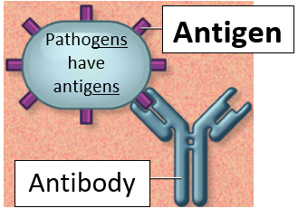
Lymphocyte | Type of white blood cell that produces unique antibodies in response to recognising a specific antigen. The antibodies are complementary to the antigens; binding kills the pathogen.
Monoclonal antibodies  (mABs) | Produced from a single clone of cells. A cell that has been identified to make a specific antibody is cloned to create many cells that all make antibodies with the same unique shape. | 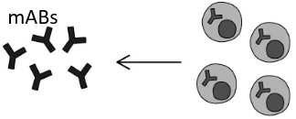
Hybridoma | A cell made from combining a lymphocyte with a tumour cell, which can both divide and make antibodies. | 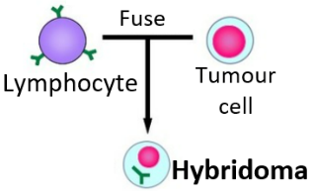
Chlorosis | Magnesium ion deficiency in plants that results in lack of chlorophyll, hence yellow leaves. With less chlorophyll, less light energy is absorbed so the lower rate of photosynthesis results in less glucose being made; ultimately leading to stunted growth. | 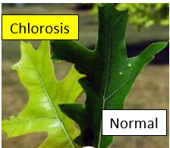

Five key ideas  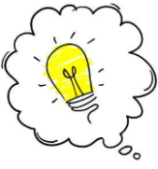  Plant defence responses  - Physical (all plants) e.g. cellulose wall  - Chemical (some plants) e.g. poisons  - Mechanical (some plants) e.g. thorns |  |  | mABs create more side effects than expected, but some uses include:  - Pregnancy tests.  - In labs to measure chemicals in the blood, or to detect pathogens.  - When bound to a fluorescent dye, they can locate or identify specific molecules in cells or tissues.  - When bound to toxic drugs, they can deliver the drug to cancer cells. | Making monoclonal antibodies  - Inject antigen into mouse.  - Remove mouse lymphocytes.  - Fuse lymphocytes with tumour cells, to make hybridoma.  - Find hybridoma that makes specific antibodies.  - Clone hybridoma, making many identical cells.  - Extract monoclonal antibodies.
 |  |  | 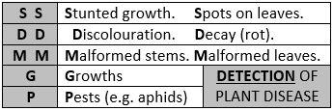 | 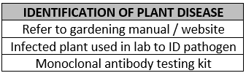
Fulford School Science Department
Developing the next generation of Super Scientists

GCSE Science – Five key terms | Topic B4 Part 1 – Photosynthesis

Photosynthesis | 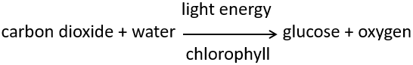  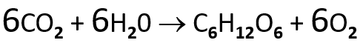 | 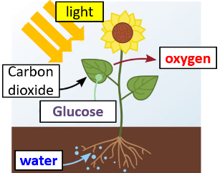
Chlorophyll | A green pigment inside chloroplasts that absorbs light energy for photosynthesis. | 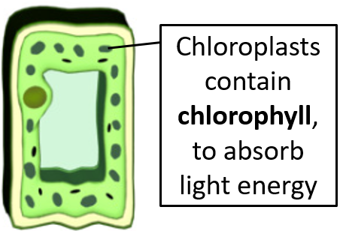
Endothermic reaction | Photosynthesis is endothermic, in which energy is transferred from the environment to chloroplasts by light; the energy is used to create glucose and oxygen, from carbon dioxide and water. | 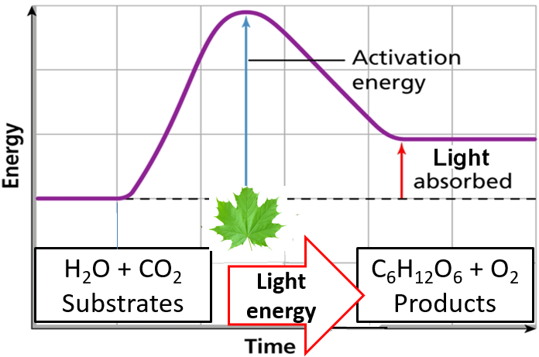
Limiting factors | Temperature, light intensity, CO₂ concentration and the amount of chlorophyll, affect the rate of photosynthesis. Any one factor can limit photosynthesis; increasing a limiting factor will increase the rate of photosynthesis. | 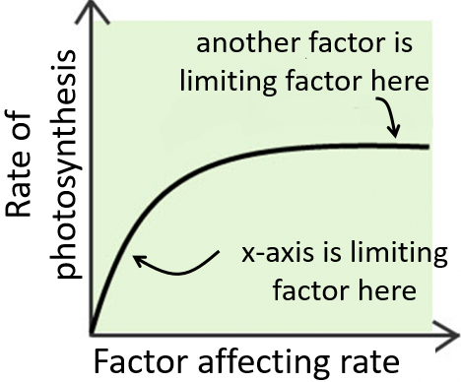
Inverse square law  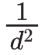 | (HT) Light intensity is inversely proportional to the square of the distance between a plant and the light source. | 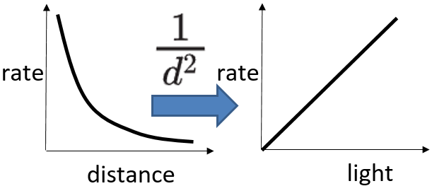

Five key ideas  Chlorosis  If a plant lacks Mg²⁺, less chlorophyll is made, so less light energy is absorbed for photosynthesis | Limiting factor graphs  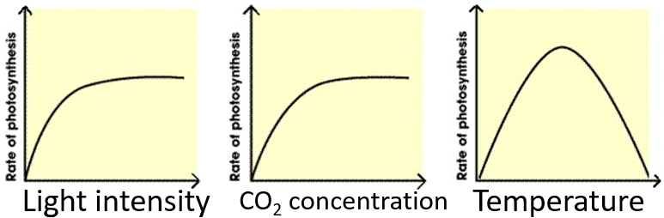 | Limiting factors are important in economics of enhancing conditions in greenhouses to gain maximum rate of photosynthesis while still maintaining profit.
 | Uses of glucose after photosynthesis  • for respiration, to release energy  • to make insoluble starch for storage  • to make fat or oil for storage  • to make cellulose, to strengthen cell walls  • to make amino acids for protein synthesis | To make proteins, plants need glucose from photosynthesis and nitrate ions, which are absorbed from the soil

Fulford School Science Department
Developing the next generation of Super Scientists

GCSE Science – Five key terms | Topic B4 Part 2 – Respiration

Aerobic respiration | Releasing energy from glucose using oxygen:  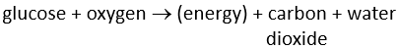 | 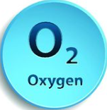  More  energy
Anaerobic respiration in muscle cells | Releasing energy from glucose without oxygen:  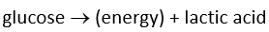 | 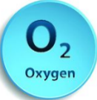  Less  energy
Fermentation | Anaerobic respiration (without oxygen) that  occurs in plants and yeast cells:  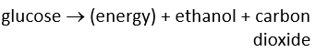  Has economic importance in making bread and alcoholic drinks. | Less  energy
Oxygen debt | The build up of lactic acid during long periods of vigorous activity results in muscles becoming fatigued and an oxygen debt builds up.  (HT) Volume of extra oxygen needed to react with lactic acid and remove it from cells is the oxygen debt. | 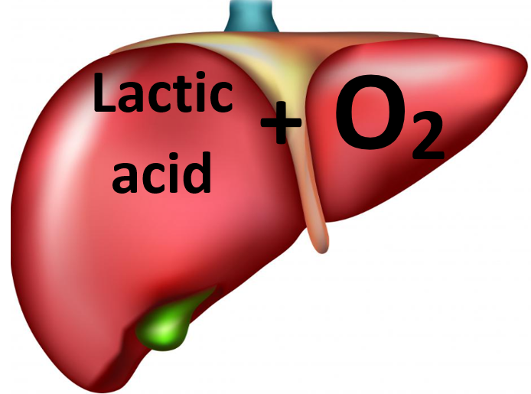
Metabolism | The sum of all the reactions in a cell or the body. The energy needed for enzyme-controlled processes of metabolism is transferred by respiration in cells.

Five key ideas  Respiration is an exothermic reaction, that occurs all the time in living cells. In eukaryotic cells, most of the reactions occur inside mitochondria | Cellular respiration, releases energy from glucose, transferring energy to cells for their life processes. The complete oxidation of glucose via aerobic respiration transfers more energy than the incomplete oxidation via anaerobic respiration. | Uses of energy  Organisms need energy for:  - Building larger molecules  - Muscle contraction to move  - Keeping warm  - Active transport
 | Reactions of metabolism include:  - Respiration, to transfer energy to cells  - Making starch and cellulose using glucose in plants  - Making amino acids, from glucose and nitrates, for protein synthesis in plants  - Making glycogen in animals  - Making lipids from glycerol and fatty acids  - Breaking down excess proteins into urea | During exercise the heart rate and breathing rate (& depth) increase – muscle cells need:  - to do more respiration  - to release more energy, so need to get…..  - more oxygenated blood  Never say respiration ‘makes/produces’ energy

