Useful contacts
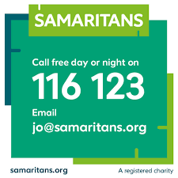 | Samaritans: Provides emotional support to anyone in emotional distress, struggling to cope, or at risk of suicide.  Call 116 123 24 hours a day (everyday), or email jo@samaritans.org  Write to us  Freepost SAMARITANS LETTERS
Shout: A text service, free on all major mobile networks, for anyone in crisis 24 hours a day, every day.
Text 85258
https://giveusashout.org/
Childline: Free, private and confidential service for anyone under 19 where you can talk about anything.
Call 0800 1111 or email or chat via www.childline.org.uk
Switchboard LGBT+ helpline: a one-stop LGBT+ listening service on the phone, by email and through instant messaging.
0800 0119 100
Open 10:00-22:00 every day
https://switchboard.lgbt/

Are you not coping with life? For confidential suicide prevention advice contact HOPELINE247.
0800 068 4141
pat@papyrus-uk.org
Text - 07860 039967
https://www.papyrus-uk.org/

Apps

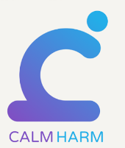 | Calm Harm - helps young people manage the urge to self-harm.
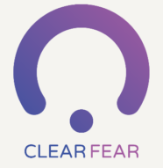 | Clear Fear - provides you with a range of ways to manage anxiety.
 | Move Mood - an app designed to help you manage low mood and depression. The app supports you to increase motivation to carry out a variety of tasks in order to help you to move forward, take control and feel positive.
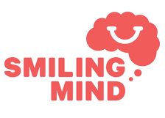 | Smiling Mind – A range of daily meditation and mindfulness exercises. Topics include but not limited to: stress, sleep, wellbeing, focus & attention.
 | ThinkNinja - a mental health app using a variety of content and tools, it allows young people to learn about mental health and emotional wellbeing, and develop skills they can use to build resilience and stay well.
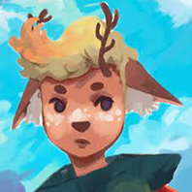 | https://www.apartofme.app/ Apart of Me an app for grief and loss  You can feel safe and rediscover a sense of calm  You can hear the stories of people like you who have had similar experiences, so you know you aren’t alone  You can learn to accept your feelings, however intense or uncomfortable they are  You take on real-world quests to discover the strength and wisdom deep inside you

Websites

Beat - a website dedicated to Eating Disorders. https://www.beateatingdisorders.org.uk/

Child Bereavement UK - providing information & support to families when a child is bereaved. https://www.childbereavementuk.org/

Mind-Ed - an online learning and advice resource for anyone interested in, or concerned about, the mental health of children and teenagers. https://www.minded.org.uk/

NHS Inform – Information on a variety of mental health problems and disorders, plus a wide range of mental health self-help guides.
https://www.nhsinform.scot/illnesses-and-conditions/mental-health

Young Minds - the UK's leading charity committed to improving the emotional well-being and mental health of children and young people. https://youngminds.org.uk/

