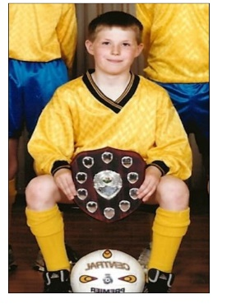
Teacher Profile –
Mr Wardell
Time at school
I enjoyed a range of subjects at school, including English, History, DT and obviously PE. I was really lucky that both my primary and secondary school offered a wide variety of different sports and I was fortunate enough to represent my school at football, rugby and athletics. My advice is to get involved in as many clubs as possible as many of my best school memories come from playing sport and the opportunities and that come with it.
When I chose my GCSE options, my form tutor advised me to pick the subjects that I had the most passion for, which included GCSE PE. I enjoyed learning the theory behind the sports I loved and started a lifelong interest in sport and social science.
After Y11
After my GCSEs, I stayed in the sixth form at my secondary school to study A level PE, Geography and English Language. I enjoyed all the subjects and the challenge of studying at a higher level. It was during my A levels that I first developed an interest in sport psychology, in addition to being able to study my other passion, history, during the history of sport unit. That is one of the great things about studying PE, it links to so many other subjects, interests and careers.
I continued to play football for school and moved up to the seniors at my local club, in addition to starting to play badminton and going to the gym. It’s really easy to stop playing sport after Y11, but there are plenty of opportunities if you know where to look.
University
I enrolled at Northumbria University in Newcastle to study a BA (Hons) in Sports Development and Coaching. My degree course enabled me to explore the many different avenues of sport as an academic subject, including anatomy and physiology, psychology, biomechanics, sport marketing and sociology. I took a particular interest in sport sociology, with this being the focus of my third year dissertation.
In my third year, I joined the rugby league team that competed in the university BUCs league. It was great to experience higher level coaching and see the sports science I was learning in my degree put into practice.
It was during my time at Northumbria that I realised that a wanted to purse at career in teaching, when I completed an assessed placement at a local secondary school. I instantly knew that I’d found the career path I wanted to take as I enjoyed the experience so much.
After university
After graduating from university, I knew I wanted to gain some more experience and see more of the world. I was lucky enough to gain a place through Camp America at Canyon Creek Sports Camp in California. I learned loads of new skills, met some amazing people and saw some incredible places. It was also here that I realised the impact sport can have on the lives of young people, when I worked on a project providing sport for children from inner city Los Angeles. Between my two summers in California, I moved to Sydney, Australia and got a job working in a gym. It was here I got to put into practice the knowledge I had gained at university around sport marketing.
I returned to Yorkshire after nearly 2 years abroad and completed my teacher training at All Saints and Joseph Rowntree’s in York, before starting at Fulford in 2016.

