Teacher Profile –
“Mr Russell”
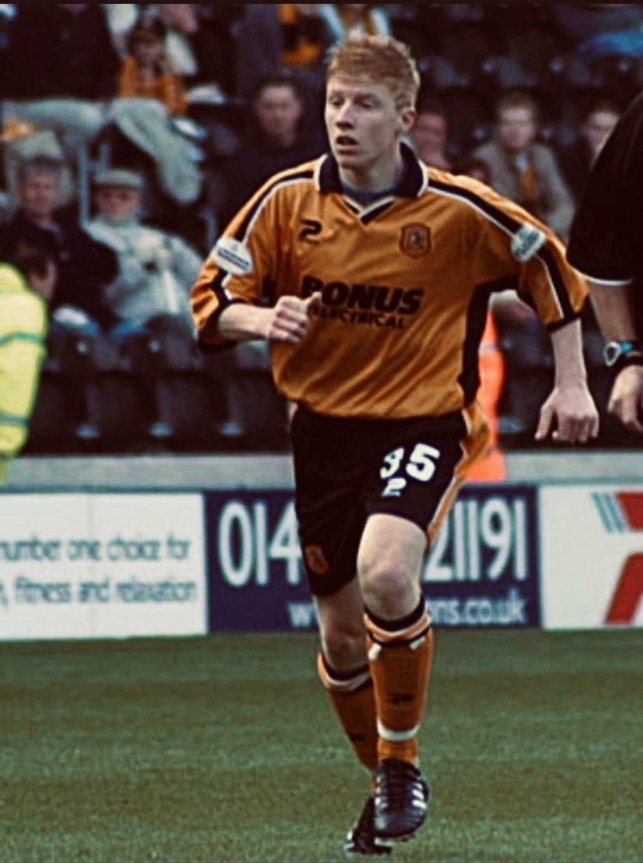
University…
At the age of 32 and coming towards the end of my football career I decided to do a Sport, Exercise and Science degree at Bishop Burton College. It involved a number of units including anatomy and physiology, sports coaching and sports psychology. Sports psychology was my favourite unit and this is what I did my dissertation in. I find it really interesting how the mind contributes to sports performance. I managed to gain a 1st in my degree which I only gained through sheer hard work and dedication.
At 32 I was playing semi-professional football for Gainsborough Trinity and balancing that with my full-time degree but I really enjoyed it. I lacked the belief that I could complete a degree but after speaking to my old PE Teacher and some close family and friends, they reassured me that I could do it and it was the best decision I ever made!
After Y11…
I was lucky to be offered a football scholarship at Hull City after being with the academy from 8 years old so that was my pathway after leaving school. I trained every day alongside the first team, preparing their kit, cleaning their boots and ensuring everything was ready for them. Then, we would train! It was the best three years of my life. You learnt so much on and off the pitch. I studied BTEC Diploma in Sport Studies which was part of the football scholarship. I particularly enjoyed the anatomy and physiology units. During these three years I was lucky enough to make my professional debut at 17 in the LDV Vans Trophy away at Port Vale and at 18 my professional league debut at 18 at the KC Stadium in front of 14,000 fans – amazing but safe to say I was rather nervous!!!
After university…
I did things backwards!! My career mainly consisted of playing professional football for 13 years after leaving school and then 8 years as a semi-professional. The highlight has to be two appearances at Wembley, one in front of 60,000 fans live on TV. I feel very fortunate to have been paid to play football for 21 years but this was only possible through hard work and dedication. In my last few years of playing semi-professional football and after completing my degree I started a PGCE as a Secondary PE Teacher and was lucky to come to Fulford School for my training year. I then spent a year at York High School before the opportunity to return to this fantastic school was one I could not miss.
Time at school…
I loved school especially playing sport at school and my PE teachers were my favourite teachers throughout school! They supported me throughout my 5 years and always believed in me. I represented my school at football (obviously!), cricket, volleyball and athletics. There was a limited number of sports and extra-curricular clubs provided back then so I was pretty much involved in everything there was to offer. I captained the school football team from Y7 through to Y11 and I was proud to lead my peers. I was adamant that despite my ability to play football at a high level and being part of the Hull City Academy, I ensured that I studied hard so that I got the best GCSE’s possible for my future.

