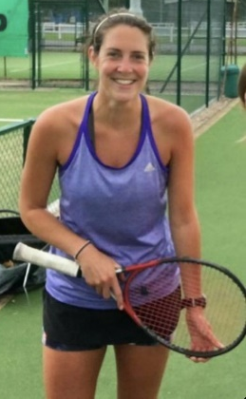
Teacher Profile –
Mrs Wise
University
I am incredibly proud and thankful that I got to study BA (Hons) Physical Education at Leeds Beckett University within the Carnegie Faculty of Sport. The degree course was so varied, looking at many different elements of Sport & PE (teaching, physiology, psychology, biomechanics, sociology etc.)
As there was also a Regional Tennis Centre on the campus, I loved being able to train and compete within the university BUCS league. I met some friends for life through my tennis involvement at university.
My time at university also inspired me to use my long summer holidays to teach abroad. I spent my university summers teaching English and Sport at a summer camp in Austria. I managed to pick up a little German speaking through this and got to teach people of all nationalities in the beautiful hills around the Salzburg area!
After Y11
During my time at sixth form I played district netball and continued to play lots of sport outside of school. I attended a dance school up until the age of 17 alongside playing hockey and tennis for local teams.
At sixth form I studied A Levels in PE, Biology, Sociology & Geography – PE obviously being my favourite! I loved the modules that looked at the Sociology and History of Sport.
Time at school
I loved all things PE at school! I joined any club that was on offer but hockey, tennis, netball, rounders and dance were my particular favourites. I was lucky enough to play in lots of fixtures at school and also represented my district in tennis. Outside of school I would go to dance, tennis and swimming.
After university
After graduating I worked in an office (very dull!) in order to get money so I could go travelling. I went to various places, my favourites being India, Nepal, Thailand & Cambodia. I also volunteered in a couple of PE departments to get more hands on experience of teaching.
Following this I started my teacher training (PGCE) at Durham University. This involved teaching in schools in Sunderland & Hartlepool. During this year I gained other qualfications to help my teaching in things such as trampolining, tennis, hockey, netball, parkour and football.
After my PGCE I worked at a school in Seacroft in Leeds for 4 years, before coming to wonderful Fulford!

