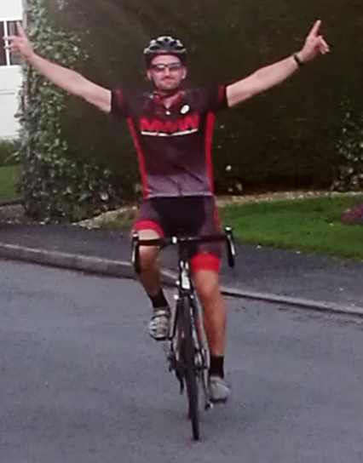

**Through school from an early age I was an active child who was given opportunities to experience a broad range of sports and activities. I can remember primarily playing Football and Tennis whilst at Primary school. During the summer holidays I would attend Football camps run by the FA and LTA sponsored Tennis coaching. I think at that age though sport was predominantly about having fun with my friends and an opportunity to be active in and out of school.**

**As I progressed through school to secondary Sport and general Health and Fitness became more important to me and I began to take a much more keen interest in it. The secondary school I attended was small in comparison to Fulford and as such not as many opportunities where available to compete. My PE lessons where often predominantly focused on Rugby, Football and Cricket which I enjoyed so PE quickly became one of my favourite subjects and I went on to study it at GCSE and A Level. I represented my school in nearly all sports but was fortunate that my parents would support me in accessing teams away from school to perform at a higher level. School PE lessons and sports teams allowed me to form bonds with other students who still remain my friends many years after leaving school.**

**Mr Copeland**

**I went to Leeds Metropolitan University (now Leeds Carnegie) and studied Sport and Recreation Development. This course was based on the promotion of sport and the business structures around it on both a public and private sector level. I particularly enjoyed the events and marketing side of this but was most enthused by the coaching and anatomy and physiology elements. Many of the units on my course I can see elements of in the AQA GCSE PE we deliver in school at the moment.**

**Whilst at University I played Rugby League and was fortunate enough to train and play with some brilliant players who went on to represent Super League Clubs. During my time at university I again like school made friends who are still part of my life now.**

**Whilst still at university in 2005 I was diagnosed with a Brain Tumour which was removed during the summer between 2nd and 3rd year. I had a shunt fitted to help drain fluid from around my Brain which is still in place today and has been replaced once in 2018. This essentially immediately meant that I was unable to participate in many of the sports I loved. I completed my degree on time and went on to work for numerous people before getting a job with Education Leeds at a Carr manor High School, from here I went on to work in an unqualified teaching role at City of Leeds School this confirmed to me that I wanted a career in Education and I applied for and was successful in a GTP at Sirius Academy in Hull and gained my Teaching Qualification. Since then I have worked in Pontefract and now at Fulford. Away from school I still watch lots of Sport including my own children and do a lot of cycling. Sport has introduced me to so many brilliant experiences and people over the years. If I could give you any advice it is to try everything and never turn down the opportunity to play because you won’t be able to play forever.**

**I stayed to 6th Form in the same school as my GCSE’s and continued to play the same sports for the same teams away from school as well as playing, Tennis, Golf, Running and using the Gym. At this point I was playing seniors which was a completely different environment to juniors and showed me that Sport becomes a lifestyle choice and shapes you as an individual not only physically but socially as well.**