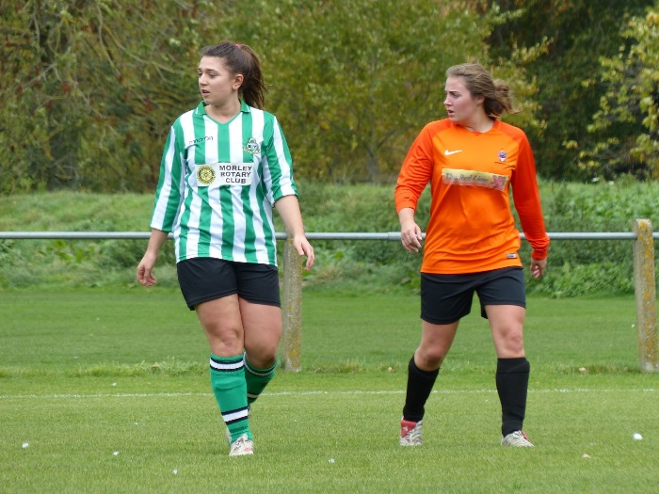**Teacher Profile –   
Miss Sweet**

**After university**Straight after my time at Leeds Beckett University, I started my teacher training (PGCE) through Sheffield Hallam University and the White Rose Alliance. This involved teaching at different schools in York/Harrogate to gain experience.

After my PGCE year, I went straight into a teaching job where I worked at Joseph Rowntree School and I completed my NQT year. I was then extremely lucky to get my job here at Fulford School ☺

**After Y11**I continued at the same school and went to sixth form where I studied A Levels in PE, Photography and Psychology. These were all really enjoyable but PE was obviously my favourite! The topic I found most interesting was Anatomy and Physiology. I loved learning about the human body and this particular module inspired me to go to University and study it in more detail. During sixth form, I took a step back from playing as much sport and joined the school gym instead. I was still involved with the PE department through being a sports leader/head of house where I volunteered at local primary schools to lead PE lessons and I also helped organise sports events at my school.

**University**I went to Leeds Beckett University where I completed a 3 year course doing an Undergraduate BSc (Hons) in Sport and Exercise Therapy. Although I always had it in the back of my mind that I wanted to be a PE teacher (since about Y7!) I chose to do a different course at University that could lead to multiple paths and opportunities in the sports industry in case teaching wasn’t for me. Due to my passion of anatomy and physiology, this course focused on a lot of information to do with that, as well as sport psychology, biomechanics, working pitch-side and first aid, working in a clinic to assess injuries and then create rehabilitation plans. It was very interesting and I enjoyed it a lot. As part of my course, I had to volunteer and complete 200 hours of placement. I was lucky enough to work in a physiotherapy clinic where I had to assess patients and diagnose their issues and then implement treatment. I also did work experience with the sports therapist of Sunderland Football Club. In between lectures, I went back to my secondary school to volunteer in the PE department to help out in lessons and sports trips. In regards to playing sport, I returned back to playing football for a local club.

**Time at school**  
I absolutely loved school, especially anything to do with PE! From primary school and all the way through secondary school I joined any club that was on offerbut my favourite ones were football, netball, athletics, dance and rounders.As well as attending a PE club most days, I also got to represent my school in lots of different fixtures and also represented my district in athletics doing 100m and long jump. I also got involved with the PE department through being a member of the sports council.