Fulford Paper Airplane Challenge 2021

Who can make the paper airplane that travels the furthest?

What you will need:
- A tape measure/ Ruler
- 4 pieces of Paper ( A4 if possible)

Step 1: Watch the video link
https://m.youtube.com/watch?v=3dbmsdprJoA
Step 2: Make your first plane
Step 3: Throw it and measure how far it travels, repeat 2 more times and calculate a mean
Step 4: Repeat with the different designs

 | Distance Travelled (cm)
Type of airplane | Attempt 1 | Attempt 2 | Attempt 3 | Mean
Arrowhead
F15
Dagger
Own design

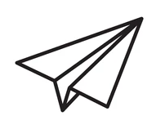
- What is the independent variable?
- What is the dependent variable?
- What are the control variables?
- Did you have any anomalous results?
- What is the range of your F15 results?
- Which design was the best one, can you explain why?

To win the competition - please email stablerk@fulford.york.sch.uk (You must say your name, science teacher, form, distance travelled by the plane, the design used, plus photographic evidence)

