Fulford School Physical Education Department want you to stay fit and healthy throughout Lockdown and the school holidays. So why not:

Workout the Wright Way

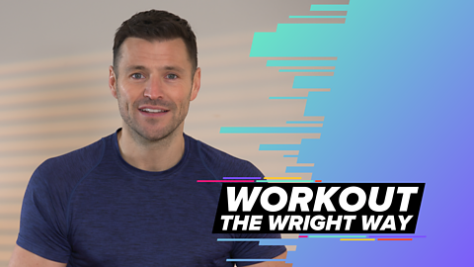
Join Mark Wright as he leads you through a range of fun and achievable exercises to help keep you feeling fit and healthy, whether you are a sport superstar or a complete novice. Here you can find all the episodes from Workout the Wright Way, with a new episode added each day at 8am. You can also watch the series on BBC Two at 8.45am each weekday and catch up on BBC iPlayer.
Follow this link to find the workouts Workout the Wright Way - BBC Bitesize
