**FULFORD SCHOOL**



**Year 10**

**Information Evening**

**Booklet**

**September 2020**

|  |  |
| --- | --- |
|  |  |
|  | **English** |
| **Course title:** GCSE English Language; GCSE English Literature (students study BOTH qualifications)  **Examination board:** AQA  **Tiered/untiered:** Untiered  **Proportion assessed by examination:** 100%  **Proportion assessed by non-examined assessment (NEA):** 0%  **Number and length of examinations:** GCSE English Language – 2 examinations: 1 hour 45 minutes each; GCSE English Literature – 2 examinations: 1 hour 45 minutes and 2 hours 15 minutes  **Grading:** 9-1 | |
|  | **Mathematics** |
| **Course title:** GCSE Mathematics  **Examination board:** Edexcel  **Tiered/untiered:** Two tiers – Higher and Foundation level  **Proportion assessed by examination:** 100%  **Proportion assessed by non-examined assessment (NEA):** 0%  **Number and length of examinations:** 3 examinations: 1 hour 30 minutes each  Paper 1 is non-calculator, Papers 2 and 3 are calculator (regardless of tier)  **Grading:** 9-1 | |
|  | **Science** |
| **Course title:** GCSE Separate Sciences (Triple Sciences – three different GCSEs in Biology, Chemistry and Physics); GCSE Combined Science (Dual Science – two GCSEs, combining elements of Biology, Chemistry and Physics)  **Examination board:** AQA  **Tiered/untiered:** Two tiers – Higher and Foundation level  **Proportion assessed by examination:** 100%  **Proportion assessed by non-examined assessment (NEA):** 0%  **Number and length of examinations:** Separate Sciences – 6 examinations (at both tiers): 1 hour 45 minutes each (2x Biology, 2x Chemistry & 2x Physics); Combined Science - 6 examinations (at both tiers): 1 hour 15 minutes each (2x Biology, 2x Chemistry & 2x Physics)  **Grading:** 9-1 | |
|  | **Art & Design** |
| **Course title:** GCSE Fine Art  **Examination board:** Pearson  **Tiered/untiered:** Untiered  **Proportion assessed by examination:** 0%  **Proportion assessed by controlled assessment or coursework:** 40% controlled assessment and 60% coursework  **Number and length of examinations:** Controlled assessment is 12 weeks long, with a 10 hour timed controlled assessment examination that runs over multiple sessions  **Grading:** 9-1 | |
|  | **Business Studies** |
| **Course title:** GCSE Business  **Examination board:** AQA  **Tiered/untiered:** Untiered  **Proportion assessed by examination:** 100%  **Proportion assessed by non-examined assessment (NEA):** 0%  **Number and length of examinations:** 2 examinations: 1 hour 45 minutes each  **Grading:** 9-1 | |
| MC900019332[1] | **Computing** |
| **Course title:** GCSE Computer Science (2020)  **Examination board:** Pearson  **Tiered/untiered:** Untiered  **Proportion assessed by examination:** 100%  **Proportion assessed by non-examined assessment (NEA):** 0%  **Number and length of examinations:** 2 examinations: 1 hour 30 minutes (paper) and 2 hours (on screen)  **Grading:** 9-1 | |
| Description: MCj02904170000[1] Description: MMj02840550000[1] | **Design and Technology:** with a specialism in Graphic Products, Resistant Materials and Textiles Technology |
| **Course title:** GCSE Design and Technology  **Examination board:** AQA  **Tiered/untiered:** Untiered  **Proportion assessed by examination:** 50%  **Proportion assessed by non-examined assessment (NEA):** 50%  **Number and length of examinations:** 1 examination: 2 hours  **Grading:** 9-1 | |
| Description: MCj03394480000[1] | **Drama** |
| **Course title:** GCSE Drama  **Examination board:** AQA  **Tiered/untiered:** Untiered  **Proportion assessed by examination:** 40%  **Proportion assessed by non-examined assessment (NEA):** 60%  **Number and length of examinations:** 1 examination: 1 hour 45 minutes  **Grading:** 9-1 | |
|  | **Food Preparation and Nutrition** |
| **Course title:** GCSE Food Preparation and Nutrition  **Examination board:** AQA  **Tiered/untiered:** Untiered  **Proportion assessed by examination:** 50%  **Proportion assessed by non-examined assessment (NEA):** 50%  **Number and length of examinations:** 1 examination: 1 hour 45 minutes  **Grading:** 9-1 | |
| Description: MCj04380590000[1] | **Geography** |
| **Course title:** GCSE Geography  **Examination board:** AQA  **Tiered/untiered:** Untiered  **Proportion assessed by examination:** 100%  **Proportion assessed by non-examined assessment (NEA):** 0%  **Number and length of examinations:** 3 examinations: 2 x 1 hour 30 minutes and 1 x 1 hour 15 minutes  **Grading:** 9-1 | |
| Description: MCj01493240000[1] | **History** |
| **Course title:** GCSE History  **Examination board:** AQA  **Tiered/untiered:** Untiered  **Proportion assessed by examination:** 100%  **Proportion assessed by non-examined assessment (NEA):** 0%  **Number and length of examinations:** 2 examinations: 2 hours each  **Grading:** 9-1 | |
| Description: j0205582 | **IMedia** |
| **Course title:** Cambridge National Certificate in Creative iMedia  **Examination board:** OCR  **Tiered/untiered:** Untiered  **Proportion assessed by examination:** 25%  **Proportion assessed by controlled assessment or coursework:** 75%  **Number and length of examinations:** 1 examination: 1 hour 15 minutes  **Grading:** Level 2 Distinction* - Level 1 Pass | |
| Description: MMj01782480000[1]MC900015880[1] | **MFL** |
| **Course title:** GCSE French and Spanish (the same assessment format applies to both subjects)  **Examination board:** AQA  **Tiered/untiered:** Two tiers – Higher and Foundation level  **Proportion assessed by examination:** 100%  **Proportion assessed by non-examined assessment (NEA):** 0%  **Number and length of examinations:** Foundation tier – 4 examinations: 1 x 35 minutes, 1 x 7-9 minutes, 1 x 45 minutes and 1 x 1 hour; Higher tier - 4 examinations: 1 x 45 minutes, 1 x 10-12minutes, 1 x 1 hour and 1 x 1 hour 45 minutes  **Grading:** 9-1 | |
| Description: MCj04325480000[1] | **Music** |
| **Course title:** GCSE Music  **Examination board:** Eduqas  **Tiered/untiered:** Untiered  **Proportion assessed by examination:** 40%  **Proportion assessed by non-examined assessment (NEA):** 60% (30% Performance, 30% composition)  **Number and length of examinations:** 1 examination: 1 hour 15 minutes  **Grading:** 9-1 | |
| Description: MCj04125460000[1] | **Physical Education** |
| **Course title:** GCSE PE  **Examination board:** AQA  **Tiered/untiered:** Untiered  **Proportion assessed by examination:** 60%  **Proportion assessed by non-examined assessment (NEA):** 40%  **Number and length of examinations:** 2 examinations: 1 hour 15 minutes each  **Grading:** 9-1 | |
|  | **Religious Studies** |
| **Course Title:** GCSE Religious Studies A  **Examination Board:** AQA  **Tiered/untiered:** Untiered  **Proportion assessed by examination:** 100%  **Proportion assessed by non-examined assessment (NEA):** 0%  **Number and length of examinations:** Full course - 2 examinations: 1 hour 45 minutes each;  Short course: 1 examination, 1 hour 45 minutes  **Grading:** 9-1 | |
| HappyPC[1] | **Work Skills** |
| **Course Title:** BTEC Level 1 WorkSkills  **Examination board:** Pearson  **Tiered/untiered:** Untiered  **Proportion assessed by examination:** 0%  **Proportion assessed by controlled assessment or coursework:** Ongoing assessment by work-related projects and presentations  **Number and length of examinations:** None  **Grading:** Level 1 Pass/Fail   |  |  | | --- | --- | |  | **Enterprise** | | **Course title:** BTEC Level 1/Level 2 Tech Award in Enterprise  **Examination board:** Pearson  **Tiered/untiered:** Untiered  **Proportion assessed by examination:** 40%  **Proportion assessed by controlled assessment or coursework:** 60%  **Number and length of examinations:** 1 examination: 2 hours  **Grading:** Level 2 Distinction* - Level 1 Pass | | | |

***Please note that further information about specifications and course content is available via the ‘Curriculum Information’ tab on the school website.***

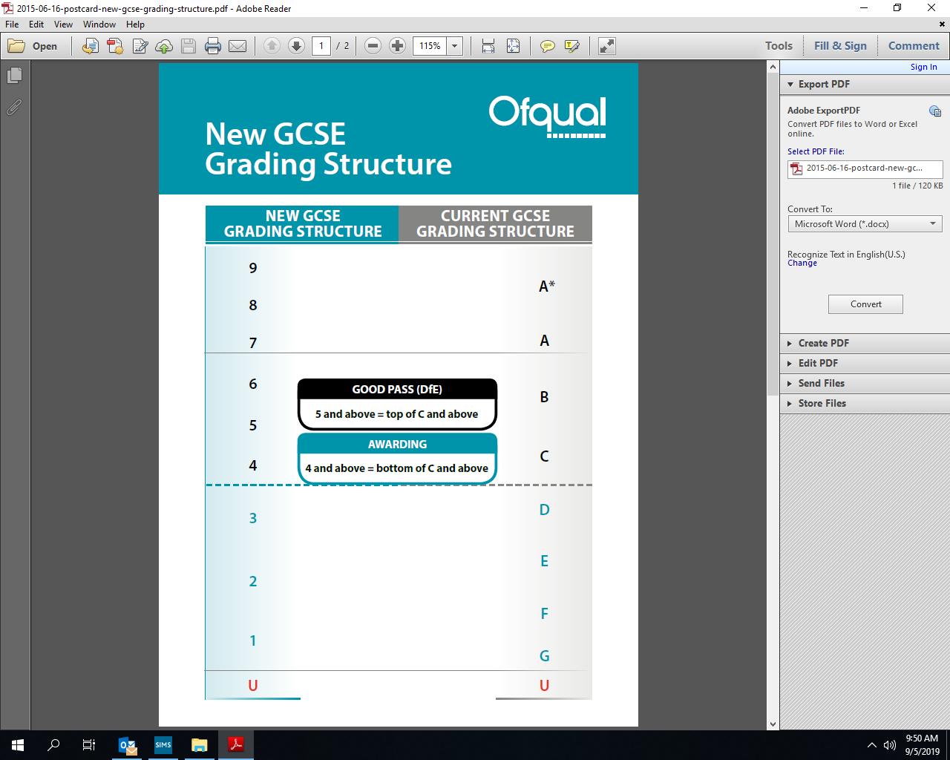

PREVIOUS GRADING STUCTURE

Recommended Support and Revision Resources

|  |  |
| --- | --- |
| English | GCSE English Language   * Revise AQA GCSE (9-1) English Language Revision Workbook: for the 9-1 exams ISBN 978-1447987833 * Revise AQA GCSE (9-1) English Language Model Answer Workbook ISBN 978-1292230221 * REVISE AQA GCSE (9-1) English Language Practice Papers Plus ISBN 978-1292213255   GCSE English Literature   * Romeo and Juliet: New Grade 9-1 GCSE English Literature AQA Text Guide (Collins GCSE 9-1 Snap Revision) ISBN 978-0008247072 * A Christmas Carol: New Grade 9-1 GCSE English Literature AQA Text Guide (Collins GCSE 9-1 Snap Revision) ISBN 978-0008247119 * An Inspector Calls: New Grade 9-1 GCSE English Literature AQA Text Guide (Collins GCSE 9-1 Snap Revision) ISBN 978-0008235918 * Power & Conflict Poetry Anthology: New GCSE Grade 9-1 AQA English Literature: GCSE Grade 9-1 (Collins GCSE 9-1 Snap Revision) ISBN 978-0008320102 * Unseen Poetry: New GCSE 9-1 English Literature AQA (Collins GCSE 9-1 Snap Revision) ISBN 978-0008320119 |
| Maths | Websites : mymaths.co.uk, hegartymaths.com  REVISE Edexcel GCSE (9-1) Mathematics **Foundation** Guided Revision Workbook: for the 2015 specification  ISBN-13: 978-1292213712  REVISE Edexcel GCSE (9-1) Mathematics **Higher** Guided Revision Workbook: for the 2015 specification  ISBN-13: 978-1292213705 |
| Science | **Triple Science: Biology**  New Grade 9-1 GCSE Biology AQA Complete Revision & Practice with Online Edition  ISBN-10: 1782945830 ISBN-13: 978-1782945833 |
| **Triple Science: Chemistry**  New Grade 9-1 GCSE Chemistry AQA Complete Revision & Practice with Online Edition ISBN-10: 1782945849 ISBN-13: 978-1782945840 |
| **Triple Science: Physics**  New Grade 9-1 GCSE Physics AQA Complete Revision & Practice with Online Edition - ISBN-10: 1782945857 ISBN-13: 978-1782945857 |
| **Dual Science**  New Grade 9-1 GCSE Combined Science: Physics AQA Complete Revision & Practice with Online Edition ISBN-10: 1782945881 ISBN-13: 978-1782945888  New Grade 9-1 GCSE Combined Science: Chemistry AQA Complete Revision & Practice with Online Edition ISBN-10: 1782945873 ISBN-13: 978-1782945871  New Grade 9-1 GCSE Combined Science: Biology AQA Complete Revision & Practice with Online Edition ISBN-10: 1782945865 ISBN-13: 978-1782945864 |
| Geography | Revision guide: New Grade 9-1 GCSE Geography AQA Revision Guide ISBN-13 9781782946106   Workbook: New Grade 9-1 GCSE Geography AQA Complete Revision & Practice, CGP. ISBN-13 9781782946137   Website: [https://www.kerboodle.com/users/login](https://mail.fulford.york.sch.uk/owa/redir.aspx?REF=xr3cia0_K5OvkPstE8PCsWwDqmw74EjO9ja9VZyTMPOQ1NYXpXfUCAFodHRwczovL3d3dy5rZXJib29kbGUuY29tL3VzZXJzL2xvZ2lu) Students have been given a username, password and institution code (kz1) |
| History | ‘My Revision Notes: AQA GCSE History 9-1’ by Tim Jenner, David Ferriby etc. ISBN = 978 – 1 – 5104 -0404 -5  Oxford AQA GCSE History Unit Guides:-  Norman England c1066-c1100 ISBN=978-0-19-843284-5  Power and the People c1170-Present Day ISBN = 978-0-19-843290-6  Conflict and Tension between East and West 1945-1972 ISBN = 978-0-19-843288-3  America 1920-1973 Opportunity and Inequality ISBN = 978-0-19-843282-1  CGP have now also started to do unit guides but these are not AQA specific so we would recommend the Oxford Unit Guides in preference to CGP.  Please see the school’s VLE for our departmental revision resources which are quite extensive. We also produce our own revision booklets for each topic which are available on the VLE. |
| French | CGP: New GCSE French AQA Revision Guide - for the Grade 9-1 Course (with Online Edition) ISBN: 978 1 78294 537 6  CGP: New GCSE French AQA Exam Practice Workbook - for the Grade 9-1 Course (includes Answers) ISBN: 978 1 78294 538 3  Website – [www.memrise.com](http://www.memrise.com) and [www.kerboodle.com](http://www.kerboodle.com) |
| Spanish | New GCSE Spanish AQA Revision Guide - for the Grade 9-1 Course (with Online Edition) ISBN: 978 1 78294 546 8  New GCSE Spanish AQA Exam Practice Workbook - for the Grade 9-1 Course (includes Answers) ISBN: 978 1 78294 547 5  Website: [www.memrise.com](http://www.memrise.com) and [www.kerboodle.com](http://www.kerboodle.com) |
| DT: Textiles | Study/ Exam practice book: Collins GCSE Grade 9-1 Revision - AQA GCSE 9-1 Design & Technology All-in-One Complete Revision and Practice. (ISBN: 978-0-00-822740-1) <https://collins.co.uk/products/9780008227401> Website:  <https://www.bbc.co.uk/bitesize/examspecs/zby2bdm>  <http://www.technologystudent.com/> |
| DT: Graphics | Study/ Exam practice book: Collins GCSE Grade 9-1 Revision - AQA GCSE 9-1 Design & Technology All-in-One Complete Revision and Practice. (ISBN: 978-0-00-822740-1) <https://collins.co.uk/products/9780008227401> Website:  <https://www.bbc.co.uk/bitesize/examspecs/zby2bdm>  <http://www.technologystudent.com/> |
| Food and Nutrition | Study/ Exam practice book: Collins GCSE Grade 9-1 Revision - AQA GCSE 9-1 Food Preparation and Nutrition All-in-One Complete Revision and Practice. (ISBN: 978-0-00-816634-2) <https://collins.co.uk/products/9780008166342> Website: <http://www.illuminate.digital/aqafood/>  login: SFULFORD3  password: STUDENT3 |
| DT: Resistant materials | Study/ Exam practice book: Collins GCSE Grade 9-1 Revision - AQA GCSE 9-1 Design & Technology All-in-One Complete Revision and Practice. (ISBN: 978-0-00-822740-1) <https://collins.co.uk/products/9780008227401> Website:  <https://www.bbc.co.uk/bitesize/examspecs/zby2bdm>  <http://www.technologystudent.com/> |
| PE | Revise AQA GCSE (9-1) Physical Education: Revision Guide (Pearson)  Revise AQA GCSE (9-1) Physical Education: Revision Workbook (Pearson)  AQA GCSE Physical Education Third Addition Kirk Bizley  <https://www.bbc.co.uk/bitesize/examspecs/zp49cwx> |
| Music | WJEC/Eduqas Revision guide by Jan Richards  Focus on Sound: <https://fulford.musicfirst.co.uk/app/>  BBC Bitesize: Music – Eduqas: <https://www.bbc.co.uk/bitesize/examspecs/zbmct39> |
| Computer Science | Revision guide for the revised 2020 specification due to be published in Feb 2021  Website: <https://tools.withcode.uk/keywords/subject/edexcel_gcse_computer_science_2020>  Website: <https://vle.fulford.york.sch.uk/course/view.php?id=940>  Website: <https://tools.withcode.uk/quickref> |
| iMedia | OCR Nationals in Creative iMedia L 1 / 2: Pre-production skills and Creating digital graphics ISBN-13: 978-1471886683  Website: <https://tools.withcode.uk/keywords/subject/imedia_r081_pre_production_skills> |
| RE | GCSE AQA A Religious Studies: For Grade 9-1 Course. ISBN: 978 1 78294 641 0  Departments own revision guide. Can be purchased from the Religious Studies Department.  Religious Studies Spec A (AQA approved) ISBN: 978 1 471 866685 2  Website: <http://www.bbc.co.uk/education/subjects/zb48q6f> |
| Business | New GCSE Business AQA Revision Guide - for the Grade 9-1 Course; ISBN: 978 1 78294 689 2 New GCSE Business AQA Exam Practice Workbook - for the Grade 9-1 Course, CGP; ISBN: 978 1 78294 692 2 GCSE AQA Business textbook; ISBN-13: 9781471899386  <https://www.bbc.com/bitesize/subjects/zpsvr82> |
| Art | Visiting local galleries: York Art Gallery, The Yorkshire Sculpture Park and The Hepworth. Other helpful websites include [www.pinteret.com](http://www.pinteret.com) and [www.art2day.com](http://www.art2day.com)  No revision guides but the following link has examples of work:  <https://qualifications.pearson.com/en/qualifications/edexcel-gcses/art-and-design-2016.coursematerials.html#filterQuery=Pearson-UK:Category%2FTeaching-and-learning-materials> |
| Enterprise | BTEC Tech Award Enterprise 2nd Edition for BTEC Specification issue 3, ISBN 9781292279343; Time 2 Resources Pearson BTEC Level 1/Level 2 Tech Award in Enterprise Component 3 Promotion and Finance Enterprise, ISBN 9781910769638; Revise BTEC Tech Award Enterprise Revision Guide ISBN 9781292245607 |
| Drama | AQA GCSE Drama (New spec from Sept 2016) ISBN: 978-1-911208-21-1  Blood Brothers: York Notes for GCSE (9-1) Paperback ISBN: 1292138068  Blood Brothers Play Guide for AQA GCSE Drama Paperback – 7 Jan 2019 by [Annie Fox](https://www.amazon.co.uk/Annie-Fox/e/B00JH1Q4X0/ref=dp_byline_cont_book_1)  (Author) ISBN-10: 1911208705  DVD of the RSC production of The Tempest Simon Russell Beale; Joe Dixon; Mark Quartley; Jenny Rainsford; Simon Trinder; Tony Jayawardena; Oscar Pearce; [Opus Arte: OA1249D] [DVD] Released July 2017 |
| Students are also encouraged to register with Seneca Learning, a free website that provides information and tutorials across a range of subjects. Please visit <https://senecalearning.com/> for more information. | |

A number of departments produce their own revision guides, which are available on the school VLE website and the recommended guides should be seen as supplementary to this.